**© Copyright Envision SBS. 2007. All rights reserved. Protected by the copyright laws of the United States & Canada and by international treaties. IT IS ILLEGAL AND STRICTLY PROHIBITED TO DISTRIBUTE, PUBLISH, OFFER FOR SALE, LICENSE OR SUBLICENSE, GIVE OR DISCLOSE TO ANY OTHER PARTY, THIS PRODUCT IN HARD COPY OR DIGITAL FORM. ALL OFFENDERS WILL BE SUED IN A COURT OF LAW.**

**© Copyright BizTree. 2006. All rights reserved. Protected by the copyright laws of the United States and Canada and by international treaties. IT IS ILLEGAL AND STRICTLY PROHIBITED TO DISTRIBUTE, PUBLISH, OFFER FOR SALE, LICENSE OR SUBLICENSE, GIVE OR DISCLOSE TO ANY OTHER PARTY, THIS PRODUCT IN HARD COPY OR DIGITAL FORM. ALL OFFENDERS WILL AUTOMATICALLY BE SUED IN A COURT OF LAW.**

Raven Games

BUSINESS PLAN

# 

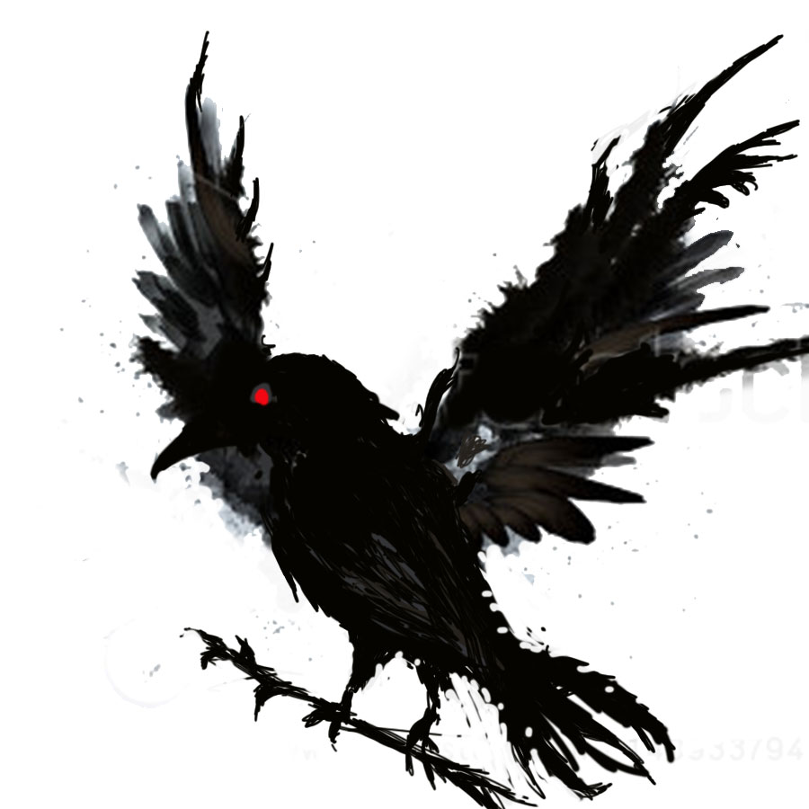

**Insert a colour company logo or picture representing company or product/service**

Alexander Sanchez

President

581 Richmond St

London, Ontario, N6A 3G2

Canada

519-636-0421

alexandermagus6@icloud.com

http://triosdevelopers.com/A.Sanchez

May 7, 2015

**Table of Contents**

**© Copyright BizTree. 2006. All rights reserved. Protected by the copyright laws of the United States & Canada and by international treaties. IT IS ILLEGAL AND STRICTLY PROHIBITED TO DISTRIBUTE, PUBLISH, OFFER FOR SALE, LICENSE OR SUBLICENSE, GIVE OR DISCLOSE TO ANY OTHER PARTY, THIS PRODUCT IN HARD COPY OR DIGITAL FORM. ALL OFFENDERS WILL BE SUED IN A COURT OF LAW.**

**© Copyright BizTree. 2006. All rights reserved. Protected by the copyright laws of the United States and Canada and by international treaties. IT IS ILLEGAL AND STRICTLY PROHIBITED TO DISTRIBUTE, PUBLISH, OFFER FOR SALE, LICENSE OR SUBLICENSE, GIVE OR DISCLOSE TO ANY OTHER PARTY, THIS PRODUCT IN HARD COPY OR DIGITAL FORM. ALL OFFENDERS WILL AUTOMATICALLY BE SUED IN A COURT OF LAW.**



Statement of Confidentiality & Non-Disclosure 3

Executive Summary 4

Business Description 4

Products and Services 4

The Market 5

Competition 5

Operations 6

Management Team 7

Risk/Opportunity 7

Financial Summary 7

Capital Requirements 8

1. Business Description 10

1.1 Industry Overview 10

1.2 Company Description 11

1.3 History and Current Status 12

1.4 Goals and Objectives 14

1.5 Critical Success Factors 14

1.6 Company Ownership 15

1.7 Exit Strategy 15

2. Products/Services 16

2.1 Product/Service Description 16

2.2 Unique Features or Proprietary Aspects of Product/Service 18

2.3 Research and Development 19

2.4 Production 19

2.5 New and Follow-on Products/Services 20

3. The Market 21

3.1 Industry Analysis 21

3.2 Market Analysis 25

3.3 Competitor Analysis 28

4. Marketing Strategies and Sales 35

4.1 Introduction 35

4.2 Market Segmentation Strategy 35

4.3 Targeting Strategy 35

4.4 Positioning Strategy 35

4.5 Product/Service Strategy 36

4.6 Pricing Strategy 36

4.7 Distribution Channels 36

4.9 Sales Strategy 37

4.10 Sales Forecasts 38

5. Development 39

5.1 Development Strategy 39

5.2 Development Timeline 39

5.3 Development Expenses 41

6.1 Company Organization 42

6.2 Management Team 42

6.3 Management Structure and Style 42

6.4 Ownership 43

7. Operations 44

7.1 Operations Strategy 44

7.2 Scope of Operations 44

7.3 Ongoing Operations 44

7.4 Location 44

7.5 Personnel 45

7.6 Production 46

7.7 Operations Expenses 46

7.8 Legal Environment 46

7.9 Inventory 47

7.10 Suppliers 47

8. Financials 48

8.1 Start-up Funds 48

8.2 Current Financial Position (current, takeover or franchise businesses only) 48

8.3 Operating Forecast 48

8.4 Break-Even Analysis 48

8.5 Balance Sheet 49

8.6 Income Statement 49

8.7 Cash Flow 49

Legal 50

Labour B 50

Labour 52

9. Funding Requests 53

9.1 Capital Requirements 53

9.2 Risk/Opportunity 53

9.3 Exit Strategy 54

10. Refining the Plan 55

10.1 Refine According to Type of Business 55

11. Appendix 56

# Statement of Confidentiality & Non-Disclosure

# 

**© Copyright BizTree. 2006. All rights reserved. Protected by the copyright laws of the United States & Canada and by international treaties. IT IS ILLEGAL AND STRICTLY PROHIBITED TO DISTRIBUTE, PUBLISH, OFFER FOR SALE, LICENSE OR SUBLICENSE, GIVE OR DISCLOSE TO ANY OTHER PARTY, THIS PRODUCT IN HARD COPY OR DIGITAL FORM. ALL OFFENDERS WILL BE SUED IN A COURT OF LAW.**

**© Copyright BizTree. 2006. All rights reserved. Protected by the copyright laws of the United States and Canada and by international treaties. IT IS ILLEGAL AND STRICTLY PROHIBITED TO DISTRIBUTE, PUBLISH, OFFER FOR SALE, LICENSE OR SUBLICENSE, GIVE OR DISCLOSE TO ANY OTHER PARTY, THIS PRODUCT IN HARD COPY OR DIGITAL FORM. ALL OFFENDERS WILL AUTOMATICALLY BE SUED IN A COURT OF LAW.**

This document contains proprietary and confidential information. All data submitted to [RECEIVING PARTY] is provided in reliance upon its consent not to use or disclose any information contained herein except in the context of its business dealings with Raven Games. The recipient of this document agrees to inform its present and future employees and partners who view or have access to the document's content of its confidential nature.

The recipient agrees to instruct each employee that they must not disclose any information concerning this document to others except to the extent that such matters are generally known to, and are available for use by, the public. The recipient also agrees not to duplicate or distribute or permit others to duplicate or distribute any material contained herein without Raven Games' express written consent.

Raven Games retains all title, ownership and intellectual property rights to the material and trademarks contained herein, including all supporting documentation, files, marketing material, and multimedia.

BY ACCEPTANCE OF THIS DOCUMENT, THE RECIPIENT AGREES TO BE BOUND BY THE AFOREMENTIONED STATEMENT.

# Executive Summary

**© Copyright BizTree. 2006. All rights reserved. Protected by the copyright laws of the United States & Canada and by international treaties. IT IS ILLEGAL AND STRICTLY PROHIBITED TO DISTRIBUTE, PUBLISH, OFFER FOR SALE, LICENSE OR SUBLICENSE, GIVE OR DISCLOSE TO ANY OTHER PARTY, THIS PRODUCT IN HARD COPY OR DIGITAL FORM. ALL OFFENDERS WILL BE SUED IN A COURT OF LAW.**

**© Copyright BizTree. 2006. All rights reserved. Protected by the copyright laws of the United States and Canada and by international treaties. IT IS ILLEGAL AND STRICTLY PROHIBITED TO DISTRIBUTE, PUBLISH, OFFER FOR SALE, LICENSE OR SUBLICENSE, GIVE OR DISCLOSE TO ANY OTHER PARTY, THIS PRODUCT IN HARD COPY OR DIGITAL FORM. ALL OFFENDERS WILL AUTOMATICALLY BE SUED IN A COURT OF LAW.**

## Business Description

Raven Games develops mobile and online games that are unique, creative, and thematically current to captivate today’s modern game needs. The following will illustrate our market segments and the strategies we are employing to obtain customers and create a solid revenue stream. Our unique focus of creating games with an educational twist gives us advantage over our competitors by providing customers with a new outlet to enjoy mobile games while they learn something new. We will also develop classic style and modern 2D retro games for mobile and web and, of course, add our own stylistic spin to captivate our players with the same immersive approach most pc and console games utilize to ensure sales among classic gamers.

Raven Games is a small company with ambitiously focused aspirations. Our team is comprised of two unique individuals who have a solid background video game programming, video game art, and marketing. Together with a team of local and international software development staff, we are able to bring to market a wide array of unique mobile games that provide an experience that other gaming companies do not.

We will fund development of our own games by providing consulting services to create similar games for corporations who are looking to create mobile games for promotional purposes. These consulting assignments will come from advertising sponsorship relationships that we will establish with companies who are interested in embedding their brand and offers inside our other games and would also like something more custom that they can offer as their own game. In the first 3 years of the business, we expect consulting to constitute a large portion of our revenue stream.

Alexander Sanchez, President, oversees the general management, including game development, of Raven Games studio. Prior to forming the company, he was Lead Programmer and Manager at 851 Entertainment /Auto-Obsessions and prior to that became a Video Game Design graduate. He did his internship by assisting his Video Game instructor Ross Driedger with the development of a website to host the London Regional Bridge Tournament and Strafford Regional Bridge Tournament. He also went to school abroad for 3 years and took some Marketing and Advertising.

Tyler Drury will be the lead Programmer and executive assistant. He also has an extensive background in all programming languages and has and has also been lead programmer in the past during his time at Sky Orchard in London, Ontario. Later he was hired by Auto-Obsessions as support lead programmer under the management of Alexander Sanchez. Together they build and currently maintain the Auto-Obsessions Video Game which is a game like Fantasy Football for Automobile Auction fans. His role at Raven Games is to oversee quality and all Video Game Interns as well as lead and partake in collaborating in all major projects, video games, or apps.

Raven Games is a video game development studio that produces primarily cutting edge video games and applications that live online or in app stores. Much of the focus of internal resources is spent on these projects and to help sustain the business in the first years of operation, as we offer clients small websites and software solutions.

## Products and Services

* Raven Games is proud to be offering exciting and high quality video games and mobile device applications with traditional and new, all-original game concepts across many developer platforms.
* All our products are made on our personal laptops, most being Alienware Laptops, with files shared between employees using secure, online repositories.
* The goal of each discipline within the company is to make our games as immersive as possible for as many people as we can reach. We strive to touch the hearts of the players who will remember our games for all the marvel and level of excellence and hard work that was invested in to each game or application we create. We also add value to our products with our careful attention to the educational as well as entertainment aspect.

* We make innovative games and apps that will provide customers with an educational and immersive experience, as well as a massive multiplayer online role-playing game (MMORPG). We also offer clients small websites and software solutions and therefore the majority or all of our services will be performed online.

* Our products are different because they are educational and remarkable in functionality and artwork aspects. Our services are different as we can customize most any project to be multi-platform at a reasonable price and fast pace. This separates our company from the rest of the pack.

* The game engines we use are copyrighted and are free to use up to a certain point. As we are an emerging company, we have not yet obtained the necessary licensing, patents or copyrights for our intellectual property.

## The Market

* As the uptake of smartphones and tablets continue to increase in Canada and abroad, Canadian developers are increasingly taking a keen interest in mobile platforms. Although big-budget AAA console games will likely continue to be a staple in the video game industry, business models organized around mobile game development are gaining momentum in their ability to generate substantial revenue. The free-to-play business model and continued uptake of mobile screens is largely responsible for introducing a new type of gamer to the world of video games: the casual gamer. These factors have also played a crucial role in driving the increase in gamers and in-app purchases. Ontario’s introduction of tax-incentives have also been instrumental in attracting medium and larger size companies.
* Our products are marketed towards children, general audiences, and children of all ages.
* We will educate our customers to buy from us through online advertising, either on our website, through advertising on the Android and iOS app stores as well as Steam, and advertising through social websites such as Facebook and Twitter. Advertising could be direct as well through affiliations like triOS College with postings and attending job/career fairs; networking with people in this or similar industries is essential.

## Competition

**© Copyright BizTree. 2006. All rights reserved. Protected by the copyright laws of the United States & Canada and by international treaties. IT IS ILLEGAL AND STRICTLY PROHIBITED TO DISTRIBUTE, PUBLISH, OFFER FOR SALE, LICENSE OR SUBLICENSE, GIVE OR DISCLOSE TO ANY OTHER PARTY, THIS PRODUCT IN HARD COPY OR DIGITAL FORM. ALL OFFENDERS WILL BE SUED IN A COURT OF LAW.**

**© Copyright BizTree. 2006. All rights reserved. Protected by the copyright laws of the United States and Canada and by international treaties. IT IS ILLEGAL AND STRICTLY PROHIBITED TO DISTRIBUTE, PUBLISH, OFFER FOR SALE, LICENSE OR SUBLICENSE, GIVE OR DISCLOSE TO ANY OTHER PARTY, THIS PRODUCT IN HARD COPY OR DIGITAL FORM. ALL OFFENDERS WILL AUTOMATICALLY BE SUED IN A COURT OF LAW.**

**Direct & Indirect Competition in Ontario**

* Major/Direct Competitors
* Minor/Indirect Competitors

|  |  |  |  |
| --- | --- | --- | --- |
| **COMPETITOR** | **LOCATION** | **FOCUS/PLATFORM** | **NATURE OF COMPETITOR** |
| Activision | Barrie | PC, Console | Activision is a developer and distributor of computer and video games. |
| Arctic Empire | Ottawa | Mobile | Arctic Empire is a developer of mobile social games. |
| Arkadium | Toronto | PC, Mobile, Online | Arkadium is a developer and publisher for mobile, social and casual games. |
| Big Blue Bubble | London | Handheld, Mobile | Big Blue Bubble is a game development company striving for the highest quality games possible and to deliver them on time and within budget. |
| Big Viking Games | London | Online, Mobile | Big Viking Games is a developer mobile and casual social games. |
| Bytemark Games | Toronto | Mobile | Bytemark Games is a digital mobile game publisher. |
| Capcom Mobile | Burlington | Mobile | Capcom Mobile is focused on developing games for mobile platforms. |
| Capybara Games | Toronto | Handheld, Mobile | Capybara Games is a mobile and handheld game studio focused on the creation of immersive and innovative games. |
| Digital Extremes | London | PC, Console, Online | Digital Extremes is a development studio in the interactive entertainment industry. |
| Electronic Arts | Toronto, Waterloo | PC, Console, Handheld, Mobile, Online | Electronic Arts is a developer and publisher of interactive entertainment software for advanced entertainment systems as well as PC and games for mobile phone devices. |
| Halfbot | London | Mobile | Halfbot is an independent game development studio. |
| Hardline Studios | Ottawa | Mobile | Hardline Studios is a developer of high end mobile games. |
| Longbow Digital Arts | Toronto | PC | Longbow Digital Arts has been developing technically innovative and artistically unique computer games and utilities since 1998. |
| mindyourmind.ca | London | Mobile, Online, Service Provider | mindyourmind.ca is non-profit mental health engagement program that utilizes interactive games to work with youth, emerging adults and the professionals who serve them. |
| Pleznt Interactive | London | Mobile | Pleznt Interactive is an independent app developer. |
| Ratrod Studio | Ottawa | Console, PC, Handheld, Mobile, Online, Other | Ratrod Studio is an entertainment software company that specialize in cross platform game development. |
| Rocking Pocket Games | London | Mobile | Rocking Pocket Games is an independent developer of games for mobile devices. |
| Rockstar Toronto | Oakville | Console | Rockstar Toronto is a video game development studio that develops action titles exclusively for Rockstar Games. |
| Sago Sago | Toronto | Mobile | Sago Sago is a team of designers and developers who create apps that children love and parents trust. |
| Sky Orchard Studios | London | Mobile, PC | Sky Orchard Studios is an independent company that uses GameMaker Studio to make apps. |
| Spinning Reality | London | Console | Spinning Reality is forging itself as a developer of entertaining, co-operative online-enabled console videogames. |
| UntitledD | London | Mobile | UntitledD is an independent company focused on mobile apps and games. |
| Voices.com | London | Service Provider | Voices.com is the online marketplace that connects businesses with voice actors and voice over talents. |
| Wiggles 3D | London | Mobile, Online | Wiggles 3D develops board games, online and mobile applications. |

**Main / Direct Competitors**

|  |  |  |
| --- | --- | --- |
| Competitor Name | **Sales (2014)** | **Nature of Competitor** |
| Digital Extremes | Over $10 million | Develops PC, console games, and a MMORPG |
| Big Blue Bubble | $5 000 000 to $9 999 999 | Develops handheld and mobile games |
| Big Viking Games | $5 000 000 to $9 999 999 | Develops mobile and social games |

* Our corporate size is much smaller than the competition in physical numbers. That being said we are not faster cheaper or better but we are equally equipped with the skills to make complete and polished games that are immersive and addictive and furthermore because we are not tied down to any particular clients, our companies production allows for further flexibility and creativity during development time and the result of that would be new original ideas and some old with our stylistic twist.
* There is a steady increase in the demand for mobile games and as long as we continuously target the mobile market, as well as keep up-to-date with market research, our position will be protected.
* From the competition, we have learned to take advantage of every opportunity the provincial government offers, grant and tax-exemption wise, and to advertise across as many different types of media as possible while offering perks to customers whenever possible.

## Operations

* Initially, with the quality of the staff already there, it is sufficient to sustain for the first year, interns are always accepted. Employees are well compensated and appreciated.
* We will use our operations to add value for customers in the target market by constantly improving our products as well as repositioning our products. We hope to always ensure the educational value of our products though.
* We will be stressing constant market research to keep up with latest market trends, both locally and provincially, our main focus will always be mobile development, but website development, although less significant, will be a focus as well.
* All of our production takes place in-house and all we need for that is the software to create the programs and the people who make will make them. The finished product is the software that is purchased by our users who download a game or application.
* We only require a small office space once a week for a few hours for company meetings with an internet connection established.
* The inventory we will have on hand will consist of multiple backed-up copies saved to all contributing laptops as well as external hard drives with master copies as well.

## Management Team

**© Copyright BizTree. 2006. All rights reserved. Protected by the copyright laws of the United States & Canada and by international treaties. IT IS ILLEGAL AND STRICTLY PROHIBITED TO DISTRIBUTE, PUBLISH, OFFER FOR SALE, LICENSE OR SUBLICENSE, GIVE OR DISCLOSE TO ANY OTHER PARTY, THIS PRODUCT IN HARD COPY OR DIGITAL FORM. ALL OFFENDERS WILL BE SUED IN A COURT OF LAW.**

**© Copyright BizTree. 2006. All rights reserved. Protected by the copyright laws of the United States and Canada and by international treaties. IT IS ILLEGAL AND STRICTLY PROHIBITED TO DISTRIBUTE, PUBLISH, OFFER FOR SALE, LICENSE OR SUBLICENSE, GIVE OR DISCLOSE TO ANY OTHER PARTY, THIS PRODUCT IN HARD COPY OR DIGITAL FORM. ALL OFFENDERS WILL AUTOMATICALLY BE SUED IN A COURT OF LAW.**

* President /Lead Programmer/Web Developer/Artist and Marketing manager

Current work position is that of Video Game Company General Manager oversees all production and head of Programming, Art and Human Resources.

Education Background: Marketing and Advertising 3 years

Web Development 8 months

Video Game Design and Development 2.5 years

See resume and web portfolio

* Lead Programmer - A Programming wizard who will plan structure, and manage code base of all projects. Problem solver and maintains code executing.
* Financial Officer /Accountant
* Programmer
* Video Game Interns
* Art Interns
* Website Development Interns

## 

## Risk/Opportunity

* There is an unmet need in the marketplace for our products. There is a higher and higher demand for mobile and social network games and less and less companies fulfilling those needs.
* Possible risks involve market saturation, economic decline, new regulations, hardware advancements, and potential loss of financial backing by clients
* The services our business can offer act as a kind of contingency plan. As we are aware of the risks involved, we also offer clients small websites and software solutions and therefore the majority or all of our services will be performed online.
* Our products are different because they are educational and remarkable in functionality and artwork aspects. Our services are different as we can customize most any project to be multi-platform at a reasonable price and fast pace.
* Financial risks would involve the loss of financial backing by a client and possibly new provincial regulations. To minimize these risks, we have excellent lines of communication with our clients as well as keeping up to date with all market trends and changes. We can also offer website solutions as well.
* The worst-case scenario is making no profit at all. But if we have to we can handle this as we will always have a relationship with our affiliate triOS college to keep receiving their interns periodically, as well as the passion for the industry will not stop current employees from doing what they love.

## Financial Summary

The financial section of the business plan will help you estimate how much money will be required and how much profit and sales will be generated. This process will force you to think through the various scenarios that may arise through the course of business and the respective responses to each. Be sure to answer the following questions that are usually asked by our Review Panel:

* Have you stated your break-even point?
* What are the potential problems you are certain your business will face and what are the solutions to these problems?
* Are the balance sheet and income statement completed for three years?

Recap of income statement:

**© Copyright BizTree. 2006. All rights reserved. Protected by the copyright laws of the United States & Canada and by international treaties. IT IS ILLEGAL AND STRICTLY PROHIBITED TO DISTRIBUTE, PUBLISH, OFFER FOR SALE, LICENSE OR SUBLICENSE, GIVE OR DISCLOSE TO ANY OTHER PARTY, THIS PRODUCT IN HARD COPY OR DIGITAL FORM. ALL OFFENDERS WILL BE SUED IN A COURT OF LAW.**

**© Copyright BizTree. 2006. All rights reserved. Protected by the copyright laws of the United States and Canada and by international treaties. IT IS ILLEGAL AND STRICTLY PROHIBITED TO DISTRIBUTE, PUBLISH, OFFER FOR SALE, LICENSE OR SUBLICENSE, GIVE OR DISCLOSE TO ANY OTHER PARTY, THIS PRODUCT IN HARD COPY OR DIGITAL FORM. ALL OFFENDERS WILL AUTOMATICALLY BE SUED IN A COURT OF LAW.**

Expected Case Scenario

|  |  |  |  |  |  |
| --- | --- | --- | --- | --- | --- |
|  | **Year 1** | Year 2 | Year 3 | Year 4 | Year 5 |
| **Revenue** | $112,256 | $269,716.5 | $384,895 | $425,105 | $661,752 |
| **Cost of Goods Sold** | $81327.98 | $139,488 | $165407 | $165407 | $165407 |
| **Gross Profit** | $212,256 | $269,716.5 | $384,895 | $425,105 | $661,752 |
| Operating Costs | $0 | $460 | $460 | $460 | $460 |
| Finance & Admin | $5000 | $5000 | $10,000 | $15,000 | $15,000 |
| Sales & Marketing | $20,000 | $30,000 | $60,000 | $70,000 | $120,000 |
| **Total Expenses** | $106,327.98 | $174,948 | $235,867 | $250,867 | $300,867 |
| **Net Income Before Tax** | $5928.02 | 94,768.5 | $149,029 | $174,238 | $360,885 |
| **Less: Income Tax 30%** | $1778.41 | $28,430.55 | $44708.7 | $52,271.4 | $108,265.5 |
| **DM Tax Credit 30% Applied** | $1244.89 | $22,482.5 | $38,827.95 | $36,589.98 | $75,785.35 |
| **Net Income** | $4683.13 | $19,901.39 | $31,295.39 | $137,648 | $285,099.65 |

Summary of balance sheet:

|  |  |  |  |  |  |
| --- | --- | --- | --- | --- | --- |
| As of [Date] | Year 1 | Year 2 | Year 3 | Year 4 | Year 5 |
| **Assets** |  |  |  |  |  |
| **Liabilities** |  |  |  |  |  |
| **Equity** |  |  |  |  |  |

**Financial Summary**

## Capital Requirements

Clearly state the capital needed to start or expand your business. You should have a very clear idea of how much money you will need to operate your business for the first full year. If possible, summarize how much money has been invested in the business to date and how it is being used. Describe why you need the funds and why the opportunity is exciting. Keep in mind that one of the most common causes of new business failures is under-capitalization. The following tables are useful to portray the sources and uses of funds:

**Source of funds:**

|  |  |  |
| --- | --- | --- |
| **Source** | **Amount** | **Percentage** |
| Your contribution (If any) | $5000 Website | 5% |
| Grant | 100,000 |  |
| Loans | 0 |  |
| **Total** |  |  |

**Use of funds:**

**© Copyright BizTree. 2006. All rights reserved. Protected by the copyright laws of the United States & Canada and by international treaties. IT IS ILLEGAL AND STRICTLY PROHIBITED TO DISTRIBUTE, PUBLISH, OFFER FOR SALE, LICENSE OR SUBLICENSE, GIVE OR DISCLOSE TO ANY OTHER PARTY, THIS PRODUCT IN HARD COPY OR DIGITAL FORM. ALL OFFENDERS WILL BE SUED IN A COURT OF LAW.**

**© Copyright BizTree. 2006. All rights reserved. Protected by the copyright laws of the United States and Canada and by international treaties. IT IS ILLEGAL AND STRICTLY PROHIBITED TO DISTRIBUTE, PUBLISH, OFFER FOR SALE, LICENSE OR SUBLICENSE, GIVE OR DISCLOSE TO ANY OTHER PARTY, THIS PRODUCT IN HARD COPY OR DIGITAL FORM. ALL OFFENDERS WILL AUTOMATICALLY BE SUED IN A COURT OF LAW.**

|  |  |  |
| --- | --- | --- |
| **Category** | **Amount** | **Percentage** |
| Sales & Marketing | 20000 | 0.2 |
| Capital Expenditures |  |  |
| G & A Expenses |  |  |
| Other |  |  |
| **Total** |  |  |

**Executive Summary checklist:**

* Does your Executive Summary capture the essence of your business plan?
* Does your Summary sell your distinctive competence for executing the plan?
* Does it sell your strategy for success?
* Does it stand-alone from your business plan (without reference to the business plan)?
* Is your Summary short, clear and exciting? Does it make the reader want to dive into the complete plan for more details?
* Do you cover all of the main elements of your plan (Business Description, Products and Services, The Market, Competition, Operations, Management Team, Risk/Opportunity, Financial Summary and Capital Requirements)

# 1. Business Description

**© Copyright BizTree. 2006. All rights reserved. Protected by the copyright laws of the United States & Canada and by international treaties. IT IS ILLEGAL AND STRICTLY PROHIBITED TO DISTRIBUTE, PUBLISH, OFFER FOR SALE, LICENSE OR SUBLICENSE, GIVE OR DISCLOSE TO ANY OTHER PARTY, THIS PRODUCT IN HARD COPY OR DIGITAL FORM. ALL OFFENDERS WILL BE SUED IN A COURT OF LAW.**

**© Copyright BizTree. 2006. All rights reserved. Protected by the copyright laws of the United States and Canada and by international treaties. IT IS ILLEGAL AND STRICTLY PROHIBITED TO DISTRIBUTE, PUBLISH, OFFER FOR SALE, LICENSE OR SUBLICENSE, GIVE OR DISCLOSE TO ANY OTHER PARTY, THIS PRODUCT IN HARD COPY OR DIGITAL FORM. ALL OFFENDERS WILL AUTOMATICALLY BE SUED IN A COURT OF LAW.**

## Industry Overview

The gaming industry in Canada already employs 14,000 people, according to a 2010 report from the Entertainment Software Association of Canada. It’s worth $1.7 billion in direct economic activity, not including retail sales.

The lucrative industry is poised to grow even more.

Canada is set to be the fastest-growing entertainment and media market in North America, with a projected annual growth of five per cent between 2010 and 2014, the report says.

Brainy graduates of video game and animation programs have generally flocked to Quebec and B.C., Canada’s established gaming hubs. But industry players say Toronto – and the rest of Ontario – is catching up.

B.C. has the Electronic Arts studio in Burnaby – the largest studio owned by the California based company. Electronic Art, known for The Sims, Medal of Honor and Madden NFL titles, also has a studio in Montreal.

Radical Entertainment, known for its Crash Bandicoot series, was founded in Vancouver.

Toronto has more small game companies than Montreal or Vancouver, but overall, the industry still employs fewer people.

Ian Kelso, the president of Interactive Ontario, a not-for-profit digital media trade organization, said he’s seen a surge over the past three years in the number of gaming companies starting up in Ontario.

“Toronto has become globally recognized for its thriving independent scene. We’ve seen it reflected in our membership, which has gone from about 120 companies to about 300 companies,” Kelso said. “A lot of those are game start-ups.”

To support these start-ups, the Ontario government announced in last year’s budget they would increase the Ontario Digital Media Tax Credit to 40% from 30% for corporations that develop and market their own products.

This means video game companies can get help covering labour costs, and marketing and distribution expenses.

The Ontario Media Development Corporation (OMDC) also doles out the interactive digital media fund. Last month, it announced 19 recipients from across the province would share $2 million in funding.

Most of those recipients’ projects were gaming related.

Financial incentives and industry growth have helped foster a supportive and creative environment, said Kristine Murphy, the OMDC’s director of industry development.

“Ontario is a thriving independent game development jurisdiction,” she said. “There’s growth in the independent games, (particularly) for games being developed for a variety of platforms: the iPhone, BlackBerry, all of the small hand-held devices (and) social media games.”

More platforms means the games will appeal to a broader range of people.

Forty-nine per cent of gamers play on the computer, according to the Entertainment Software Association of Canada.

Thirty-four per cent play on a console like the Xbox 360, 10% play on a hand-held system and 7% use a mobile device like a cellphone.

The digital game industry is a central component of the interactive digital media sector. The latest data from PricewaterhouseCoopers (PwC) states that the global digital game market is anticipated to be worth US $59.3 billion in 2011, up 6.8% from 2010. In previous years, market growth in North America had been slower than that of the rest of the world, with negative growth in 2009. It is estimated that in 2011, the Canadian videogame market (including console/handheld games, online and wireless games and PC games) was worth US $1.7 billion — a 4.8% increase above 2010. The United States is projected to show even more growth for 2011 at $14.1 billion, an increase of 3.9% from 2010, however the Canadian market will catch up with a higher annual increase than the U.S. by 2015.

ESAC reports that the Canadian computer and videogame industry comprises nearly 350 companies, employing almost 16,000 people. The sector grew by 11% from 2009-2011 and is expected to show 17% growth annually to 2013.

ESAC also estimates that, in Ontario, there were 96 videogame companies operating in 2011, employing 2,600 people and spending an estimated $238 million. Historical growth for this industry in Ontario has been 20%, with an expected growth of 21% for 2011. Ontario's industry is not as based around traditional console games as other regions such as Quebec - a larger share of Ontario industry resources are allocated to mobile, social and casual games and the province is home to the greatest number of micro and small companies in Canada.

Canada is a major game developing centre. PwC reports that Canada has passed the U.K. as the third-largest developer of videogames, after the U.S. and Japan. A large pool of talent exists, in no small part due to the presence of several post-secondary institutions with game development programs or curricula. Canada is home to several top videogame developers, including Ubisoft in Montreal, Quebec City, Toronto and Vancouver, and Electronic Arts in Vancouver, Montreal, Edmonton and Waterloo. French videogame publisher GameLoft and prominent social game publisher Zynga have also set up digital gaming studios in Toronto. Investments from the provincial government assist these companies to grow and contribute jobs and economic impact to Ontario.

Consumer market PwC reports that, in 2011, over 400 million smartphones were sold globally, with US $11 billion in spending on mobile apps. ComScore data reveals that, in Canada, smartphone adoption reached 8 million people or 40% of the mobile market in 2011, with 53% of subscribers playing games on their device. As the adoption of newer digital devices increases, consumers have more choice around when and how to consume digital media content. In one recent Canadian consumer study, 48% of those surveyed reported owning a smartphone with a data plan in the fourth quarter of 2012. Eighty percent of smartphone owners used the browser and 63% reported watching a video clip. Between 2008 and 2012, the usage of smartphones in Canada to access video content increased over 500%. Tablet owners in Canada are even heavier media content users, reporting playing more games, accessing more entertainment content and more TV channels or apps than smartphone owners.

## 1.2 Company Description

Raven Games is a brand new Video Game/App Development and Website Design company that is in the initial phases, owned by Alexander A Sanchez. Raven Games will compete in the latest market trends producing video games and applications primarily and, as an aside, will also offer the design of websites to companies.

Raven Games is a virtual office with no physical address at the present time. We will rent an office space for meetings once a week and that is because with the funding we are requesting we only require to cover the costs of members wages and the tools to fulfill their duties. With that being said, the company members can work from home during the first year of production the company exists, virtually, as the programming members that conform the company will be using file sharing tools to keep in close communication during the development of any applications or games. Members will also meet accordingly once or twice, up to 4, times a month in an office space or meeting room.

Raven Games is a video game development studio that produces primarily cutting edge video games and applications that live online or in app stores. Much of the focus of internal resources is spent on these projects and finally to help sustain the business in the first years of operation. We offer our clients small websites and software solutions as well.

Its team members are all highly talented and savant in the art of making video games. We are knowledgeable of the latest market trends in games and the different developer platforms that are most popular. We have an experienced programmer partnership who work in harmony and who together have been producing intricate and high polished projects that require the knowledge of many different programming languages. The high quality and caliber of projects could be considered to use efficacious and complex systems that generate optimal results.

As an alternative location, the members of this company also happen to all be alumni of the same college and are welcome to use the college campus for their meetings as part of the relationship established between the owner and the college. Also included in this harmonious relationship in which both parties benefit, is us accepting their pre-graduates in to our internship programs.

Raven Games hopes to become the next Digital Extremes or Big Blue Bubble as it opens its doors for the first time as a smaller indie video game development company, but its hopes and aspirations are not limited to its physical size. The talented outfit that is Raven Games strives to make quality video games and software applications that will leave a serious and positive imprint in today’s players.

### Mission Statement

**© Copyright BizTree. 2006. All rights reserved. Protected by the copyright laws of the United States and Canada and by international treaties. IT IS ILLEGAL AND STRICTLY PROHIBITED TO DISTRIBUTE, PUBLISH, OFFER FOR SALE, LICENSE OR SUBLICENSE, GIVE OR DISCLOSE TO ANY OTHER PARTY, THIS PRODUCT IN HARD COPY OR DIGITAL FORM. ALL OFFENDERS WILL AUTOMATICALLY BE SUED IN A COURT OF LAW.**

**© Copyright BizTree. 2006. All rights reserved. Protected by the copyright laws of the United States & Canada and by international treaties. IT IS ILLEGAL AND STRICTLY PROHIBITED TO DISTRIBUTE, PUBLISH, OFFER FOR SALE, LICENSE OR SUBLICENSE, GIVE OR DISCLOSE TO ANY OTHER PARTY, THIS PRODUCT IN HARD COPY OR DIGITAL FORM. ALL OFFENDERS WILL BE SUED IN A COURT OF LAW.**

### 

Everything we do at Raven Games is based on the success of the gaming experiences we provide our players. The goal of each discipline within the company – be it art, programming, or customer support – is to make our games as immersive as possible for as many people as we can reach. Raven Games strives to touch the heart of the players who will remember our games for all the marvel and level of excellence and hard work that was invested in to each game or application we create.

Quality is our top priority all throughout the development of each product. The highly adept team of Raven Games is determined and driven to contribute their greatest talents to making games that will be remembered by the masses for many years yet to come.

We make games that are based on innovation and creativity.

We work very hard on our games to reach broader audiences with our content and technology.

## 1.3 History and Current Status

Raven Games begins with a lifetime devotion and a soul passion for video games. Like many of the greatest Video Game company predecessors we begin with the love for the art of video games. The love for video games is so great the owners decided to go to school to learn how to make games, and that they did, and became leading edge candidates for competing and becoming leaders in today’s current video game crazed markets.

Raven Games is just beginning as a brand new company in a conceptual and virtual stage of existence. The members of Raven Games have all completed the Video Game Design and Development course at triOS College in London, Ontario and have established great bonds during the time of their enrollment and continuous relationship established with the schools administrative members and faculty.

We have built a mobile aware website and upon receiving funding we will register a domain name, set-up corporate email accounts, and get business cards.

**Internship Enrollment Program**

A great part of our companies’ members will be conformed of students who have completed their courses in college and are searching to complete their required internships and gain practical experience in a real life work environment. From this, all parties can benefit from each other and work in harmony in the exciting venture which is video game and website development.

Interns will also have to opportunity to join our smaller or larger projects during their 4 months of internship as a follow up advancement course which all interns of the Video Game Design and Development course require to complete their course and graduate.

The internship is not only limited to those who graduate the Video Game Design and Development course as we are video game and software application company and we can employ many interns from different career paths, which are all related in our field of study. An immediate example being the Video Game Technical Artist course which focuses on the artistic aspect of game development with, for example, the development of 2-dimensional artwork for character sprite-sheets and GUI (graphical user interface) elements like game HUD (heads-up display) or game interface. They also can aid in the creation of 3-dimensional games as they have the knowledge and required technical skills for the fabrication of 3D models that are used in most modern console games, like PlayStation and Xbox, or PC games.

But that is not all and certainly not where it ends, we would also be able to extend and open our doors to the Website Development course and offer interns the hands on practice that they can only receive in a real life work environment and we could benefit mutually from these internship programs. In turn, our company would have these different aspects covered and our reach is extended that much farther and we will be able to offer a more flexible and fun environment to work for our employees and interns and, therefore, increase our service capacity.

## 1.4 Goals and Objectives

**Objectives**

The main objective our company has is to touch the hearts of our players so that we may be remembered and thought of by our consumers, as the signature mark of a great video game. Our intentions to put our stamp in the masses and offer high quality games that are either strictly for entertainment value or in some way send a positive message and/or partake in the educational realm of mobile applications for children and our many target markets. We hope to expand and double in size by the end of our first year of production and any further expansion is most certainly welcome. We believe we do have the possibility of growth, especially since we will be able to employ many college interns at no cost to us, cover higher productivity volumes, and assure that quality will exist in every aspect of development. As time continues to move forward, we will be opening our doors to anyone who would like to join one of our departments and there is a possibility to host many interns at one time. Success will come later once our products are produced and available in the different mobile device stores. Diversity exists of course wherever there is a science or form of art and we try and remain open minded and flexible, and with our technological backgrounds, can offer so much to ensure company growth. Our long term goals are to become a larger studio that could employ 80-200 people like Digital Extremes and be their top competitors in the production of AAA titles that are played and enjoyed by so many.

## 1.5 Critical Success Factors

* Our success relies on the efficient utilization of hours worked by our programmers, and their abilities will determine productivity each hour of work measured.
* **Internship Programs**: Raven Games will also rely on some of the minor or more trivial tasks to be completed by our programming and artist interns.
* Creative ideas and distinct and professional artwork produced by our artists.
* Game Expos or Exhibitions , Demos and Video Trailers
* The developer tools that will be used, like the 3D game engine Unity, will allow programmers to complete the games much faster than coding everything from scratch, like is the scenario with most programming languages and environments.
* File sharing tools are also a good way to measure the work being done by an individual working on a project as there are time stamps and details including metrics analysis for measuring employee quantity and quality of commits on a project.
* Some of the internal and external elements that have an immediate and direct impact on our company might be the changing trends and rapid changes in technology.
* The originality and quality of our games separate us from the bunch.
* Some of our competitive strengths are our cutting edge artwork and original style games along with our extensive video game programming knowledge.

* We are requesting funding to essentially pay for our programmers wages, myself included, being that our primary cost that makes everything possible, along with the developer tools that are needed to make our games. Most file sharing systems are free to use online, like GitHub.
* Products include but not limited to educational games and applications for children.

## 1.6 Company Ownership

**© Copyright BizTree. 2006. All rights reserved. Protected by the copyright laws of the United States and Canada and by international treaties. IT IS ILLEGAL AND STRICTLY PROHIBITED TO DISTRIBUTE, PUBLISH, OFFER FOR SALE, LICENSE OR SUBLICENSE, GIVE OR DISCLOSE TO ANY OTHER PARTY, THIS PRODUCT IN HARD COPY OR DIGITAL FORM. ALL OFFENDERS WILL AUTOMATICALLY BE SUED IN A COURT OF LAW.**

**© Copyright BizTree. 2006. All rights reserved. Protected by the copyright laws of the United States & Canada and by international treaties. IT IS ILLEGAL AND STRICTLY PROHIBITED TO DISTRIBUTE, PUBLISH, OFFER FOR SALE, LICENSE OR SUBLICENSE, GIVE OR DISCLOSE TO ANY OTHER PARTY, THIS PRODUCT IN HARD COPY OR DIGITAL FORM. ALL OFFENDERS WILL BE SUED IN A COURT OF LAW.**

|  |  |  |  |
| --- | --- | --- | --- |
| As of May 7, 2015 |  |  |  |
| **Name** | **Title (if Applicable)** | **Number of Shares** | **Percentage of Ownership** |
| Alexander Auriel Sanchez | Owner /President/Lead Programmer/Art Director and head of Web Development Department | 100% | 100% |
|  |  | 0% | 0% |
|  | TOTAL | 100% | 100% |

**Ownership of Company**

## 1.7 Exit Strategy

In the case that I may want to exit the company, the sale or merger of the company is one sure way to go as we live in the Hub for video game development and there are so many website companies here before us. As an alternative, there is also the possibility of a management buyout if the lead programmer or lead artist just underneath in the company hierarchy would want to purchase the company shares.

# 2. Products/Services

**© Copyright BizTree. 2006. All rights reserved. Protected by the copyright laws of the United States & Canada and by international treaties. IT IS ILLEGAL AND STRICTLY PROHIBITED TO DISTRIBUTE, PUBLISH, OFFER FOR SALE, LICENSE OR SUBLICENSE, GIVE OR DISCLOSE TO ANY OTHER PARTY, THIS PRODUCT IN HARD COPY OR DIGITAL FORM. ALL OFFENDERS WILL BE SUED IN A COURT OF LAW.**

**© Copyright BizTree. 2006. All rights reserved. Protected by the copyright laws of the United States and Canada and by international treaties. IT IS ILLEGAL AND STRICTLY PROHIBITED TO DISTRIBUTE, PUBLISH, OFFER FOR SALE, LICENSE OR SUBLICENSE, GIVE OR DISCLOSE TO ANY OTHER PARTY, THIS PRODUCT IN HARD COPY OR DIGITAL FORM. ALL OFFENDERS WILL AUTOMATICALLY BE SUED IN A COURT OF LAW.**

## 2.1 Product/Service Description

Raven Games is proud to be offering exciting and high quality video games and mobile device applications with traditional and new, all-original game concepts across many developer platforms including iOS, Android, and HTML5 web.

Our focus is the mobile market as it is the quickest and most efficient market we could compete in because it is the latest trend in technology, making it incredibly popular among our generation’s youth. Even if we are just a few, our company size is just the right mix of talent that we can produce games that are quality packaged software of equal or greater quality to the games that exist today and are successfully generating a lot of money.

The titles that are released under our seal of approval are for entertainment value mostly and, in some cases, some of our applications may be geared towards the younger crowds that advocate learning and may be used as educational tools. Combine that with entertainment value of our products, we hope that our products may be used by children everywhere who enjoy reading, puzzles and math, or science and that it may be helpful and, most importantly, an enjoyable learning experience.

Our products will be available for purchase in the popular app stores for iOS and Android, and some of our games may also exist as online games redirected from our home website. For games that exist in the app stores, the owners of the device are members of their app stores and there they can download our games for a small price that usually ranges from $0.99 - $10, depending on the titles. As for the latter, our online games will exist on a website(s) somewhere with databases to contain all of our users’ accounts in one place. Users can register their accounts and log in to collect their items and retrieve their saved game data. The games in some cases could be pay to register or free to register and the users pay when they want special items or upgrades, add-ons, and in-app purchases that can be used within the game.

Raven Games has not yet started its production process and therefore have no games ready for the stores at the current time.

The costs of production include mainly labour and the cost of tools or software that is required to make the games.

There are no impediments to our supply and once our games hit the stores and find a dwelling place, downloads of our games are of unlimited supply. There are also no physical boundaries to how far our products can extend as we make our products available to all demographics worldwide.

The future also holds the possibility of services such as website and software development to the general public.

### Existing Products (Conceptual - see Game Design Documents in Appendix)

**© Copyright BizTree. 2006. All rights reserved. Protected by the copyright laws of the United States & Canada and by international treaties. IT IS ILLEGAL AND STRICTLY PROHIBITED TO DISTRIBUTE, PUBLISH, OFFER FOR SALE, LICENSE OR SUBLICENSE, GIVE OR DISCLOSE TO ANY OTHER PARTY, THIS PRODUCT IN HARD COPY OR DIGITAL FORM. ALL OFFENDERS WILL BE SUED IN A COURT OF LAW.**

**© Copyright BizTree. 2006. All rights reserved. Protected by the copyright laws of the United States and Canada and by international treaties. IT IS ILLEGAL AND STRICTLY PROHIBITED TO DISTRIBUTE, PUBLISH, OFFER FOR SALE, LICENSE OR SUBLICENSE, GIVE OR DISCLOSE TO ANY OTHER PARTY, THIS PRODUCT IN HARD COPY OR DIGITAL FORM. ALL OFFENDERS WILL AUTOMATICALLY BE SUED IN A COURT OF LAW.**

* Animal Tales learn to spell children’s game/app.
* Our products or games are high quality and made with love and high standards using production code our programmers are professionally adept to make excellent software.
* Professional Artwork designed with the latest in technology.
* We make games people will want to play.
* Immersive and captivating.
* Affordable.
* Educational.
* Entertaining and we promote good ethics and moral values, most of our games will be for the general audience.
* We are starting the business so we have to make the games once we hire the team.
* Weaknesses or limitations might include the fact that we are a small outfit and in direct competition with large companies producing console and AAA titles. We are a slightly different market and in comparison to these titles that take 2-4 years to make and sell their games anywhere from $30-$90, we sell our games at no more than $3.99 a download, initially, and they can only be played on mobile devices which could prolong the time required to meet our sustainability. The reason for this, of course, is the size and work capacity of our team, hence, we limit ourselves to development on smaller platforms, like mobile devices, until we get up on our own feet. There are visions of AAA titles being produced within the company, perhaps 3 or 4 years later in its life cycle of the company, and by then we will be in direct competition with companies like Big Viking Games and Digital Extremes, also home-based here in London, Ontario.
* Some of our target markets include general audiences and/or children of all ages, and video game fanatics.

### Description of the Products

* Video Games.
* Recreational use 2D and 3D games and applications.
* All games and applications generally have a Menu and interface with which the player interacts with the games different events, sounds music, animations, and creative artwork.
* Creative design and artistic originality so we use all original artwork.
* Entertainment Value.
* Copyright Protection of all intellectual property.
* Our games will be priced anywhere from 99 cents US download to US10.00 for our larger projects.
* Costs for labour are the highest but tools and materials is very low.
* Later once the company is more established Web Design services will be offered.
* We will focus on servicing with smaller websites and be able to offer them to companies at ½ the going rate as they will be created by interns under the supervision of myself, the Web director.

### Stage of Development

* Products are early in the production stages. There are game demonstrations in beta and silver versions created in Unity and a Windows 8 store app which we feel we could invest the resources and make fully functional polish the artwork and make ready for release in 2-3 months.
* Obstacles include to recreate some of the same titles in other platforms to allow them to compete in the major mobile store environments like IOS for IPhone and Android.
* Our applications vary in the amount of labour and resources that are allocated to each product depending on its technical requirements.
* Most applications can be ready in 1 or 2 months.
* Smaller games may take 2-3 months.
* Large games have a bigger development time 6-8 months.

## 

## 2.2 Unique Features or Proprietary Aspects of Product/Service

In today’s mobile market, there is a great constant of unmet demand for top quality standardized games and applications that are as incredibly immersive and captivating as they are well produced. Henceforth, we plan to instill our presence and offer high quality software products that are both well designed and produced by an adept crew of professional technicians conformed of software developers and artists. Our programming team strongly advocates object oriented programming and good software design and the artists use advanced techniques in the latest in 2D and 3D artwork with programs like Photoshop, Illustrator, Maya, and Blender. Our games are very lustrous and rich in its look and feel. The environments that exist in the game worlds are very engaging and atmospheric effects customers and leaves them on the edge of their seats and wanting more. Games can be made quickly and under licensing with high powered 3D game engine Unity 5.Our team of artists produce high resolution and polished artwork to make our games genuine and original. We take making games very seriously and the quality of the games speaks for itself.

Patents for intellectual property will be obtained once the funding is available.

## 2.3 Research and Development

**© Copyright BizTree. 2006. All rights reserved. Protected by the copyright laws of the United States & Canada and by international treaties. IT IS ILLEGAL AND STRICTLY PROHIBITED TO DISTRIBUTE, PUBLISH, OFFER FOR SALE, LICENSE OR SUBLICENSE, GIVE OR DISCLOSE TO ANY OTHER PARTY, THIS PRODUCT IN HARD COPY OR DIGITAL FORM. ALL OFFENDERS WILL BE SUED IN A COURT OF LAW.**

**© Copyright BizTree. 2006. All rights reserved. Protected by the copyright laws of the United States and Canada and by international treaties. IT IS ILLEGAL AND STRICTLY PROHIBITED TO DISTRIBUTE, PUBLISH, OFFER FOR SALE, LICENSE OR SUBLICENSE, GIVE OR DISCLOSE TO ANY OTHER PARTY, THIS PRODUCT IN HARD COPY OR DIGITAL FORM. ALL OFFENDERS WILL AUTOMATICALLY BE SUED IN A COURT OF LAW.**

**© Copyright BizTree. 2006. All rights reserved. Protected by the copyright laws of the United States & Canada and by international treaties. IT IS ILLEGAL AND STRICTLY PROHIBITED TO DISTRIBUTE, PUBLISH, OFFER FOR SALE, LICENSE OR SUBLICENSE, GIVE OR DISCLOSE TO ANY OTHER PARTY, THIS PRODUCT IN HARD COPY OR DIGITAL FORM. ALL OFFENDERS WILL BE SUED IN A COURT OF LAW.**

**© Copyright BizTree. 2006. All rights reserved. Protected by the copyright laws of the United States and Canada and by international treaties. IT IS ILLEGAL AND STRICTLY PROHIBITED TO DISTRIBUTE, PUBLISH, OFFER FOR SALE, LICENSE OR SUBLICENSE, GIVE OR DISCLOSE TO ANY OTHER PARTY, THIS PRODUCT IN HARD COPY OR DIGITAL FORM. ALL OFFENDERS WILL AUTOMATICALLY BE SUED IN A COURT OF LAW.**

**© Copyright BizTree. 2006. All rights reserved. Protected by the copyright laws of the United States & Canada and by international treaties. IT IS ILLEGAL AND STRICTLY PROHIBITED TO DISTRIBUTE, PUBLISH, OFFER FOR SALE, LICENSE OR SUBLICENSE, GIVE OR DISCLOSE TO ANY OTHER PARTY, THIS PRODUCT IN HARD COPY OR DIGITAL FORM. ALL OFFENDERS WILL BE SUED IN A COURT OF LAW.**

**© Copyright BizTree. 2006. All rights reserved. Protected by the copyright laws of the United States and Canada and by international treaties. IT IS ILLEGAL AND STRICTLY PROHIBITED TO DISTRIBUTE, PUBLISH, OFFER FOR SALE, LICENSE OR SUBLICENSE, GIVE OR DISCLOSE TO ANY OTHER PARTY, THIS PRODUCT IN HARD COPY OR DIGITAL FORM. ALL OFFENDERS WILL AUTOMATICALLY BE SUED IN A COURT OF LAW.**

Our young interns are highly motivated and have the required knowledge about games to become our researchers. One or all interns may at one point be appointed the task of market research in areas of latest trends, technologies and competitors.

Research would be to help us determine what kind of games we want to make in our upcoming projects.

Areas of interest are of course the functionality that lives in each application will help us to determine our milestones we need to set and the resources we need to allocate to each individual project.

* Relatively low investment requirements
* Positive return on investment
* Feasibility of development and execution
* Uniqueness in the market
* Relatively low risk
* Timeliness of results
* Surveys on social Media sites like Facebook, Twitter and Tumblr
* Interns may participate in smaller corporate roles to do market research

## 

## 2.4 Production

### Products

All of our products are manufactured in-house.

We make use of our gaming computers and software such as Unity, Adobe Photoshop, Illustrator, Corel, Maya , Blender, Visual Studio, and Notepad++ for most of our games and applications, this of course may vary depending on the platform that is being developed for and the respective game or application being created.

Production is a result of our programmers and artists making use of these available tools and their craft.

Our costs are highly focused on labour and tools. Labour is 70% of the cost and tools is about 5-10%. Marketing the games conforms the rest of the 20% needed to promote our products.

Most of the software, like Adobe Creative Suite CS6, is already in the hands of the developers. The only additional requirements would be to develop for iPhone/iOS is a couple of MacOS computers and a membership/developers fee.

Cute games are becoming increasingly more and more popular and we intend to get in on some of the action. Our artists are able to produce high resolution and high quality 2D and 3D art characters and level design.

Original music is contracted to Slavel Pavic. He is a musician and composer with studio equipment and software to create all of our original musical scores. He is adept in guitars, keyboards, drums and percussions, and voice.

### Services

## *Website Development Department* - A team of web design interns will operate in this division and put to practice their skills in the development of small applications and small client websites.

## 2.5 New and Follow-on Products/Services

**© Copyright BizTree. 2006. All rights reserved. Protected by the copyright laws of the United States & Canada and by international treaties. IT IS ILLEGAL AND STRICTLY PROHIBITED TO DISTRIBUTE, PUBLISH, OFFER FOR SALE, LICENSE OR SUBLICENSE, GIVE OR DISCLOSE TO ANY OTHER PARTY, THIS PRODUCT IN HARD COPY OR DIGITAL FORM. ALL OFFENDERS WILL BE SUED IN A COURT OF LAW.**

**© Copyright BizTree. 2006. All rights reserved. Protected by the copyright laws of the United States and Canada and by international treaties. IT IS ILLEGAL AND STRICTLY PROHIBITED TO DISTRIBUTE, PUBLISH, OFFER FOR SALE, LICENSE OR SUBLICENSE, GIVE OR DISCLOSE TO ANY OTHER PARTY, THIS PRODUCT IN HARD COPY OR DIGITAL FORM. ALL OFFENDERS WILL AUTOMATICALLY BE SUED IN A COURT OF LAW.**

**© Copyright BizTree. 2006. All rights reserved. Protected by the copyright laws of the United States & Canada and by international treaties. IT IS ILLEGAL AND STRICTLY PROHIBITED TO DISTRIBUTE, PUBLISH, OFFER FOR SALE, LICENSE OR SUBLICENSE, GIVE OR DISCLOSE TO ANY OTHER PARTY, THIS PRODUCT IN HARD COPY OR DIGITAL FORM. ALL OFFENDERS WILL BE SUED IN A COURT OF LAW.**

**© Copyright BizTree. 2006. All rights reserved. Protected by the copyright laws of the United States and Canada and by international treaties. IT IS ILLEGAL AND STRICTLY PROHIBITED TO DISTRIBUTE, PUBLISH, OFFER FOR SALE, LICENSE OR SUBLICENSE, GIVE OR DISCLOSE TO ANY OTHER PARTY, THIS PRODUCT IN HARD COPY OR DIGITAL FORM. ALL OFFENDERS WILL AUTOMATICALLY BE SUED IN A COURT OF LAW.**

### Our home base website will keep our fans up to date with any news about upcoming release dates on any current or future products.

### Future Products

List of Products that are included within revenue and cost projections and their respective production timeframes:

* Animal Tales (2-3 months)
* Vampire Runner (2-3 months)
* Squirrel Adventures 1 and 2 (4-8 months)
* Anti-Bullying Double Dragon Spinoff (4-6 months)
* Word Run (4-6 months)
* Purple Pendulum Online MMORPG (1year)

### Market Comparison

* Our principle competitors are iOS and Android developers/companies and indirectly some large online games. They produce high quality games and applications.
* Our games have a unique artistic style look and feel in each of our titles that is signature of our brand. If we are working on a children’s app to teach them to spell words correctly for points, we brought in a gang of really cute high polished characters a lion, a snake, monkey, rabbit, squirrel, frog, and wolf who together advance to the next character in the forest by solving riddles and spelling words in the exciting Animal Tales.
* We intend to make many puzzle and educational games that can be purchased for roughly $3.99, providing children of all ages with fun tools that will make learning their math and spelling fun and engaging.

# 

# 3. The Market

## 3.1 Industry Analysis

* This industry is defined as a company that creates digital content and environments that provide users with a rich interactive experience - either with content itself or with other users - for the purposes of entertainment, information or education, or that provides services that directly enable these products/services. The North American Industry Classification code is 511212 - Video Game Publishers (Canadian Industry). This Canadian industry comprises establishments primarily engaged in video game publishing. These establishments carry out operations necessary for producing and distributing computer video game software, such as designing video games, providing documentation, and providing support services to video game purchasers. They may design and publish, or publish only. Canadian Class only.
* This industry is segmented along four key axes: (a) the type of experience being created; (b) the platforms for which content is being developed; (c) the market segments or customer groups being targeted; and (d) the distribution channels being used to bring interactive digital media products to customers.
* Current trends include the majority of global game revenues now being generated through smartphones and tablets, that’s 34% of the total revenue. Reports also show that 21% of Canadians play video games most frequently on their mobile device. 11 of the top 15 paid apps on the iTunes app store were games and 10 out of the top 15 paid apps on the Android app store are also games. Large growth rates are projected for online games, wireless games, and app development. Within Canada, Ontario is a hub for mobile application development. Another trend also shows that Ontario has the greatest number of small (35%) and micro-sized (53%) firms in Canada. Important developments include Ontario’s introduction of provincial tax credits. This is attracting more medium and larger studios.
* Canada is the third largest developer of video games after the U.S. and Japan. Canada is also home to some of the biggest studios in the industry with Edmonton’s [BioWare](http://en.wikipedia.org/wiki/BioWare) and Prince Edward Island’s [Other Ocean Interactive](http://en.wikipedia.org/w/index.php?title=Other_Ocean_Interactive&action=edit&redlink=1). Other important players include Ubisoft in Montreal, Quebec City, Toronto and Vancouver, and Electronic Arts in Vancouver, Montreal, Edmonton and Waterloo. French video game publisher GameLoft and prominent social game publisher Zynga have also set up digital gaming studios in Toronto.
* Problems and issues the video game industry is experiencing are that in spite of its economic importance, recognition of interactive digital media as a distinct sector has lagged behind some of the other creative industries. It had not been part of the standard series of North American Industry Classification System until the creation of NAICS codes for some digital media activity in 2012. This means industry figures have been captured by a combination of existing categories. This gap is attempting to be addressed. Also, companies cannot always depend on the small Canadian market for sustainability and must look to foreign markets, as well as relying on foreign sales for the majority of their revenue. Financing in this industry also has its challenges, particularly with respect to access to venture capital for seed and early stage growth, as well as with securing loans for operating cash flow. In many cases, companies must sacrifice ownership of their intellectual property, and therefore potential future revenue streams, to ensure that their projects actually reach completion as the development timetable can be quite long and expensive.
* Events are influencing this industry include the provincial tax incentives and government assistance Ontario now has available. Internationally, with the increase in broadband penetration worldwide, digital distribution of content grows as well as the popularity of online gaming.
* Along with online gaming, growth forecasts are high with mobile games and surprisingly high with video game advertising.
* In total, the video game industry generated over $2.3 billion in GDP for the Canadian economy in 2012. Over the next 5 years, Revenue growth in video games for Canada is projected at 5.1%.
* Industry standards include those of the specific language and game engine used, as well as those of the middleware market, which is mainly software licensing. Performance requirements are continuously increasing due to rapid innovations in technology.

### General Information

**© Copyright BizTree. 2006. All rights reserved. Protected by the copyright laws of the United States & Canada and by international treaties. IT IS ILLEGAL AND STRICTLY PROHIBITED TO DISTRIBUTE, PUBLISH, OFFER FOR SALE, LICENSE OR SUBLICENSE, GIVE OR DISCLOSE TO ANY OTHER PARTY, THIS PRODUCT IN HARD COPY OR DIGITAL FORM. ALL OFFENDERS WILL BE SUED IN A COURT OF LAW.**

**© Copyright BizTree. 2006. All rights reserved. Protected by the copyright laws of the United States and Canada and by international treaties. IT IS ILLEGAL AND STRICTLY PROHIBITED TO DISTRIBUTE, PUBLISH, OFFER FOR SALE, LICENSE OR SUBLICENSE, GIVE OR DISCLOSE TO ANY OTHER PARTY, THIS PRODUCT IN HARD COPY OR DIGITAL FORM. ALL OFFENDERS WILL AUTOMATICALLY BE SUED IN A COURT OF LAW.**

* The structure of the video game industry can be broken down into five vertical stages: development, publishing, manufacturing, distribution, and retail. Then it is broken down again into two more areas of hardware and software. There are both downstream and upstream markets in the video games industry as well. The upstream market is mostly dominated by the manufacturing of hardware and the development of software. The downstream market is the beginning of the distribution stage in which there are both hardware and software areas. The software distribution is organized by the publishers. The publishers have to obtain a license for the rights to sell a game for a specific console and they must pay the manufacturer royalties for each game that is sold. The manufacturers also have to examine the optimal cost structure for their company to determine if the costs/benefits of In-House publishers outweigh the costs/benefit of using Independent or Third Party publishers.
* The majority of the software is developed In-House, by Third Party Contractors, or by an Independent Party. The In-House developers are owned directly by the publishers so they have less freedom but a better funding security than others, due to this consumers expect the game to be highly polished and have graphic intensive games. Now due to rising costs, Independent developers are having trouble competing financially. The industry has a high amount of mergers and acquisitions due to developers lacking financial backing and lager firms recognizing the advantages in the rights over the top developers.
* All the hardware manufacturers organize their own distribution of product by using local or regional subsidiaries, and then from their pass it on to retailers. The retailers may include video game retailers, supermarkets, toy specialist (i.e. Toys R’ Us), discounters, department stores, and internet sales.
* This particular type of industry is the video game development and publishing industry or the digital game industry. Ontario’s Digital Game Industry was defined to include developers and/or publishers located in a permanent establishment in Ontario whose products educate, inform or entertain through text, sound and images that allows users to interact with the content.
* In terms of structure, medium-sized and large companies are incorporated to a greater extent (77% and 83%, respectively) than small and very large ones (52% and 66%, respectively). The share of private partnerships is relatively constant across small, medium-sized and large companies (between 9% and 10%), but relatively greater in very large ones (24%). Sole proprietorships are more common in small (24%) and very large companies (19%) than in medium-sized and large firms.
* The level of competition is currently moderate-high with it constantly rising. In Ontario, the dominant players include Ubisoft in Montreal, Quebec City, Toronto and Vancouver and Electronic Arts in Vancouver, Montreal, Edmonton and Waterloo. These are the main conglomerates who have ownership of many smaller companies throughout the nation. Noticeable new entries to Ontario include larger companies like GameLoft, Zynga, and Sago Sago in Toronto.

### Size, Growth Rate, Trends, Drivers of the Industry

* The Canadian video game sector is anticipated to grow at a compound annual rate of 5.1% to US $1.4 billion by 2017, outpacing most other entertainment and media categories. Revenue growth in video games for Canada is projected at 5.1% to 2017. Growth in the mobile game market in Canada is expected to outpace the U.S. in the next few years, with 9.2% growth expected to 2017, compared to 7.5% for the U.S. Ontario's entertainment and creative industry adds more than $12.7 billion to the province's GDP. Industry expenditures in 2013 in Canada were $1.6 billion, up 12.5% since 2011, and in Ontario alone the industry spent over $134 million. $2.3 Billion is contributed to Canada’s GDP (Gross Domestic Product).
* This specific sector might differ slightly due to advertising methods as well as limitations due to funding available. Although focus will still largely be on the mobile platform.
* Key trends are: the evolution of existing platforms, innovations in console/hardware technology support the production of more AAA games. Also, the emergence of “lighter” platforms, which is more desirable to develop for with the smaller capital investment, as well as the ongoing penetration of broadband technology, these make for many smaller companies emerging.
* With one of the major industry trends being mobile and social gaming, Ontario has been home to the largest producers of mobile and social gaming mainly due to the large number of micro-sized companies. Taking advantage of this would be most beneficial.
* Due to the predicted growth rate of mobile and social games, as well as the increased use of tablets and smartphones, making products available online is essential. As mobile devices are smaller, apps are becoming the norm. Not only are they simple and addictive, they have become daily use items, as well as educational.

### Sensitivity to Economic Cycles & Seasonality

* National and international trends that could affect this business would include the emergence of more small and micro-sized companies, making for more competition.
* With the possible closure of one of the three major companies in London, this makes for a greater demand for products as well as employment.
* Seasonal variations in business should not affect cash flow. Other than the fact that in the winter, people stay inside more and may play games a little more that time of year, there are no real significant variations.
* Demand cycles would include high consumption days or holidays such as Christmas or Black Fridays. Anniversaries of best-selling titles would also be in demand. Updates or bug-fixes to any games would also come in high demand in frequent cycles.

### Legal, Political and Economical Factors

* Present and future laws and policies affecting this business would include business and licensing laws and regulations as well as intellectual property and copyright laws.
* The Ontario Technology Corridor offers the following incentives to bring further investment into the province including the Ontario Computer Animation and Special Effects Tax Credit (OCASE) - a refundable tax credit of 20%, the Ontario Interactive Digital Media Tax Credit (OIDMTC) - a tax credit of 35-40%, the Ontario Media Development Corporation (OMDC) Interactive Digital Media Fund - a contribution of up to $150,000/maximum of 50% of project budget, the Ontario Production Service tax Credit (OPSTC) - a refundable tax credit of 25%, SR&ED - tax incentives to reduce R&D costs, and the Ontario Media Development Corporation (OMDC) tax incentives.
* There are government agencies and regulating bodies for this industry that include licensing laws and regulations and copyright laws. The ESRB controls which consumers can purchase which products according to content.
* Provincial tax-credit and funding programs as well as the federal Scientific Research and Experimental Development (SR&ED) program are the most frequently accessed public sources for both operational/project financing and for financing for capital investments.
* Both political climate and the government are currently relatively stable.
* Local and national regulation can currently affect business in a positive way with the introduction of new tax credits and incentives. The purpose of this is to attract larger companies to Ontario.

### Sociocultural Factors

* With an economy recovering from a recession, lifestyle changes have become a factor to success. This caused a change in the use of consumers’ disposable income and therefore, expensive console games have become more of a luxury that many forego for mobile or social network games. With many of these being inexpensive or free with in-app purchases they are becoming more and more desirable.
* There are no current environmental concerns that could affect this business.
* Majority of target consumers in the immediate context (London, Ontario) have amenities such as locations with free Wi-Fi to download/purchase and/or use the games or applications. Many residential locations have free utilities (included in their rent) causing more disposable income and purchases of luxuries. London has minimal pollution that affects living conditions.

### Technological Factors

* Breakthrough technologies include the PS4 and XboxOne consoles and their move technologies, as well as recent 3D capabilities. Technologies under development include graphic and animation technologies.
* The rate of technological innovation is always growing and at a more rapid rate.
* With high growth rates and technology always improving, the relative cost of technology, research and development has grown as well. The demand for better, faster technology will always be there to support this high cost.
* This industry has a high dependence on technological factors. There has been a huge impact with technological innovation in this industry. The better and faster the technology available, the more opportunities for development available.
* Energy use would be relatively moderate. Use of hydro for running computers with an internet connection would have minimal impact on energy consumption provincially.

### Finance Norms & Patterns

* There are four main vendors that are in the hardware business and they are: consoles, PCs, online, and mobile.  With consoles having a 73% market share, they are the most significant. The console market is currently being run by the big three companies: Microsoft, Sony, and Nintendo. Each of these companies target different segments of the market. There are PC games, handheld games, and consoles that are segments.
* The standard markup of products vary by platform but can range anywhere from 99 cents to $69.99 for AAA titles. It greatly varies with monthly and yearly online subscriptions as well.
* Profit expectations for the first year intend to be minimal but still positive, profit margins calculated bi-annually and expected to steadily increase.

## 3.2 Market Analysis

### Market Segmentation and Target Market

There is an unmet need in the marketplace for our products. There is a higher and higher demand for mobile and social network games and less and less companies fulfilling those needs. We will sell products directly to consumers.

**Demographics**

* Target age ranges from 8 to 40, target income range would be any, target sex is both, target occupations would be any, target marital status would be single and married, target family size would be 1-5, target ethnic groups would be all groups, mainly Canadian, target education would be around entering high school or earlier.

**Geographics**

* Immediate area served is London, Ontario and roughly a 50km radius around it. The target neighborhood is in central or Downtown London or within 5km.
* This is a densely populated area in an urban setting.
* This is London’s Downtown location. It is a central hub for business, shopping.
* Downtown London is also a hub/central location for the public transportation system. There is also ample parking, paid and otherwise.

**Lifestyle**

* Target family status includes those who are single to families with up to 5 members. Most products are geared towards children and the younger generation.
* Hobbies would involve the use mainly of console games, sports enjoyed, to play and watch, include OHL and the London Knights, and entertainment interests vary from comedians to famous musicians/ bands due to our large arena, Budweiser Gardens, as well as some theatre with Centennial Hall and the Grand Theatre, etc.
* Local television includes that on CTV, as well as the small London Network channel through Rogers. There are also many local FM radio stations including Virgin Radio (97.5), Energy Radio (103.1), BobFM (102.3), FM96 (95.9), BX93 (92.7), as well as news Radio AM980 and the local colleges’ broadcast stations such as Fanshawe’s 106.9fm. Other media preferences include the internet and online media.
* Our business currently has no political affiliation but has a strong connection to triOS College London Campus as we look to them for interns and graduates of the Video Game Design and Development course.

**© Copyright BizTree. 2006. All rights reserved. Protected by the copyright laws of the United States & Canada and by international treaties. IT IS ILLEGAL AND STRICTLY PROHIBITED TO DISTRIBUTE, PUBLISH, OFFER FOR SALE, LICENSE OR SUBLICENSE, GIVE OR DISCLOSE TO ANY OTHER PARTY, THIS PRODUCT IN HARD COPY OR DIGITAL FORM. ALL OFFENDERS WILL BE SUED IN A COURT OF LAW.**

**© Copyright BizTree. 2006. All rights reserved. Protected by the copyright laws of the United States and Canada and by international treaties. IT IS ILLEGAL AND STRICTLY PROHIBITED TO DISTRIBUTE, PUBLISH, OFFER FOR SALE, LICENSE OR SUBLICENSE, GIVE OR DISCLOSE TO ANY OTHER PARTY, THIS PRODUCT IN HARD COPY OR DIGITAL FORM. ALL OFFENDERS WILL AUTOMATICALLY BE SUED IN A COURT OF LAW.**

**Psychographics**

* We are currently in the status seeking stage.
* We tend to be more socially conscious.
* Initially, spending is to be as conservative as possible but as profits are made, spending can become freer.
* Our products are more fun seeking with a moral behind the game, such as anti-bullying.

**Buying** **Factors and Sensitivity**

* Customers today tend to be attracted to the products with not only a recognizable brand name, but a reasonable price is just as or possible more desirable. Many customers still very much impulse buy products based on visuals and packaging. They will also be attracted to our special product features such as promotions and extras.
* Location will be in a centralized downtown location in London with a clean, professional, office setting.
* Our non-target customers in some way will still be exposed to technology and our advertising and therefore have full and easy access to our products at any time. There are not many people anymore today that do not own a mobile device or at least 1 piece of technology compared to those who do. And those who do generally own multiple devices.

### Market Size and Trends

**Table 1. Video Game Market Revenue, Worldwide, 2012-2015 (Millions of Dollars)**

|  |  |  |  |  |
| --- | --- | --- | --- | --- |
| Segment | **2012** | **2013** | **2014** | **2015** |
| Video Game Console | 37,400 | 44,288 | 49,375 | 55,049 |
| Handheld Video Games | 17,756 | 18,064 | 15,079 | 12,399 |
| Mobile Games | 9,280 | 13,208 | 17,146 | 22,009 |
| PC Games | 14,437 | 17,722 | 20,015 | 21,601 |
| **Total Video Game Market** | **78,872** | **93,282** | **101,615** | **111,057** |
|  |  |  |  |  |

*The worldwide video game marketplace, which includes video game console hardware and software, online, mobile and PC games, will reach $93 billion in 2013, up from $79 billion in 2012, according to Gartner, Inc. Driven by strong mobile gaming and video game console and software sales, the market is forecast to reach $111 billion by 2015.*

*Mobile games are the fastest-growing segment of the market, with revenue set to nearly double between 2013 and 2015 from $13.2 billion to $22 billion (see Table 1).*

*"As mobile devices (smartphones and tablets) continue to grow, the mobile game category will show the biggest growth due to the entertainment value provided by games compared with other app categories," said Brian Blau, research director at Gartner. "This growth is fueled by healthy premium mobile device sales globally and a desire by consumers to play games on these multifunction devices that are capable of displaying increasingly sophisticated game content."*

*2013 is an important year for the game industry as Sony, Microsoft and recently Nintendo are releasing their next-generation video game consoles to a market that may be moving in another direction due to the popularity of mobile devices.*

*Some of the significant growth in mobile games also comes from revenue in the emerging markets. Today, mobile app revenue comes from the U.S. and Europe, where smartphone and tablet penetration is greatest. However, growth in device sales in emerging markets is accelerating. The potential to sell-in back catalog games exists in emerging markets, because many game players in these regions don't have the means to purchase games on multiple platforms, and games titles on mobile devices are considerably less expensive than those on game consoles."*

*(Source: Gartner, October 2013)*

* This is a very fast growing market that has no signs of slowing down.
* This market seems to be heading mainly towards mobile devices as well as social and casual games. Ontario will see a huge growth with the attraction of new companies.
* With disposable income slowly becoming more and more available, leisure items like video games are being purchased more. Console games are also on the rise again with the introduction of new console systems (PS4, XboxOne). Although, with constantly advancing technology, mobile games and apps are in high demand.
* The market’s needs will always slightly differ. In Ontario, social network and casual games are a huge fad, but if technology introduces a new and better piece of hardware, needs could easily change. Advancing technology is the main reason right now for market needs changing.

### Market Needs

Current needs in today’s market include those on mobile devices and social network games. Our product is interactive and responsive across multiple platforms appealing to numerous consumers. Focus will be on those products in high demand but a variety of others as well. Addressing and advertising online will be a main concentration as well.

**Market Growth**

* The price of products should only slightly increase after a long period of time on the market, just as every other product in other markets will as well, mostly due to demand.
* This market is growing fast. Consumer spending in this industry is on the rise as well.

* The stage of development of this market is the growth stage.

The market is affected by the state of the economy directly due to consumption, which would decrease if the economy was in a state of decline. The rapid advancement of technology causes a higher cost of development and production and therefore the price of products. Technology will always advance, the economy on the other hand is sometimes unstable. This market will continue to grow in the short run, and start to perfect and mature in the long run but will still grow with technological advancements.

## 3.3 Competitor Analysis

### Competitive Landscape

* There is a moderate to high but increasing level of competition in this industry with roughly 150 companies in Ontario alone and about 329 companies in Canada.
* The types of competition affecting this business would include other indie studios that are constantly emerging within London and web-based business making games as well.
* The competition types would include those in the video game developing and publishing industry, the digital gaming industry, and the interactive digital media industry (although these could be considered one industry), including similar web-based indie companies.

**Competition in Ontario:**

Legend:

* Major/Direct Competitors
* Minor/Indirect Competitors

|  |  |  |  |
| --- | --- | --- | --- |
| **COMPETITOR** | **LOCATION** | **FOCUS/PLATFORM** | **NATURE OF COMPETITOR** |
| 3Di Solutions | Toronto | Service Provider | 3Di Solutions uses realtime 3D game engine technologies to create interactive 3D content. |
| Absurd Games | Toronto | Mobile | Absurd Games is an independent mobile games developer. |
| Activision | Barrie | PC, Console | Activision is a developer and distributor of computer and video games. |
| Algoma Games for Health | Sault Ste. Marie | Service Provider | Algoma Games for Health is a serious game development studio. |
| Alien Concepts | Toronto | Service Provider | Alien Concepts is a 2D and 3D art and design studio. |
| Alt Software | Toronto | Service Provider | ALT Software delivers inventive software products, services, and design solutions to enable integrators to rapidly produce, deploy and use embedded devices. |
| AngelFrog Games | Agincourt | PC | AngelFrog Games is a company dedicated to creating super-cool-fun games for the Mac. |
| Arctic Empire | Ottawa | Mobile | Arctic Empire is a developer of mobile social games. |
| Arkadium | Toronto | PC, Mobile, Online | Arkadium is a developer and publisher for mobile, social and casual games. |
| Arpix Media | Toronto | Service Provider | Arpix Media is involved in handling both music licensing and composer management for film, television, and video games. |
| Atlantis Systems International | Brampton | Other | Atlantis Systems International is a developer of military and commercial training simulators. |
| Autodesk Canada | Toronto, Ottawa | Service Provider | Autodesk is a software and services company for the manufacturing, infrastructure, building, media and entertainment, and wireless data services fields. |
| Battle Goat Studios | Ancaster | PC | BattleGoat Studios is a sofware developer committed to developing leading edge intelligent strategy games for the PC. |
| Big Blue Bubble | London | Handheld, Mobile | Big Blue Bubble is a game development company striving for the highest quality games possible and to deliver them on time and within budget. |
| Big Impact Studios | Milton | Online, Mobile | Big Impact Studios is an independent developer of social MMORTS games. |
| Big Viking Games | London | Online, Mobile | Big Viking Games is a developer of a MMORPG. |
| Bitcasters | Toronto | PC, Console, Handheld, Mobile, Online | Bitcasters is a media company that develops broadcast, Internet, and gaming properties. |
| BlackCherry | Ottawa | Mobile, Online | BlackCherry creates 3D games for the web and mobile platforms. |
| Breakthrough New Media | Toronto | PC, Handheld, Online | Breakthrough New Media creates innovative, convergent websites and games based on television properties. |
| Bytemark Games | Toronto | Mobile | Bytemark Games is a digital mobile game publisher. |
| Capcom Mobile | Burlington | Mobile | Capcom Mobile is focused on developing games for mobile platforms. |
| Capybara Games | Toronto | Handheld, Mobile | Capybara Games is a mobile and handheld game studio focused on the creation of immersive and innovative games. |
| Cat Amuck Studios | Toronto | Mobile | Cat Amuck Studios is an independent game studio focusing on creating interactive media for the downloadable market. |
| Cerebral Vortex Games | St.Catharines | PC | Cerebral Vortex Games is a games developer. |
| Chocolate Liberation Front | Toronto | Service Provider | Chocolate Liberation Front is focused on the development and production of content for television, online and video games. |
| Cieo Creative | Toronto | Service Provider | Cieo is a creative agency specializing in developing innovative products for children across all platforms. |
| CrowdWave | Ottawa | Other | CrowdWave is a mass-participation, interactive, game and entertainment platform for arenas and stadiums |
| Digital Extremes | London | PC, Console | Digital Extremes is a development studio in the interactive entertainment industry. |
| Digital Leisure | Gormley | PC, Console | Digital Leisure is a software publisher that also that acquires, remasters, and publishes numerous classic video-based arcade games into new platforms. |
| Distil Interactive | Ottawa | PC, Console | Distil Interactive creates automated teaching and testing solutions that enhance personnel skills training and assessment. |
| dotBunny | Peterborough | PC, Console, Mobile, Online, Service Provider | dotBunny is an independent game studio that also does work in the areas of application development and visualization. |
| Dreamcatcher Interactive | Toronto | PC, Console | DreamCatcher is a publisher and distributor of interactive entertainment for both core gamers and the mass-market audience. |
| Drinkbox Studios | Toronto | Console | DrinkBox Studios is an independent video game developer. |
| Egerter Software | London | PC | Egerter Software are the creators of Power Render, a full blown general purpose commercial 3D engine. |
| Electron Jump Games | Toronto | Handheld | Electron Jump Games is a game software development studio dedicated to producing simple, fun games. |
| Electronic Arts | Toronto, Waterloo | PC, Console, Handheld, Mobile, Online | Electronic Arts is a developer and publisher of interactive entertainment software for advanced entertainment systems as well as PC and games for mobile phone devices. |
| Emotional Robots | Niagara Falls | Mobile | Emotional Robots is an independent software developer for mobile platforms. |
| eyeon Software | Toronto | Service Provider | eyeon Software develops 3D computer graphics and digital special effects postproduction software for gaming, commercials, and feature films. |
| Five Archers | Port Hope | PC | Five Archers is an independent developer. |
| Firetoad Software | Toronto | PC, Console | Firetoad Software is a video games development studio. |
| Frozen A.V.E | Toronto | Mobile | Frozen A.V.E is an independent mobile development company. |
| Frozen North Productions | Waterloo | Console | Frozen North Productions is an independent game development studio. |
| Fuel Games | Ottawa | PC, Console, Mobile, Online | Fuel Games is the games development division of Fuel Industries. |
| FUN Technologies | Toronto | Mobile, Online, Other | FUN Technologies is a provider of online and interactive casual and fantasy sports games and sports information. |
| G4Box | Toronto | PC | G4Box is a publisher and distributor of interactive entertainment products. |
| Game Pill | Aurora | Console, Mobile, Other, Service Provider | Game Pill creates interactive entertainment for broadcasters, brands, producers, & agencies. |
| Ganz Studios | Woodbridge | Online | Ganz Studios a developer of online children's entertainment. |
| GestureTek | Toronto | Other | GestureTek creates and develops interactive arenas used primarily in the museum, science centre and hall of fame industry. |
| Get Set Games | Toronto | Mobile | Get Set Games is an independent game studio working on mobile devices. |
| GiroKa | Ottawa | Console, PC, Mobile | GiroKa is an independent video game development studio. |
| Glinkie Games | Oakville | PC, Mobile | Glinkie Games is a small (one person) independent game development company focused on the creation of engaging digital entertainment products. |
| GlitchSoft | Ottawa | Mobile | GlitchSoft develops premium mobile games targeted at core fans of action and super hero content. |
| GMA Games | Toronto | PC | GMA develops games designed to be fully accessible to blind and visually impaired individuals. |
| Golden Gear Games | Toronto | PC, Mobile, Service Provider | Golden Gear Games is a games and applications developer. |
| Halfbot | London | Mobile | Halfbot is an independent game development studio. |
| Hard Circle | Hamilton | Online | Hard-Circle is a casual video game company. |
| Hardline Studios | Ottawa | Mobile | Hardline Studios is a developer of high end mobile games. |
| HeadGames | Ottawa | Service Provider | HeadGames is a behind-the-scenes development partner that helps studios and middleware companies get great games and products to market quickly. |
| Howling Moon Games | Rockwood | PC, Mobile, Online | Howling Moon Games creates high quality, compelling, interactive entertainment environments. |
| Incubator Games | Toronto | Online | Incubator Games is an indie developer currently focusing on online and digitally distributed titles. |
| Industry Corporation | Kitchener | PC, Console, Mobile, Online, Other, Service Provider | The Industry Corporation is a technology and multimedia company. |
| Iteration Games | Ottawa | PC | Iteration Games is the company of an independent game developer. |
| Jesler Enterprises | Peterborough | Other | Jesler Enterprises manufactures motion based simulation equipment and interactive games. |
| JPK Games | Toronto | Mobile | JPK Games is the website of independent games developer Jason P Kaplan. |
| JVL Corporation | Concord | Other | JVL Corporation primarily manufactures multimedia touch screen entertainment machines. |
| Ketsujin | Toronto | PC, Console, Handheld | Ketsujin has published single, multiplayer and massively multiplayer games. |
| Level Up Audio | Toronto | Service Provider | Level Up Audio is a recording studio that creates professional music and sound for games and other media. |
| Longbow Digital Arts | Toronto | PC | Longbow Digital Arts has been developing technically innovative and artistically unique computer games and utilities since 1998. |
| Magitech | Toronto | PC, Mobile | Magitech is a historical strategy computer game developer. |
| Magmic Games | Ottawa | Mobile | Magmic Games is a developer and publisher of mobile entertainment, offering a wide variety of action, sports, casino, puzzle, and multiplayer games. |
| Mammoth Interactive | Toronto | Console, Handheld, Service Provider | Mammoth Interactive is an independent development studio. |
| marblemedia | Toronto | Service Provider | marblemedia produces casual games and interactive experiences for the web and mobile. |
| March Entertainment | Sudbury, Toronto | Service Provider | March Entertainment is a producer of branded digital content experiences for television, film, Internet and wireless platforms. |
| Massive Damage | Toronto | Mobile | Massive Damage is focused on building a next generation location based social gaming platform. |
| Metanet Software | Toronto | PC | Metanet Software is devoted to creating fun, innovative, unique games. |
| MK-ULTRA Games | Toronto | Console | MK-ULTRA Games is an independent games studio. |
| Microforum | Toronto | Mobile | Microforum develops and publishes mobile games and provides mobile gaming solutions. |
| mindyourmind.ca | London | Mobile, Online, Service Provider | mindyourmind.ca is non-profit mental health engagement program that utilizes interactive games to work with youth, emerging adults and the professionals who serve them. |
| NotSoft Games | Ajax | PC | NotSoft is an independent entertainment software company that follows its own vision in creating exciting computer games in a variety of genres. |
| Odd Thought | Markham | Online | Odd Thought Inc. is an independent developer of online multi-player games and social network applications. |
| Okino Computer Graphics | Mississauga | Service Provider | Okino Computer Graphics is a provider of high quality and industry respected 3D data translation and photo-realistic rendering software for Microsoft Windows and component libraries for software developers. |
| OmniG Software | Toronto | Mobile, Service Provider | OmniG Software is a provider of graphics development tools and mobile games. |
| Parallel Worlds Labs | Toronto | Other | Parallel Worlds Labs is a company that creates interactive exhibits. |
| Parlay Entertainment | Oakville | Online | Parlay Entertainment is a developer and licensor of Internet bingo solutions. |
| Phantom Compass | Toronto | PC, Online | Phantom Compass is a game production company that provides creative and technical services and support to broadcasters and independent producers. |
| PixelNAUTS | St. Catharines | Service Provider | PixelNAUTS is a game development and art outsourcing studio. |
| Playbrains | Ottawa | Console, PC, Mobile | Playbrains is a game development studio specializing in digitally-distributed games. |
| Pleznt Interactive | London | Mobile | Pleznt Interactive is an independent app developer. |
| Purely Educational | Courtice | Mobile | Purely Educational is a game development studio specializing in Windows phone game development and engine programming. |
| Q-Kmbr Games | Markham | Online | Q-Kmbr Games is a small, independent Flash games studio. |
| Queasy Games | Toronto | Console, PC | Queasy Games is an independent game developer. |
| Ratrod Studio | Ottawa | Console, PC, Handheld, Mobile, Online, Other | Ratrod Studio is an entertainment software company that specialize in cross platform game development. |
| Redblox Games | Kitchener | Mobile, Online | Redblox Games is an indie developer of mobile games and game-based training simulations. |
| Red Jade | London | Service Provider | Red Jade specializes in providing outsourced art, with a focus on modeling and texturing of 3d content, as well as rigging and animation of characters. |
| Red Piston | Windsor | Mobile, Service Provider | Red Piston specializes in developing applications and games for the iPhone and iPod Touch. |
| Reverie World Studios | Toronto | PC, Console | Reverie World Studios is set to take full advantage of the rapidly expanding market for interactive entertainment media. |
| RocketOwl | Ottawa | Mobile, Online | RocketOwl is a game development company that specializes in creating interactive games for social and mobile platforms. |
| Rocking Pocket Games | London | Mobile | Rocking Pocket Games is an independent developer of games for mobile devices. |
| Rockstar Toronto | Oakville | Console | Rockstar Toronto is a video game development studio that develops action titles exclusively for Rockstar Games. |
| Sago Sago | Toronto | Mobile | Sago Sago is a team of designers and developers who create apps that children love and parents trust. |
| Sherpa Games | Markham | Service Provider | Sherpa Games is a business-to-business organization offering services for the interactive entertainment industry. |
| Side Effects Software | Toronto | Service Provider | Side Effects are developers of 3D imaging software. |
| Signalsoft | Lucan | PC | Signalsoft is a developer of simulation and training software for the railway industry. |
| Silicon Knights | St.Catharines | Console | Silicon Knights is a guild of individuals dedicated to creating groundbreaking video games. |
| Sinking Ship Interactive | Toronto | Mobile, Online | Sinking Ship Interactive specializes in mobile and web development. |
| Sky Orchard Studios | London | Mobile, PC | Sky Orchard Studios is an independent company that uses GameMaker Studio to make apps. |
| SnakeHead Games | Hamilton | Mobile, Online | SnakeHead Games is a developer of casual browser based games. |
| Snowed In Studios | Ottawa | PC, Console, Handheld, Other | Snowed In Studios is a custom software solutions provider specializing in games and interactive media. |
| Social Game Universe | Toronto | Online | Social Game Universe is a social games innovator. |
| Social Graph Studios | Toronto | Mobile, Online | Social Graph Studios delivers Facebook and iPhone applications. |
| Space Monkey Games | Oshawa | PC | Space Monkey Games is an independent developer that places emphasis on story driven experiences which incorporate an air of nostalgia to both gameplay and narrative. |
| Spinning Reality | London | Console | Spinning Reality is forging itself as a developer of entertaining, co-operative online-enabled console videogames. |
| Splashworks | Toronto | Online | Splashworks is an advergame developer specializing in Flash games, Shockwave games, real-time 3D games and multi-player games that are used in online advertising. |
| Spongelab Interactive | Toronto | PC, Service Provider | Spongelab Interactive is a developer of educational games and service provider. |
| Spooky Squid Games | Toronto | Console | Spooky Squid Games is a small indie games development studio. |
| Spore Productions | Toronto | PC, Online | Spore provides specialized graphics and multimedia development for a variety of interactive mediums. |
| Squabble Studios | Oshawa | Service Provider | Squabble Studios is a serious game development studio. |
| Steakhouse Games | Toronto | Handheld | Steakhouse Games is a games developer. |
| Streaming Colour Studios | Guelph | PC, Mobile | Streaming Colour Studios is a small, independent video game development studio. |
| Stitch Media | Toronto | Service Provider | Stitch Media is a digital media production company specializing in interactive storytelling across many formats and technology. |
| Studio 13 | Toronto | Service Provider | Studio13 provides creative and technical audio production services to video game and broadcast industry clients. |
| Super Bert Bros | Toronto | Mobile | Super Bert Bros is an independent mobile games developer. |
| Swappz Interactive | Toronto | Mobile | Swappz Interactive is a digital gaming studio developing mobile games using innovative technologies. |
| Sylien Games | Ottawa | Mobile, Online | Sylien Games is a social games developer. |
| Tapgage | Toronto | Service Provider | Tapgage is a mobile app distribution and monetization platform for mobile game developers. |
| TooMuchVoltage Software | Toronto | PC, Console | TooMuchVoltage Software is dedicated to producing award winning AAA video game titles. |
| Throwback Entertainment | Toronto | Service Provider | Throwback Entertainment is an interactive entertainment publisher. |
| Torn Banner Studios | Toronto | PC | Torn Banner Studios is an independent game development studio. |
| TransGaming | Ottawa, Toronto | Handheld, Mobile | TransGaming is a leader in the deployment and distribution of electronic entertainment across multiple platforms. |
| Troy Morrissey Audio Designer | Toronto | Service Provider | Troy Morrissey is a Game Audio Consultant/Director, Sound Designer, Composer and Audio Engineer. |
| Uken Games | Toronto | Mobile, Online | Uken is a social games developer. |
| UntitledD | London | Mobile | UntitledD is an independent company focused on mobile apps and games. |
| Untold Entertainment | Toronto | Online | Untold Entertainment is a boutique game development studio specializing in online games and applications. |
| Vast Studios | Toronto | PC | Vast Studios is a developer of casual games. |
| Veil Entertainment | Toronto | Online, Service Provider | Veil Entertainment is an independent developer of interactive, entertainment software. |
| Visual Sports Systems | Concord | Other | Visual Sports Systems develops interactive sports simulators. |
| Vive Technologies | Toronto | PC, Service Provider | Vive Technologies is a developer of educational and serious games. |
| Voices.com | London | Service Provider | Voices.com is the online marketplace that connects businesses with voice actors and voice over talents. |
| Vinyl Games Studio | Mississauga | Mobile | Vinyl Games Studio is an independent games developer on mobile devices. |
| Wero Creative | Toronto | PC, Console, Mobile | Wero Creative is an independent game studio currently developing mobile, pc, and console games. |
| Wiggles 3D | London | Mobile, Online | Wiggles 3D develops board games, online and mobile applications. |
| Women Wise | Toronto | Service Provider | Media content producers specializing in mobile apps, e-publishing and games. |
| Xcel Software Source | Mississauga | Service Provider | Xcel Software Source specializes in the distribution of entertainment, interactive and multimedia products. |
| Xenophile Media | Toronto | Service Provider | Xenophile Media is a producer of TV programs, games, and interactive content. |
| XMG Studio | Toronto | Mobile | XMG Studio is a developer of next-generation mobile games. |
| XYZ RGB | Ottawa | Service Provider | XYZ RGB offers 3D scanning services that are used throughout the visual effects, video game and reverse engineering industries. |
| ZAP Dramatic | Toronto | PC | ZAP Dramatic produces story-based negotiation games for entertainment and life skills development. |

* Factors that give power to competitors include being an established company in London with a strong financial backing and the ability to produce high quality products with expert employees.
* Strategies or market conditions that have allowed competitors to achieve good results are those that pertain to the focus on mobile and social game development. Focusing on this provinces’ main demand has been a working strategy so far among competitors.

### Compare your products/services with competition:

Competitive Analysis Table

| **FACTOR** | **Our Company** | **Strength** | **Weakness** | **Digital Extremes** | **Big Blue Bubble** | **Big Viking Games** | **Importance to Customer** |
| --- | --- | --- | --- | --- | --- | --- | --- |
| **Products** | Games & apps | X |  | PC & Console Games | PC, Handheld, Mobile Games | Online MMORPG | 1 |
| **Price** | 1.99 – 69.99 | X |  | 24.99-79.99 | 19.99-69.99 | Free with in-game purchases & subscriptions up to 99.99 | 2 |
| **Quality** | High | X |  | High | High | High | 3 |
| **Selection** | Variety | X |  | Variety | Some Variety | Low | 4 |
| **Service** | Direct/Online | X |  | Direct/Online | Direct/Online | Online | 5 |
| **Reliability** | Reliable | X |  | Reliable | Reliable | Reliable | 3 |
| **Stability** | Unknown |  | X | Stable | Stable | Unstable | 3 |
| **Expertise** | Intermediate to expert | X |  | From entry level to expert | From entry level to expert | Intermediate to expert | 5 |
| **Company Reputation** | Newly established |  | X | Established | Established | Established | 2 |
| **Location** | Central | X |  | Central | Central | Central | 3 |
| **Appearance** | Casual to professional | X |  | Casual to professional | Casual to professional | Casual to professional | 2 |
| **Sales Method** | Direct/Online Advertising | X |  | Direct/Online Advertising | Direct/Online Advertising | Online Advertising | 3 |
| **Credit Policies** | Pay-pal/credit card | X |  | Pay-pal/credit card | Pay-pal/credit card | Pay-pal/credit card | 4 |
| **Advertising** | Online/Web | X |  | Direct / Online/Web | Direct / Online/Web | Online/Web | 4 |
| **Image** | Professional | X |  | Professional | Professional | Professional | 2 |

### Competitive Advantage and Comparative Evaluation

Our businesses’ disadvantages in this market include our start-up size of personnel given that we are a brand new indie video game company. Advantages would include low prices and smaller overhead, costs are mostly just labour.

**Goals**

* The target price to our customers would range from 1.99 to 59.99 with no hidden costs. Credit policies would include return or exchanges.
* The target location would be within 5km of downtown/central London.
* The goal of the quality is intended to be as high as possible on every product.
* Special product features include special rewards, upgrades of items, characters, add-on material, levels and bonuses that are constantly being updated to boost sales.
* Creation of jobs in the local community.
* Our image should be that of a company that holds a high standard for quality and takes pride in delivering fun and creative games. Perceived value is a quality product that people want to own.

**Internal Strengths**

* Initial financial strength will depend on funding and purchasing power will only involve what is needed to make profits, although, if need and funding allows, larger volumes of products.
* Marketing will occur on a monthly basis and some marketing by set dates for events, update social-media, gaming-booths at game Expos, Stream Greenlight.
* Company morale is a major strength in the development of games there is a constant sense of fraternity among personnel, Weekly meetings advocate good professional relationships and help with the sharing of ideas and boost job performance when communication is clear and open among fellow members.
* We will use our strategic partnerships, currently only through triOS College, to take advantage of optimal operations and development with our all-star team of interns and graduates.
* Employees have exceptional company morale mostly as a result of having a close relationship already through triOS College as well as personnel motivation. All of our employees are 100% committed to the job and therefore productivity is always increasing.

**Market Share and Distribution**

* Currently, there are three companies that dominate the London market: Digital Extremes, Big Blue Bubble, and Big Viking Games.
* We will obtain market shares in the mobile sector with the efficacious use of funds for marketing and by producing quality games at attainable prices. Our games will either be free with in-app purchases or between the affordable range of $0.99- $19.99.

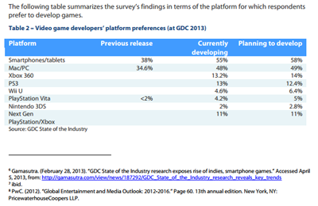

### Strategic Opportunities

* We will obtain market shares in the mobile sector with the efficacious use of funds for marketing and by producing quality games at attainable prices. Our games will either be free with in-app purchases or between the affordable range of $0.99- $19.99.
* Our competitive advantage is the ability to create quality software applications that would fulfill the many target markets and focus on educational games that make learning fun is a huge market with lots of opportunities.
* As a small company, our creative and artistic approach is not limited because we are not fixed to any particular client needs or demands. All of the titles that we will publish in the stores are our own creative concepts and we will strive to fulfill as many of those needs the market has available to us in the industry.
* We will use our competitive advantage to exploit opportunities in the marketplace by being diligent about networking. By continuously attending events such as career fairs and expos, we can meet more and different people and expand to as many different aspects of the market as possible.
* Our advantages as a small company is that we are not fixed to any clients demands our ideas and development is entirely our creativity and is flexible to adjust to any features we might find unique or fun or educational.

### Barriers to Market Entry and Exit

**© Copyright BizTree. 2006. All rights reserved. Protected by the copyright laws of the United States & Canada and by international treaties. IT IS ILLEGAL AND STRICTLY PROHIBITED TO DISTRIBUTE, PUBLISH, OFFER FOR SALE, LICENSE OR SUBLICENSE, GIVE OR DISCLOSE TO ANY OTHER PARTY, THIS PRODUCT IN HARD COPY OR DIGITAL FORM. ALL OFFENDERS WILL BE SUED IN A COURT OF LAW.**

**© Copyright BizTree. 2006. All rights reserved. Protected by the copyright laws of the United States and Canada and by international treaties. IT IS ILLEGAL AND STRICTLY PROHIBITED TO DISTRIBUTE, PUBLISH, OFFER FOR SALE, LICENSE OR SUBLICENSE, GIVE OR DISCLOSE TO ANY OTHER PARTY, THIS PRODUCT IN HARD COPY OR DIGITAL FORM. ALL OFFENDERS WILL AUTOMATICALLY BE SUED IN A COURT OF LAW.**

Barriers our business will have to overcome or have set in place for new entry to market include main ones such as of the cost of operating in Ontario, brand recognition, and the changing economy and technology, as well as other common barriers listed here:

* High production costs
* High marketing costs
* Consumer acceptance/brand recognition
* Changing economy
* Change in technology
* Patents and proprietary knowledge

Examples of entry and exit barriers:

|  |  |
| --- | --- |
| **Easy to Enter if there are:**   * Common technology * Little brand loyalty * Access to distribution channels * Low scale threshold | **Difficult to Enter if there are:**   * Patented or proprietary know-how * Difficulty in brand switching * Restricted distribution channels * High scale threshold |
|  | **Difficult to Exit if there are:**   * Specialized assets * High exit costs * Interrelated businesses |

# 4. Marketing Strategies and Sales

## 4.1 Introduction

Our target markets include the general audience, video game fans, and children ages 4 and up.

Some of our more educational mobile applications that promote learning are geared towards our youth.

To reach the masses and penetrate the markets Social Media is an integral part of the marketing mix.

Video trailers and game demos, video game expos, and developer blogs will also assist to promote our titles.

## 4.2 Market Segmentation Strategy

A Website is created and updated daily that acts as a home base for all of the games and game news. The home page features an extended overview, captivating screenshots and relevant links to demos of our games as well as product purchase information.

Social Media is vital to our marketing as much as our home base website. Facebook page, Twitter, and Tumbler, as well as LinkedIn and gaming social media sites.

Development Blogs are a good way of relaying any information or upcoming news to the video gamer crowds. They’re also a great way to humanize ourselves and connect with them on a personal level, writing down goals and struggles in the production of any game or application. For our followers, we promise to update as much as is possible and keep them connected to any news about any of our titles and or game demos to prove that the games are coming along.

* Geographic segmentation: International, marketing of our products is not limited to any geographic location but it is segmented to English speaking people of the world.
* Product-user segmentation: segmenting customers based on product usage (amount and/or consumption patterns of a product category or brand).
* Lifestyle segmentation: segmenting customers based on lifestyle (which includes: values, beliefs, perceptions, leisure activities, preference for social events, sports interest, media usage, political views, etc.)

## 4.3 Targeting Strategy

Main targeting strategies:

* Mass Marketing: go after the market as a whole with one offer that answers common needs
* Differentiated Marketing: go after several market segments with offers tailored to each

## 4.4 Positioning Strategy

To position our product vis-à-vis competitors our strategies include keeping up with market research and targeting the appropriate trend of the market at the time, keeping product prices low while maintaining the highest quality of our products as possible, and when needed, reposition our products with either a new image/artwork, upgraded components, or special editions.

### Corporate Message and Image

Everything we do at Raven Games is based on the success of the gaming experiences we provide our players. The goal of each discipline within the company – be it art, programming, or customer support – is to make our games as immersive as possible for as many people as we can reach. Raven Games strives to touch the heart of the players who will remember our games for all the marvel and level of excellence and hard work that was invested in to each game or application we create.

Quality is our top priority all throughout the development of each product. The highly adept team of Raven Games is determined and driven to contribute their greatest talents to making games that will be remembered by the masses for many years yet to come.

We make games that are based on innovation and creativity.

We work very hard on our games to reach broader audiences with our content and technology.

## 

## 4.5 Product/Service Strategy

What will differentiate our products in our target markets is our unique artistic style and creative concepts that live in each of our games or applications.

Most games are made using the same standardized principles of good design and code implementation. The distinction is made apparent in the small details such as story development, music and sounds, and original artwork.

Given our smaller company size at the current time we are able to focus on the mobile market which is given the timelines and resources feasible to our settings and is a good market to focus on to gain self- sustainability after our products have spent some time.

People will download our games because they are either free or really cheap to download.

Direct competition may occur if our games are comparable in concept to games that exist in the stores.

Nintendo will start to compete in the mobile game market.

## 4.6 Pricing Strategy

Games will be either 99 cent downloads or within a range from as low as $0.99 - $9.99 or in some variations may be free to download with in app-purchases.

Games that are free to download are an aggressive form of marketing and making money. People will download the app for free and play it until they love it and will eventually begin to purchase add-ons or items or power-ups to use in within the game, credits or extras. Nine of the most successful mobile games in the market have done this and made millions in the first year it was released.

## 

## 4.7 Distribution Channels

**© Copyright BizTree. 2006. All rights reserved. Protected by the copyright laws of the United States & Canada and by international treaties. IT IS ILLEGAL AND STRICTLY PROHIBITED TO DISTRIBUTE, PUBLISH, OFFER FOR SALE, LICENSE OR SUBLICENSE, GIVE OR DISCLOSE TO ANY OTHER PARTY, THIS PRODUCT IN HARD COPY OR DIGITAL FORM. ALL OFFENDERS WILL BE SUED IN A COURT OF LAW.**

**© Copyright BizTree. 2006. All rights reserved. Protected by the copyright laws of the United States and Canada and by international treaties. IT IS ILLEGAL AND STRICTLY PROHIBITED TO DISTRIBUTE, PUBLISH, OFFER FOR SALE, LICENSE OR SUBLICENSE, GIVE OR DISCLOSE TO ANY OTHER PARTY, THIS PRODUCT IN HARD COPY OR DIGITAL FORM. ALL OFFENDERS WILL AUTOMATICALLY BE SUED IN A COURT OF LAW.**

A distribution channel consists of the set of people and processes involved in the transfer of a product from producer to ultimate consumer. Describe your distribution strategy and explain why it is the best for your marketplace.

Register and become members of the Android and iOS stores.

IOS and Android Google stores are our main distributors.

Middlemen mainly include those involving licensing, often at a cost.

**4.8 Promotion and Advertising Strategy**

A campaign will be started long before release date on many or all titles to boost the enthusiasm for the games followers.

* A Website that acts as our home base where our games and apps are promoted and featured for sale or redistribution and will also host links to our social media pages.
* Social Media (Facebook and Twitter)
* Developer Blogs
* Steam and Greenlight
* YouTube Trailers and possibly links to demo versions (IndieGaming subreddit) is a great place to link trailers, previews, reviews, and game demos.
* Alpha Funding
* Gaming Booths: Reserve a portion of our marketing budget to attend

Employing the following promotional activities can generate awareness

* Digital media – blogs, social media
* Press
* Game Demos, redeem codes on cards distributed at Game Expos
* Specialties – packaging, T-shirts, stickers, mugs, etc.
* Networking
* Point of sale devices, promotions, and employee practices
* Public relations
* Late Stage Marketing
* Alpha-Funding
* Steam Greenlight

### Promotional Budget

We will be employing the following common promotional budget methods:

* Percentage of sales
* Budgeting by task or objectives
* In order to remain realistic during the first phase of development and advertising we will have fixed costs for game booths and most of our advertising will be done for free using social media.
* Only time will tell if we should consider spending less on some promotional activities and more on others.

## 

## 4.9 Sales Strategy

* Our games will be sold in the Google Android and IOS stores.
* Games are sold or made free to download online, in the case of the latter the games will have in-app purchasing for add-on or upgrade material.
* Internal motivation works best the idea is to make quality games and many of them.

## 

## 4.10 Sales Forecasts

**Please refer to the Sales Forecast in the** **appendix****.**

# 5. Development

We envision being able to take off and start producing great games and applications this generation will grow to cherish and there are even bigger dreams that one day we to shall create triple A titles for consoles and pc like our greatest competitors.

After we have released a few games and start to see profits we would like to rent an office space to provide a space for our team members to work as well as allow for expansion.

Along the way we hope to expand our services and offer a website department and technologies solutions department all the same that will handle relations with future clients who will help us with the expansion of our office and become a powerhouse of revenues to get us where we need to be.

After releasing our big online game we should hopefully be generating enough money to consider the next big game and we begin to peak as we get one step closer to making triple-A titles.

## 

## 5.1 Development Strategy

We are in the initial stages of development.

Upon funding requested we will incorporate company and acquire copyright protection of all intellectual property that is created by the company.

A first wave of product development which entails programming and creating all the artwork and sounds for the first few titles the company intends to release within a 6 month period.

During those first 6 months we hope to release 2 games and our Animal Tales application in the Windows 8 store, IOS and Android.

We have built a Unity C# framework and code base from our time at Auto-Obsessions as well as time spent while attending college and we have API’s and code libraries already built to handle generic functionality to serve as a template to make our games consistent in quality and reuse of this extensive code base also helps with development time allocated to each title. The code base that we possess is in itself a vital and priceless company asset. As opposed to starting from zero we have already built an extensive amount of code that is considered intellectual property of much value and are the prefabricated pieces to our products. Our games will always have certain aspects in common and that is usually the framework or skeleton of the project that will contain the same basic elements such as menus, game states, math and physics engines and API’s and UI , HUD are usually going to exist in every application. What makes each title unique is its concept and game flow. It is there where specialized functionality is different each time and new code is required.

## 5.2 Development Timeline

In the first month we will be legally incorporated before we begin to develop our games to protect our intellectual property and that includes all the scripts we write, visual and audio assets are all created by the company and will be protected under copyright laws. During this time we will establish a company logo, brand and social media marketing. Hiring key members and set employees start date right around the following month when everything is in place. While legal matters are just awaiting approval other administrative tasks are completed such as the polishing and fine tuning of video game design documents for each of our titles, technical design documents and employee contracts and internship contracts are written and saved for company use. The purchasing of Apple computers for development and this time will also be used to obtain any tools or licenses for our development.

The second month or even sooner if all is ready we can start to develop the first 3 titles that we deem to most likely to be a success and feasible within a pressed timeline such as Animal Tales an educational app for children and 2 small games.

Once these first 3 titles are available in stores we can begin to develop our larger online RPG game. At this point we will already be securing some kind of income from our first smaller games and this will generate enough funds to cover any additional smaller expenses like food and travel.

**Raven Games Development Timeline 2015**

|  |  |  |  |
| --- | --- | --- | --- |
| June | July | August | September October |
|  |  |  |  |
| Purple Pendulum  (Massive  Multiplayer  Online  Role-  Playing  Game) | Purple Pendulum  (MMORPG) | Purple Pendulum  (MMORPG) | Dark Realm Dark Realm |
|  |  |  |  |

|  |  |  |  |  |  |
| --- | --- | --- | --- | --- | --- |
| November | December | | January | | February March |
|  |  |  | |  | |
| Incorporation | Animal Tales | Animal  Tales | | Rabid Unicorn Squirrel Adventures 2 | |
| Purchase laptops | Squirrel Adventures | Squirrel A Adventures | |  | |
| Polish Base Website |  |  | |  | |
| Hire Personnel |  |  | |  | |
|  |  |  | |  | |
|  |  |  | |  | |

## 5.3 Development Expenses

Development costs would include the cost of any licensing fees required as well as membership fees that are required for developing for the iOS iTunes Store and Android’s Google Play Store. There are also domain hosting fees with Go-Daddy.

Development costs could increase if we generate enough to be able to market to other platforms in the future.

**6. Management**

**© Copyright BizTree. 2006. All rights reserved. Protected by the copyright laws of the United States & Canada and by international treaties. IT IS ILLEGAL AND STRICTLY PROHIBITED TO DISTRIBUTE, PUBLISH, OFFER FOR SALE, LICENSE OR SUBLICENSE, GIVE OR DISCLOSE TO ANY OTHER PARTY, THIS PRODUCT IN HARD COPY OR DIGITAL FORM. ALL OFFENDERS WILL BE SUED IN A COURT OF LAW.**

**© Copyright BizTree. 2006. All rights reserved. Protected by the copyright laws of the United States and Canada and by international treaties. IT IS ILLEGAL AND STRICTLY PROHIBITED TO DISTRIBUTE, PUBLISH, OFFER FOR SALE, LICENSE OR SUBLICENSE, GIVE OR DISCLOSE TO ANY OTHER PARTY, THIS PRODUCT IN HARD COPY OR DIGITAL FORM. ALL OFFENDERS WILL AUTOMATICALLY BE SUED IN A COURT OF LAW.**

## 

## 6.1 Company Organization

Our company structure is currently small but all the members that make up the team are vital players with great responsibilities and the perfect mix of talent to get the company on its own two feet.

Most of the team has already shares a history of working together on large projects and all of the members are graduates of Trios College in London, Ontario. Our company is composed of a few administrative members: President/CEO and Lead Programmer/Executive Assistant.

## 

## 6.2 Management Team

### Biographies of the Management Team

*President/CEO - Alexander Auriel Sanchez*

President and sole owner who is also the Lead Programmer, Art Director, and Head of Website Development Department. These capital duties will be fulfilled by myself. Along with my natural talent and ability for art, I have 3 years of Marketing, which I received in University, 1 year of Web Development, 2.5 years of Video game development plus 4 months of internship, and currently a year of work experience as manager of a video game company, Auto Obsessions. Lead Programmer, Creative Arts Director, and manager which are all my titles in my current position, make up a perfect nomenclature for the roles I wish to fill, seeing as I already have the experience of fulfilling each of these roles with efficiency and efficaciousness in my current position. At Auto Obsessions, I worked on many games including our main web based game Auto Obsessions available at this link. [www.auto-obsessions.me](http://www.auto-obsessions.me).

*Lead Programmer/Executive Assistant - Tyler Drury*

Next in the company hierarchy is a Lead Programmer Tyler Drury who has an extensive background in all programming languages and has also been lead programmer in the past during his time at Sky Orchard Studios in London, Ontario. Later he was hired by Auto Obsessions as support lead programmer under the management of Alexander Sanchez. Together they build and currently maintain the Auto Obsessions Video Game which is a game like Fantasy Football for Automobile Auction fans. His role at Raven Games is to oversee quality and all Video Game Interns as well as lead and partake in collaborating in all major projects video game or apps.

|  |  |  |
| --- | --- | --- |
| **Officers and Key Employees** | **Age** | **% of Ownership** |
| President | 33 | 100% |
| Vice President of Sales & Marketing | 33 | 100% |
| Vice President of Finance | xx | 0% |
| Vice President of Operations | 33 | 100% |
| Vice President of R & D | 33 | 100% |
| Controller | xx | 0% |
| Corporate Attorney | xx | 0% |

## 6.3 Management Structure and Style

Management style is a little more relaxed than most as initially our employees will be working from home with online communication and there will be mandatory meetings only bi-weekly, possibly weekly, in a scrum fashion. Less stress is put on our employees and interns but that would not affect production or growth as all are very enthusiastic and 100% dedicated. Management will also host events or contests to reward employees as well as keep company morale high and employees and interns always wanting to do more and be the best.

## 6.4 Ownership

### Organizational Chart

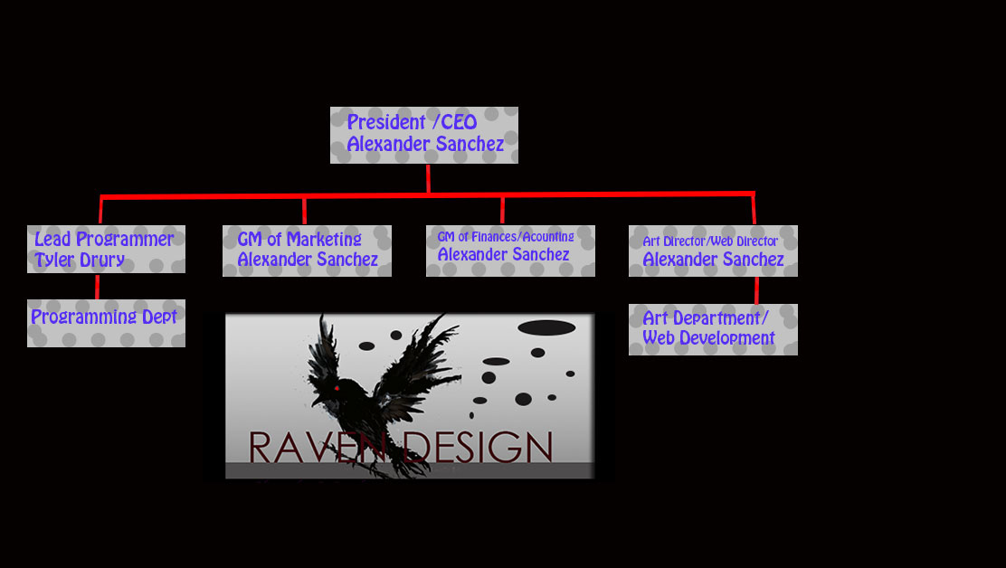

The company has one sole owner and no shares are offered to any of its members. The sole owner and founder of the company is Alexander Sanchez.

|  |  |  |
| --- | --- | --- |
| **Name** | **# Shares Held** | **% Ownership** |
| [Founder] Alexander Sanchez | 100 | 100% |
| [Inventor] Alexander Sanchez | 100 | 100% |
| [Management Team] | 0 | 0% |
| [Seed Ventures] | 0 | 0% |
| [Stock Option Pool] | 0 | 0% |

### 

### 6.5 Professional and Advisory Support

Service providers our business may consult or obtain additional services from, who are not a part of our internal staff, may include:

* Corporate attorney
* Accounting firm
* GoDaddy Webhosting service providers

# 7. Operations

## 7.1 Operations Strategy

* We will use our operations to add value for customers in the target market by constantly improving our products as well as repositioning our products. We hope to always ensure the educational value of our products though.
* We plan to win in the marketplace with low costs, high-quality products in a timely manner, and flexibility with custom services offered to our customers regarding websites or games.
* We will be stressing constant market research to keep up with latest market trends, both locally and provincially, our main focus will always be mobile development, but website development, although less significant, will be a focus as well.

## 7.2 Scope of Operations

* All of our production takes place in-house and all we need for that is the software to create the programs and the people who make will make them. The finished product is the software that is purchased by our users who download a game or application.
* The relationship with vendors is our membership to develop and sell for their platform or user base for example we intend to become developer members of the Android and iOS stores so we can develop and sell our games in their stores.

* We will need to hire people who are qualified in video game or software development as well as technical artists for the development stages of our products.

## 7.3 Ongoing Operations

Our products have a high quality focus being the nature of quality software development. There is a very significant financial focus of allocated funds to employee wages and software technologies. This includes the wages of our three main programmers on which we heavily rely to produce our games during the developmental phases of production. The first few months of operations will be establishing the company. Once the company is established and legally registered and incorporated we can begin with the developmental phases in which our games will be made.

Our products are made by the programmers. With their ability to write code or program their software and the contracts we make with our artists.

## 7.4 Location

Our location is our website and home of business. We are a digital company that hires executives that work mostly from their homes and use file sharing systems to merge their files onto shared projects.

We rent office spaces to meet once a week.

In the near future we hope to rent a small office to home-base our websites department.

Our location could be a small dispatch office that only requires an administrator who can speak to clients and handle all customer relations not required by myself.

**© Copyright BizTree. 2006. All rights reserved. Protected by the copyright laws of the United States & Canada and by international treaties. IT IS ILLEGAL AND STRICTLY PROHIBITED TO DISTRIBUTE, PUBLISH, OFFER FOR SALE, LICENSE OR SUBLICENSE, GIVE OR DISCLOSE TO ANY OTHER PARTY, THIS PRODUCT IN HARD COPY OR DIGITAL FORM. ALL OFFENDERS WILL BE SUED IN A COURT OF LAW.**

**© Copyright BizTree. 2006. All rights reserved. Protected by the copyright laws of the United States and Canada and by international treaties. IT IS ILLEGAL AND STRICTLY PROHIBITED TO DISTRIBUTE, PUBLISH, OFFER FOR SALE, LICENSE OR SUBLICENSE, GIVE OR DISCLOSE TO ANY OTHER PARTY, THIS PRODUCT IN HARD COPY OR DIGITAL FORM. ALL OFFENDERS WILL AUTOMATICALLY BE SUED IN A COURT OF LAW.**

During our first year of operations the administrative members of Raven Games will work from the home and use file sharing systems to communicate and contribute to projects. An office space may be attained for once a week meetings if funding allows. We are a small team primarily with only 3 main developers. The rest of our company will consist of the internship program we will host for Video Game Design and Development pre-grads as well as Technical Artists and Web designers that are allowed to work from their homes or classrooms all enabled and monitored using our file sharing systems like GitHub which can record the amount of work that is contributed by each its projects members.

Our business hours are during the weekdays from 9am -5pm and interns are only required to work within that time block for 5 hours a day.

## 7.5 Personnel

**© Copyright BizTree. 2006. All rights reserved. Protected by the copyright laws of the United States & Canada and by international treaties. IT IS ILLEGAL AND STRICTLY PROHIBITED TO DISTRIBUTE, PUBLISH, OFFER FOR SALE, LICENSE OR SUBLICENSE, GIVE OR DISCLOSE TO ANY OTHER PARTY, THIS PRODUCT IN HARD COPY OR DIGITAL FORM. ALL OFFENDERS WILL BE SUED IN A COURT OF LAW.**

**© Copyright BizTree. 2006. All rights reserved. Protected by the copyright laws of the United States and Canada and by international treaties. IT IS ILLEGAL AND STRICTLY PROHIBITED TO DISTRIBUTE, PUBLISH, OFFER FOR SALE, LICENSE OR SUBLICENSE, GIVE OR DISCLOSE TO ANY OTHER PARTY, THIS PRODUCT IN HARD COPY OR DIGITAL FORM. ALL OFFENDERS WILL AUTOMATICALLY BE SUED IN A COURT OF LAW.**

* Number of employees:
  + Three employees 2 are full-time and 1 is part-time.
  + In the future, if success strikes big, we will employ as many as the company sees fit and can afford.
* Type of labour (skilled, professional):
  + Must have graduated the Video Game Design and Development course
  + Expert in software development
  + At least 3 years programming experience in all the major languages C, C++, Java, HTML5, Javascript, PHP and so forth.
  + Good Programming Design Practices and implementation. MVC etc.
  + Problem solving , analytical thinking and processing and leadership skills
  + Lead and maintain a project
* Quality of existing staff:
  + Alexander Sanchez is an amazing programmer with all the above required met with an even more amazing natural ability for art.
  + Tyler Drury is an incredibly gifted programmer who has also played the role of lead programmer during his time at Sky-Orchard in London, Ontario.
  + Creative Department is managed by Alexander Sanchez this includes all game concepts, decisions, artwork, music, stories, game design documents, and even more importantly Alexander Sanchez will also be programming in all games.
  + Tyler Drury will be in charge of leading on projects in the programming aspect of all the games and applications.
  + Employees will work between the hours of 9am-4pm Monday through Fridays.
* Pay structure:
  + Will pay hourly wages for 35 hours of full time and 20hrs of part-time employment.
  + Certain employee. Find out what they are.
  + Employee compensation will result in regular full or part time hours and in some cases bonuses upon success of any games that were produced during development time.
  + If we can afford eventually, 20% of funding to cover employee vacations and possible benefits.
* Procedures for acquiring new employees
  + The people who I need to hire to start the business are available to work. In the future we would also like to hire interns at the end of their internship term.
* Training methods and requirements
  + There may be training for interns and or employees whenever there is a new project that requires the use of new programming languages or special tools are required to fulfill their duties.
  + Training on file sharing systems and all software whether it be for production or communication purposes.
  + ***Mandatory Benefits*** - Educate and train employees on policies and procedures,” it is expected that all employees will receive human rights training so that they can know and understand their obligations in the workplace. It is very important that this be done for employees providing services to the public and senior staff responsible for hiring, managing performance, accommodations, discipline, and handling human rights concerns. Failing to train these key staff may lead to human rights claims.

## 7.6 Production

* Production techniques and costs include In-house game development using Unity 5 High powered game engine (free).
* X-Code for IOS applications is written on Mac pro devices.
* Quality control is handled by constantly testing software for bugs and feature development during development time and builds or executables are also created in-house to be tested before a product is ready for publishing.

## 7.7 Operations Expenses

Overhead expenses include the following:

* Rent of a conference room in a downtown location or an office space at triOS College
* Advertising and Promotion
* Utilities (Internet and electricity)

Advertisement for office space for rent:

|  |  |
| --- | --- |
| Date Listed: | 11-Apr-15 |
| Price | **$425.00** |
| Address | 341 Talbot St, N6A 2R5, London |
|  | |

|  |
| --- |
| *Professionally furnished office spaces in Downtown London includes: Private furnished Office Space  Reception services  Boardrooms - 2 to choose from, includes 10 hours monthly  All heat, hydro, water, cleaning and maintenance  Access to building 24/7 Close to Covent Garden Market and the Budweiser Gardens  On site Building Manager  Starting at $425.00 per month  Many great business on site to network with including Lawyers, Paralegals, Software technicians, Psychologists and more.  Give Laurie a call to book a tour today, 519-685-2377* |

### Administrative and Financial Controls

* Bookkeeping systems and policies (payments, billing) will be handled by QuickBooks software for US $4.99/month.
* Sales systems will be monitored with App-Figures.

## 

## 7.8 Legal Environment

The following elements apply to our business:

* Licensing and permits
* Trademarks, copyrights, or patents [pending]
* Incorporation Fee is anywhere from $1200-$1500.

## Inventory

In order to keep track of how many sales or downloads of our products occurring in the IOS and Android stores developers and publishers nowadays resort to an application tracking platform named App-Figures. It records sales, download numbers, world-wide reviews and ranks and all sorts of miscellaneous data in clear easy to understand reports.

<https://appfigures.com>.

An alternative is Google Analytics, which basically does the same thing as App-Figures.

## 7.10 Suppliers

**Go-Daddy and Unity3D**

Our suppliers are few and consist of the support team at Go-Daddy who will host our home site and the software of our choosing Unity 3D who are both solid service providers who have a long life of commercial existence and are well established in the developer community.

# 8. Financials

## 8.1 Start-up Funds

**© Copyright BizTree. 2006. All rights reserved. Protected by the copyright laws of the United States and Canada and by international treaties. IT IS ILLEGAL AND STRICTLY PROHIBITED TO DISTRIBUTE, PUBLISH, OFFER FOR SALE, LICENSE OR SUBLICENSE, GIVE OR DISCLOSE TO ANY OTHER PARTY, THIS PRODUCT IN HARD COPY OR DIGITAL FORM. ALL OFFENDERS WILL AUTOMATICALLY BE SUED IN A COURT OF LAW.**

**© Copyright BizTree. 2006. All rights reserved. Protected by the copyright laws of the United States & Canada and by international treaties. IT IS ILLEGAL AND STRICTLY PROHIBITED TO DISTRIBUTE, PUBLISH, OFFER FOR SALE, LICENSE OR SUBLICENSE, GIVE OR DISCLOSE TO ANY OTHER PARTY, THIS PRODUCT IN HARD COPY OR DIGITAL FORM. ALL OFFENDERS WILL BE SUED IN A COURT OF LAW.**

Described in following sections are the start-up funds required to cover the costs to operate the company for the terms of a year and as well for the terms of 6 months of production. The operating costs to run the company are divided in to legal, labour, software, and as well as accounting and marketing or developer costs.

Considering both of our current situations where we work in the industry these wages described in the following sections would be of great help to both of the major parties that are currently working for Auto Obsessions. Tyler Drury and I are currently both employed by Auto Obsessions. We are working on a high level project which involves high level front-end and back-end security code handled mostly in PHP and mySql databases to host the experience our users share when they play our online game.

## 8.2 Current Financial Position (current, takeover or franchise businesses only)

The company’s current financial position is that we are a brand new company with no assets or debt. As a minor and only contribution possible at this time is a home base website which I have designed to serve as a marketing means to make our products and news accessible to our public.

## 8.3 Operating Forecast

Please refer to Appendix for Financial Projections.

## 8.4 Break-Even Analysis

This section is a calculation for the break-even point in dollars and units for the business.

|  |  |
| --- | --- |
|  |  |
| Break-even Sales $ = | Fixed Costs |
| 1- Variable Costs |
|  |  |
| Break-even Sales $ = | 81327.98 |
| 1- 6000 |
|  |  |
| Break-even Sales $ = | 81327.98 |
|  | -5999 |
|  | -13.56 |

Fixed costs are expressed in dollars but variable costs are expressed as a percent of the total sales dollar amount.

## 8.5 Balance Sheet

**© Copyright BizTree. 2006. All rights reserved. Protected by the copyright laws of the United States and Canada and by international treaties. IT IS ILLEGAL AND STRICTLY PROHIBITED TO DISTRIBUTE, PUBLISH, OFFER FOR SALE, LICENSE OR SUBLICENSE, GIVE OR DISCLOSE TO ANY OTHER PARTY, THIS PRODUCT IN HARD COPY OR DIGITAL FORM. ALL OFFENDERS WILL AUTOMATICALLY BE SUED IN A COURT OF LAW.**

**© Copyright BizTree. 2006. All rights reserved. Protected by the copyright laws of the United States & Canada and by international treaties. IT IS ILLEGAL AND STRICTLY PROHIBITED TO DISTRIBUTE, PUBLISH, OFFER FOR SALE, LICENSE OR SUBLICENSE, GIVE OR DISCLOSE TO ANY OTHER PARTY, THIS PRODUCT IN HARD COPY OR DIGITAL FORM. ALL OFFENDERS WILL BE SUED IN A COURT OF LAW.**

The balance sheet is a "snapshot" of what you own and what you owe on a specific date. A "Pro Forma Balance Sheet" shows how things will be in the future, under given conditions, rather than how they are now.

A balance sheet follows a standard format (please refer to the appendix for Balance Sheet template), however, it may contain additional items depending on circumstances relating to the business for which it is prepared. State the assumptions you used for all major changes between your last historical balance sheet and the projection.

|  |  |  |  |  |  |
| --- | --- | --- | --- | --- | --- |
| As of [Date] | Year 1 | Year 2 | Year 3 | Year 4 | Year 5 |
| **Assets** | 100,000 | 269,716.5 | 384,895 | 425,105 | 661,752 |
| **Liabilities** | 0 | 0 | 0 | 0 | 0 |
| **Equity** | 100,000 |  |  |  |  |

## 8.6 Income Statement

The income statement is a financial statement that reveals whether or not a business has earned a profit or has suffered a loss after a specified period. (Please refer to the appendix for Income Statement template.)

A "Pro Forma Income Statement" is used to show how things will be under given conditions rather than how they are at present.

* EBIT = [Revenue](http://en.wikipedia.org/wiki/Revenue) – [Operating expenses](http://en.wikipedia.org/wiki/Operating_expense) (OPEX) + [Non-operating income](http://en.wikipedia.org/wiki/Non-operating_income)

Costs Revenue - labor

Be sure to state any assumptions when creating your Income Statement.

|  |  |  |  |  |  |
| --- | --- | --- | --- | --- | --- |
|  | **Year 1** | Year 2 | Year 3 | Year 4 | Year 5 |
| **Revenue** | $112,256 | $269,716.5 | $384,895 | $425,105 | $661,752 |
| **Cost of Goods Sold** | $81327.98 | $139,488 | $165407 | $285,407 | $285,407 |
| **Gross Profit** | $212,256 | $269,716.5 | $384,895 | $525,105 | $661,752 |
| Operating Costs | $81327.98 | $162,655.23 | $200,000 | $300,000 | $350,000 |
| Finance & Admin | $5000 | $5000 | $10,000 | $15,000 | $15,000 |
| Sales & Marketing | $20,000 | $30,000 | $60,000 | $100,000 | $120,000 |
| **Total Expenses** | $106,327.98 | $197,655.96 | $270,000 | $415,000 | $485,000 |
| **Net Income Before Tax** | $30,928.02 | $107,061.27 | $184,895 | $125,105 | $376,345 |
| **Less: Income Tax 30%** | $9278.406 | $32,118.381 | $55,468.5 | $37,531.5 | $112,903.5 |
| **DM Tax Credit 30% Applied** | $6494.88 | $22,482.5 | $38,827.95 | $26,272.5 | $79,032.45 |
| **Net Income** | $24,433.14 | $84,578.77 | $146,067.5 | $98,832.5 | $297,312.55 |

## 8.7 Cash Flow

Explain your major assumptions, especially those which make the cash flow differ from the Profit and Loss Statement, such as:

* Labour during the development phases of production
* Software
* Advertising expenses for venues like Game Expos

# Legal

Corporation costs $1200 -$1500

To handle any liability issues and the protection of intellectual property.

Total Legal = $1500

**Labour A**

A.S. Labour $18/hr x 40 hours = weekly = $720

X 4 weeks = $2880

T.D. Labour $15/hr x 35 hours = weekly = $525

X 4 weeks = $2100

3 Labour $14 x 24 = weekly = $336

X 4 weeks = $1344

X12 = $16,128

Total Labour Monthly = $6324

Total Labour 6 months = $37944

Total Labour 1 year = $75888

# Labour B

A.S. Labour $20/hr x 40 hours = weekly = $800

X 4 weeks = $3200

X12months = $38,400

T.D. Labour $18/hr x 35 hours = weekly = $720

X 4 weeks = $2880

X 12months = $34,560

3 Labour $14 x 24 = weekly = $336

X 4 weeks = $1344

X12 = $16,128

Total Labour Monthly = $3200 + $2880 + $1344 = $7424

Annual L+S+T = $7424 x 12 = $89,088 + $840 = 89,928 + $3099.98 = $93,928 + Legal = $95,428

Funding – 95,428 = $4572 for marketing budget

Total Annual Labour = $38,400 + $34,560 + $16,128 = $89,088

Annual Software = $840

Total Labour 6 months = $37944

**Tools**

Mac Book Pro $1549.99 X 2 = $3099.98

Alienware laptops= $3099.98 (owned

http://iosdevelopmenttutorials.com/hardware-needed-to-develop-ios-apps

**Software**

List of Assets already owned that are used for production of games:

* Adobe CS6 Creative Suite and Creative Cloud Suite valued at $800.
* Microsoft Expression Design
* Unity5 free until person or company grosses over 1 Million then its 1500 a year
* HTML5, JavaScript, PHP, MySQL and Notepad ++ are free with programs like XAMPP and Notepad ++

List of Software that is not company assets:

* Quick-Book Pro + Payroll = US $50/month
* Payroll Tax Software = $600 a year
* Go-Daddy Web Hosting 20/month
* X12months = $240
* X6months = $120

Total Software 12 months = $840

Total Software 6 months $420

**Development Fees**

IOS Membership = $99/year

Google Play Developer fees = $25

**Totals**

Total Labour + Total Software 12 months = $840 + $75888 = $76,728

Total Labour + Total Software 6 months = $420 + $37944 = $38,364

Total Labour + Total Software + Legal = 12 months = $1500 + $76,728 = $78,228 + Tools = 81327.98

Total Labour + Total Software + Legal = 6 months = $1550 + $38,364 = $39,864 + Tools = $41,463

So with that being said we have a remainder of $18,672 for Marketing and any additional sub contract work or rent. To hire another part time employee working 24 hours a week for a year would be $16,128.

**Marketing Budget**

Labour plan A allows for more marketing to occur and cover our rent.

Having $18,672 for Marketing we could cover Labour Plan B.

After a 6 month period I could adopt using Labour B as an increase in wages for the employees since during this time we expect the company will be making some revenue and we will be at a better position financially to relieve costs to operations. As well as being able to cover unforeseen and unavoidable costs that usually always occur.

***Selected Labour***

# Labour

A.S. Labour $18/hr x 40 hours = weekly = $720

X 4 weeks = $2880

X12 months = $34,560

T.D. Labour $15/hr x 35 hours = weekly = $525

X 4 weeks = $2100

X12 months = $25,200

3 Labour $14 x 24 = weekly = $336

X 4 weeks = $1344

X12 months = $ 16,128

Total Labour Monthly = $6324

Total Labour 1 Year = A.S. + T.D. + 3L

Total Labour: $34,560 + $25,200 + $16,128 = $75,888

Total Labour 1 year = $75888

Total Labour 6 months = $37944

**Rent**

$425 /month

$5100/year

Rent is an optional and we might be able to work out something more accommodating and lower priced through our college. We would only need a room to meet once a week to discuss our development progress as a team.

**Totals**

Total Labour + Total Software 12 months = $840 + $75888 = $76,728

Total Labour + Total Software 6 months = $420 + $37944 = $38,364

Total Labour + Total Software + Legal = 12 months = $1500 + $76,728 = $78,228 + Tools = 81327.98

Total Labour + Total Software + Legal = 6 months = $1550 + $38,364 = $39,864 + Tools = $41,463

So with that being said we have a remainder of $18,672 for Marketing and any additional sub contract work. To hire another part time employee working 24 hours a week for a year would be $16,128.

**RESULTS**

Annual L+S+T = $7424 x 12 = $89,088 + $840 = 89,928 + $3099.98 = $93,928 + Legal = $95,428

Funding – 95,428 = $4572 for marketing budget

Total Annual Labour = $38,400 + $34,560 + $16,128 = $89,088 + 2 employees at 15/hr 35 hrs a week

At this point in the second year we would employ 5 paid employees including myself and allowed bonuses and raises for pioneer members.

89,088 + 50,400 = New labor $139,488

YR 3 New labor $139,488 + 80,000 = 165,407 new marketing manager and 2 programmers

YR 4 New labor $165,407+ 120,000 = 165,407

YR 5

Tax Credits

Net icome =

YR 1

Taxes are applied to net income

YR 1

Net Income - 30 % Taxes Assumption

30,928.02 x 0.3 = 9278.406

9278.406 * 0.3 = 2783.5218

9278.406 - 2783.5218 = 6494.88

YR2

$107,061.27 x 0.3 = 32,118.381

32,118.381 x 0.3 = 9635.5

32,118.381 - 9635.5 = 22,482.5

YR3

184,895 x 0.3 = 55,468.5

55,468.5 x 0.3 = 16640.55

55,468.5 - 16640.55 = $38,827.95

YR4

$125,105 x 0.3 = $37531.5

37531.5 x 0.3 = 11,259

37531.5 - 11,259 = $26,272.5

YR 5

$376,345 x 0.3 = $112,903.5

$112,903.5 x 0.3 = $33,871.05

112,903.5 - 33,871.05 = $79,032.45

Net Income = Net Income before tax - Taxes

YR 1

30,928.02 - 6494.88 = $24,433.14

YR 2

107,061.27 - 22,482.5 = 84,578.77

YR 3

184,895 - 38,827.95 = 146,067.5

YR 4

$125,105 - 26,272.5 = 98,832.5

YR 5

$376,345 - 79,032.45 = 297,312.55

# 9. Funding Requests

## 9.1 Capital Requirements

Raven Games is requesting $100,000 to cover our production costs for the first year of operation. These funds will be used mainly to cover the wages of its elemental employees that are absolutely necessary for the production and supervision during the development stages of our products. Funding would also cover the costs of the tools which are 2 Apple/Mac computers and software that required for the development of the games and applications.

## 9.2 Risk/Opportunity

The Christmas selling season accounts for about a quarter of the industry's yearly sales of video and computer games leading to a concentrated influx of high-quality competition every year in every game category, all in the fourth quarter of the year.

Product slippage is common due to the uncertain schedules of software development. Most publishers have suffered a “false launch”, in which the development staff assures the company that the game development will be completed by a certain date, and a marketing launch is planned around that date, including advertising commitments, and then after all the advertising is paid for, the development staff announces that the game will “slip”, and will actually be ready several months later than originally intended. When the game finally appears, the effects among consumers of the marketing launch – excitement and “buzz” over the release of the game and intent to purchase have dissipated, and lackluster interest leads to weak sales.

An example of this is the PSP version of *Spider-Man 3*. These problems are compounded if the game is supposed to ship for the Christmas selling season, but actually slips into the subsequent year. Some developers (notably id and Epic) have alleviated this problem by simply saying that a given game will be released "when it's done", only announcing a definite date once the game is released to manufacturing. However, this sometimes can be problematic as well, as seen with *Duke Nukem Forever*.

(Source Wikipedia)

Some of the risks our company might be faced with is the possibility that one or more of our games does not reach popularity and success.

We try and safeguard against this by the rapid production of mini games and applications that might consist of a simple but creative idea made with a polished and fully functional feel so that we have more opportunities that one of our games become popular.

Some of these smaller applications that are not as involved would mean a lot less time for development and higher art focus could be geared towards children in small but fun educational apps that teach children who to read write, spell, and even practice their math.

As humans, we have many different learning capabilities as a result of different teaching methods used. Some of us are more auditory or visual learners while others require only the written text. Whatever the case may be, our apps hope to provide a focus to each of these areas to make the learning process for children more immersive and effective.

These applications will be easier to produce using game engines henceforth shorter on development time and can be assigned to interns who assist us in our many different projects to cover more ground.

There is definitely a market and a need for educational children’s applications that are both functional and entertaining now that more and more children come in to the possession of mobile and cellular devices.

We hope to promote good values in all of our products and we can make learning fun or entertaining thanks to technology.

We also understand that many just want to kill time while they commute and just need to play. For this market we aim to please and make the most adventure packed games using the cutting edge graphics that our public mandates.

We also intend to tackle the social media game market on popular websites like Facebook where we can establish a developer relationship and produce games that people will want to play.

Worst case scenario would be that our company is not selling as many of our games as we would like after the developmental stages but the company also has its Website development department that will offer small businesses websites at competitive rates.

## 9.3 Exit Strategy

An exit strategy I would consider if need be would be to sell the company or company shares. In the case that I may want to exit the company, the sale or merger of the company is one sure way to go as we live in the Hub for video game development, and there are so many website companies here before us. As an alternative, there is also the possibility of a management buyout if the lead programmer or lead artist just underneath in the company structure would want to purchase the company shares.

# 10. Refining the Plan

## 10.1 Refine According to Type of Business

### Technology Company / Web-based Business

As company assets, we own an Alienware computer and software to build on just about every platform. We are seeking funding to cover some software costs to cover tax payroll and the purchase of 2 Mac computers to run XCode and develop games for iOS stores. The machines that would be purchased would consider a mid-priced model that should be fine to use for at least 2 -3 years of developing in the stores with rapid hardware and technological advances.

We intend to bring our products to market mainly through online delivery systems via the internet, i.e. the customer pays online and can then download it. We will always be keeping the company competitive by constantly pumping out games and apps our customers want to see. We protect our intellectual property by licensing it for use and clearly stating in every product that it is not for re-use. We will avoid technical obsolescence by keeping up with the changing technology and platforms and using the best available technologies, and being sure not to use certain technology over 4 years old. With the hard work and dedication, as well as the good relationship I know my employees and interns have, there should be no problem retaining personnel for many years.

See appendix for all financial forecasts.

# 11. Appendix

**Bibliography/Sources**

*2014 Essential Facts About The Canadian Video Game Industry;* Entertainment Software Association of Canada; [www.theESA.ca](http://www.theESA.ca)

*Industry Profile Interactive Digital Media;* November 20, 2012; Ontario Media Development Corporation; [www.omdc.on.ca](http://www.omdc.on.ca)

*Canadian Video Game Companies;* March 16, 2015; Alex Weber, CanDevs; <http://www.candevs.ca>

*Video Gaming Industry (MBA/CMA National Case Competition 2014);* <http://libguides.smu.ca/videogaming>

*2012 Canadian Interactive Industry Profile Final Research Report;* October 2013; for the Canadian Interactive Alliance by Nordicity; <http://www.cmf-fmc.ca/uploads/reports/35-ciip.pdf>

*Video gaming in Canada;* December 2013;Wikipedia, the free encyclopedia; <http://en.wikipedia.org/wiki/Video_gaming_in_Canada>

*Canada’s Video Game Industry in 2013 Final Report;* July 2013; for the Entertainment Software Association of Canada by Nordicity; <http://theesa.ca/wp-content/uploads/2013/10/ESAC-Video-Games-Profile-2013-FINAL-2013-10-21-CIRC.pdf>

*2013 Essential Facts About The Canadian Video Game Industry;* 2013; ESA Entertainment Software Association; <http://theesa.ca/wp-content/uploads/2013/10/Essential-Facts-English.pdf>

*Industry Profiles Interactive Digital Media;* April 30, 2014; Ontario Media Development Corporation; <http://www.omdc.on.ca/collaboration/research_and_industry_information/industry_profiles/IDM_Industry_Profile.htm>

*Ontario 2012: Stimulating Growth in Ontario’s Digital Game Industry;* August 2008; Secor Consulting; <http://www.omdc.on.ca/Assets/Research/Research+Reports/Ontario+2012+Stimulating+Growth+in+Ontario$!27s+Digital+Game+Industry/Stimulating+Growth+in+Ontario$!27s+Digital+Game+Industry+August+2008+English.pdf.pdf>

*Ontario Still Seeing Growth in Canada's Video Game Industry;* March 25, 2013; Business Review Canada; <http://www.businessreviewcanada.ca/finance/614/Ontario-Still-Seeing-Growth-in-Canada039s-Video-Game-Industry>

*Economic/Business Factors in Video Games;* April 20, 2013; by Video Games are Awesome; <https://videogamesramapo.wordpress.com/economicbusiness-factors-in-video-games>

*Legal Factors in Video Games;* April 20, 2013; by Video Games are Awesome; <https://videogamesramapo.wordpress.com/legal-factors-in-video-games>

*Information and Communications Technologies (ICT) Complete profile - Big Blue Bubble;* March 4, 2015; Industry Canada; <http://www.ic.gc.ca/app/ccc/srch/nvgt.do?lang=eng&prtl=1&estblmntNo=234567089712&profile=cmpltPrfl&profileId=2059&app=sold>

*London video game developer Digital Extremes bought by chicken company;* October 15, 2014; Angela Mullins, Metro News; <http://metronews.ca/news/canada/1183860/london-video-game-developer-digital-extremes-bought-by-chicken-company/>

**Research & Development**

**Survey**

The following is a quick survey to help with the selection of the games we want to produce.

Age:

Gender:

Do you play video games? Yes/No  
How many hours a week? (Below 5) (5-10) (10-15) (20+)

Do you own a mobile device:

If so, what kind is it:

* iOS/Apple
* Android/Google
* Windows
* Other

Platform most frequently played:

* Mobile (phones & tablets)
* PC/Mac
* Console
* Web
* Social Network
* Kiosk & Standalone
* Other

Favorite game genre:

* Action/adventure
* Casual
* Strategy/role-playing
* Family-oriented
* Puzzle
* Arcade
* Shooter
* Serious (e.g. edutainment)
* Card
* Kid-oriented role-playing
* Simulated gambling or casino
* Racing/flight
* Sports
* MMO role-playing
* Art-based
* Music-based
* Fighting
* Other

What is your favorite video game of all time:

Most important aspect of a game to you:

* Gameplay/Functionality
* Story
* Art/Graphics
* Music
* Customization/Upgrading

Do you make in-app purchases:

Do you play mini-games or skip past them:

If given the choice, would your character be:

Good, Evil, or Both:

Human or animal:

Male or Female:

Do you prefer to play fast-paced or long-lasting games?  
  
What is the last video game you played?  
  
Do you buy brand new games or second hand?

Will you go out of your way to buy a game on release (i.e going to midnight releases etc)?  
  
Do you do any other types of gaming such as board games/Pen and paper type games etc?  
If so what do you play?  
  
Do you subscribe to any gaming magazines?   
If so which ones?  
  
Do you use any internet websites to read up about games?  
Do you visit any gaming forums?  
  
How much money on average, do you spend on video games in a month?   
  
What current gaming console/platforms do you own? Xbox360/PS3/Nintendo Wii/PC/Nintendo DS/Nintendo 3DS/Sony PSP  
  
Do you have online for any of your chosen consoles? (Xbox Live/PSN etc.)  
Do you use online for multiplayer or just the social aspect?  
Do you prefer competitive multiplayer or co-op?  
  
Do you enjoy achievements?  
Do you go out of your way to get achievements in video games?  
  
Do you prefer challenging games or more relaxed easier games?  
  
Will you go out of your way to read up special tricks and tactics to become better a certain games?  
  
Do you prefer big open worlds (non-linear games) or always having a set path to stick to (linear games)?

**Monthly Balance**

**Expected Case**

**© Copyright BizTree. 2006. All rights reserved. Protected by the copyright laws of the United States & Canada and by international treaties. IT IS ILLEGAL AND STRICTLY PROHIBITED TO DISTRIBUTE, PUBLISH, OFFER FOR SALE, LICENSE OR SUBLICENSE, GIVE OR DISCLOSE TO ANY OTHER PARTY, THIS PRODUCT IN HARD COPY OR DIGITAL FORM. ALL OFFENDERS WILL BE SUED IN A COURT OF LAW.**

**© Copyright BizTree. 2006. All rights reserved. Protected by the copyright laws of the United States and Canada and by international treaties. IT IS ILLEGAL AND STRICTLY PROHIBITED TO DISTRIBUTE, PUBLISH, OFFER FOR SALE, LICENSE OR SUBLICENSE, GIVE OR DISCLOSE TO ANY OTHER PARTY, THIS PRODUCT IN HARD COPY OR DIGITAL FORM. ALL OFFENDERS WILL AUTOMATICALLY BE SUED IN A COURT OF LAW.**



A.S. Labour $18/hr x 40 hours = weekly = $720

X 4 weeks = $2880

X12 months = $34,560

T.D. Labour $15/hr x 35 hours = weekly = $525

X 4 weeks = $2100

X12 months = $25,200

3 Labour $14 x 24 = weekly = $336

X 4 weeks = $1344

X12 months = $ 16,128

Total Labour Monthly = $6324

Total Labour 1 Year = AS + TD + 3L

Total Labour: $34,560 + $25,200 + $16,128 = $75,888

Total Labour 1 year = $75888

Total Labour 6 months = $37944

**Software**

List of Assets already owned that are used for production of games:

* Adobe CS6 Creative Suite and Creative Cloud Suite valued at $800.
* Microsoft Expression Design
* Unity5 free until person or company grosses over 1 Million then its 1500 a year
* HTML5, JavaScript, PHP, MySQL and Notepad ++ are free with programs like XAMPP and Notepad ++

List of Software that is not company assets:

* Quick-Book Pro + Payroll = US $50/month
* Payroll Tax Software = $600 a year
* Go-Daddy Web Hosting 20/month
* X12months = $240
* X6months = $120

Total Software 12 months = $840

Total Software 6 months $420

**Rent**

$425 /month

$5100/year

Rent is an optional and we might be able to work out something more accommodating and lower priced through our college. We would only need a room to meet once a week to discuss our development progress as a team.

**Totals**

Total Labour + Total Software 12 months = $840 + $75888 = $76,728

Total Labour + Total Software 6 months = $420 + $37944 = $38,364

Total Labour + Total Software + Legal = 12 months = $1500 + $76,728 = $78,228 + Tools = 81327.98

Total Labour + Total Software + Legal = 6 months = $1550 + $38,364 = $39,864 + Tools = $41,463

So with that being said we have a remainder of $18,672 for Marketing and any additional sub contract work. To hire another part time employee working 24 hours a week for a year would be $16,128.

Net income before tax = Revenue – Operating Costs

**Income Statements**

These are assuming that in the first year of development limited products. That is 1 or 2 products of categories A and B are produced and live in app-stores after 5 or 6 months of development. RPG MMO would be released roughly around December and if we are lucky game is ready by then and making money.

Best Case

|  |  |  |  |  |  |
| --- | --- | --- | --- | --- | --- |
|  | **Year 1** | Year 2 | Year 3 | Year 4 | Year 5 |
| **Revenue** | $147,404 | $303,624 | $411,741 | $398,846 | $695,365.5 |
| **Cost of Goods Sold** | $81327.98 | $139,488 | $165,407 | $165,407 | $285,407 |
| **Gross Profit** | $212,256 | $269,716.5 | $384,895 | $525,105 | $661,752 |
| Operating Costs | $0 | $460 | $460 | $460 | $460 |
| Finance & Admin | $5000 | $5000 | $10,000 | $15,000 | $15,000 |
| Sales & Marketing | $20,000 | $30,000 | $60,000 | $60,000 | $100,000 |
| **Total Expenses** | $106,327.98 | $174,948 | $235.867 | $240,867 | $400,867 |
| **Net Income Before Tax** | $41,076.02 | $128,676 | $175,874 | $157,979 | $294,498.5 |
| **Less: Income Tax 30%** | $123,22.80 | $38,602.8 | $52,762.2 | $47,393.7 | $88,349.55 |
| **DM Tax Credit 30% Applied** | $8625.96 | $27,021.96 | $36,933.54 | $33,175.59 | $61,844.69 |
| **Net Income** | $32,450.06 | $101,654.04 | $138,940.46 | $124,803.41 | $232,653.81 |

Expected Case Scenario

|  |  |  |  |  |  |
| --- | --- | --- | --- | --- | --- |
|  | **Year 1** | Year 2 | Year 3 | Year 4 | Year 5 |
| **Revenue** | $112,256 | $269,716.5 | $384,895 | $425,105 | $661,752 |
| **Cost of Goods Sold** | $81327.98 | $139,488 | $165407 | $165407 | $165407 |
| **Gross Profit** | $212,256 | $269,716.5 | $384,895 | $425,105 | $661,752 |
| Operating Costs | $0 | $460 | $460 | $460 | $460 |
| Finance & Admin | $5000 | $5000 | $10,000 | $15,000 | $15,000 |
| Sales & Marketing | $20,000 | $30,000 | $60,000 | $70,000 | $120,000 |
| **Total Expenses** | $106,327.98 | $174,948 | $235,867 | $250,867 | $300,867 |
| **Net Income Before Tax** | $5928.02 | 94,768.5 | $149,029 | $174,238 | $360,885 |
| **Less: Income Tax 30%** | $1778.41 | $28,430.55 | $44708.7 | $52,271.4 | $108,265.5 |
| **DM Tax Credit 30% Applied** | $1244.89 | $22,482.5 | $38,827.95 | $36,589.98 | $75,785.35 |
| **Net Income** | $4683.13 | $19,901.39 | $31,295.39 | $137,648 | $285,099.65 |

Worst Case Scenario is based off from worst month in company existence where only 2 products from Categories A and B and are produced and live in the app-stores and Online RPG and 1 corporate client, higher focus on in-house titles.

|  |  |  |  |  |  |
| --- | --- | --- | --- | --- | --- |
|  | **Year 1** | Year 2 | Year 3 | Year 4 | Year 5 |
| **Revenue** | $90,814 | $173,533.5 | $152990 | $193,857 | $323743.5 |
| **Cost of Goods Sold** | $81,327.98 | $81327.98 | $81327.98 | $81327.98 | $81327.98 |
| **Gross Profit** | $190,814 | $173847.5 | $161,955.64 | $208,069 | $561,752 |
| Operating Costs | $0 | $81327.98 | $100,000 | $100,000 | $100,000 |
| Finance & Admin | $1000 | $15000 | $5000 | $15,000 | $15,000 |
| Sales & Marketing | $5,000 | $34,706 | $30,000 | $60,000 | $80,000 |
| **Total Expenses** | $87,327.98 | $130,935 | $135,000 | $175,000 | $195,000 |
| **Net Income Before Tax** | $3486 | $42,598.5 | $17990 | $18,857 | $128,743 |
| **Less: Income Tax 30%** | $1045.80 | $12,799.5 | $5397 | $5657.1 | $38623.05 |
| **DM Tax Credit 30% Applied** | $732.06 | $8965.64 | $3777.9 | $3959.97 | $79,032.45 |
| **Net Income** | $313.74 | $33,632.86 | $14,212.1 | $14,897.03 | $27,036.14 |

|  |  |  |  |  |  |
| --- | --- | --- | --- | --- | --- |
| As of [Date] | Year 1 | Year 2 | Year 3 | Year 4 | Year 5 |
| **Assets** | $124,433.14 |  |  |  |  |
| **Liabilities** |  |  |  |  |  |
| **Equity** |  |  |  |  |  |

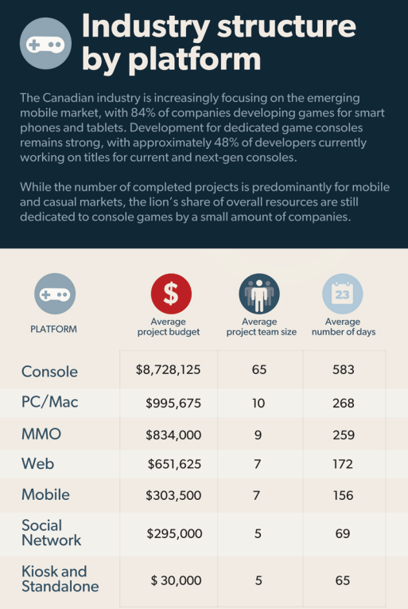



|  |  |
| --- | --- |
| Date Listed | 11-Apr-15 |
|  |  |
| Price | **$425.00** |
| Address | 341 Talbot St, N6A 2R5, London  [View map](http://www.kijiji.ca/v-commercial-office-space/london/professional-furnished-office-space-downtown/1056147852" \l "MapLightbox) |
|  | |
| For Rent By | Owner |
| Furnished | Yes |
|  | |

|  |
| --- |
| Professionally furnished office spaces in Downtown London includes: Private furnished Office Space  Reception services  Boardrooms - 2 to choose from, includes 10 hours monthly  All heat, hydro, water, cleaning and maintenance  Access to building 24/7 Close to Covent Garden Market and the Budweiser Gardens  On site Building Manager  Starting at $425.00 per month  Many great business on site to network with including Lawyers, Paralegals, Software technicians, Psychologists and more.   Give Laurie a call to book a tour today, 519 685 2377 |

<http://www.kijiji.ca/v-commercial-office-space/london/professional-furnished-office-space-downtown/1056147852>

s

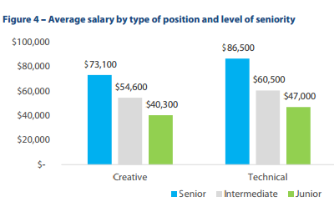

**What are the Specific Incentive Programs Available in Ontario?**

The [Ontario Media Development Corporation](http://www.omdc.on.ca/) offers the ‘Ontario Interactive Digital Media Tax Credit’ (OIDMTC). This credit can amount to 40% of eligible Ontario labour attributable to the development of interactive media products and eligible marketing and distribution expenditures. In the case of ‘specified products’ or large game companies only 35% of eligible Ontario labour can be awarded.

**Does My Gaming Company Qualify for This Credit?**

In order to qualify for this credit the corporation must be taxable in Canada and have a permanent establishment in Ontario that is focused towards the development of digital media products. The eligible interactive digital media products must be developed mainly by the applicant corporation in Ontario (>90%) for small gaming companies. For larger companies they must apply as either a ‘Specialized Digital Game Corporation’ (SDGC) or a ‘Qualified Digital Game Corporation’ (QDGC). In this case larger gaming corporations must incur a minimum of $1 million in eligible Ontario labour along with other qualifications.

**How is the Tax Credit Administered?**  
The OIDMTC is jointly administered by the Ontario Media Development Corporation (OMDC) - an agency of the Ministry of Tourism, Culture and Sport - and the Canada Revenue Agency. Application is made to the OMDC for a certificate of eligibility, which the qualifying corporation files with the Canada Revenue Agency together with its tax return in order to claim the OIDMTC. The amount of the credit, net of any Ontario taxes owing, will be paid to the qualifying corporation. If the qualifying corporation does not owe any taxes, the full amount will be paid out.

PROPRIETARY INFORMATION

Raven Games

Animal Tales

Version 1.0

Contents

1 Team Personnel 2

2 Game Overview 2

2.1 Game Description 2

2.2 Genre 2

2.3 Audience 2

2.4 Platform/Hardware 2

2.5 Requirements 2

3 Plot and Setting Information 2

3.1 Story 2

3.2 Characters 3

3.3 Setting 4

4 Core Gameplay 5

4.1 Walkthrough 5

4.2 Scoring and Points 5

4.3 Controls 5

5 Interfaces and HUD 6

5.1 Main Menu Interface 6

5.2 HUD 6

5.3 Screenshots 7

6 Menu and General Game Usage 7

6.1 Game Flow Diagram 7

7 Audio 8

8 Notes 8

9 Wish list 8

10 Development Technical Milestones 8

10.1 Milestone 1 - Alpha Version 8

10.2 Milestone 2 - Beta Version 8

10.3 Milestone 3 - Silver Version 9

10.4 Milestone 4 - Gold Version 9

# Team Personnel

Director and Programming Lead: Alexander Sanchez

Programmer: Tyler Drury  
Visual Artist: Alexander Sanchez   
Programming Interns: TBD

# Game Overview

## Game Description

Animal Tales is an educational game for children to help them learn to read. The objective is to help Mollie find her animal friends, collecting as many points as possible, and learning to spell along the way. As points are collected, you level up and the words get slightly harder to spell. Each time a mistake is made, an animal runs away and you lose points. The game is over when 5 mistakes are made.

## Genre

Educational, Family, Puzzle

## C:\Users\Nicole\AppData\Local\Microsoft\Windows\INetCache\Content.Word\e for everyone.jpgAudience

* General Audience
* Video Game Fanatics
* Ages 3 and up

## Platform/Hardware

The game will be developed using Unity’s free license. This means that there will be no costs for software used in developing the game. Since we are using Unity, we can target many platforms. However, to begin with, we will be submitting the game to Android’s Google Play Store and the Apple iTunes Store.

## Requirements

An internet connection is required to purchase/download the game, upon initial release at least.

# Plot and Setting Information

## Story

Learn to read with the help of cute animal friends such as Mollie the Monkey, Leo the Lion, Sparkles the Squirrel, and many more. Mollie will ask a question and to help find the next animal, spell the answer correctly to find them. Help Mollie find all her animal friends and learn to spell at the same time.

## Characters

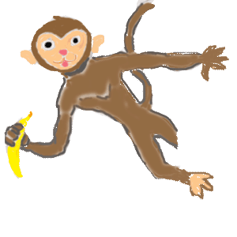

Main - Mollie the Monkey

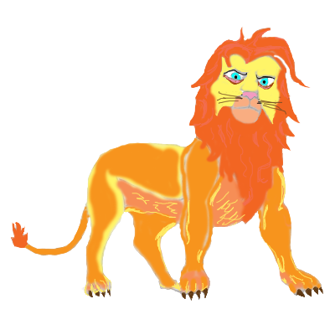

Leo the Lion



Sparkles the Squirrel

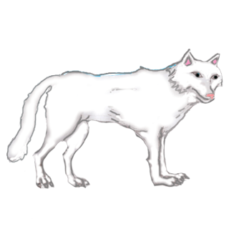

Howler the Wolf



Speedy the Turtle

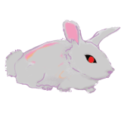

Rockso the Rabbit



Ribbert the Frog

## Setting

This game takes place in a jungle-type setting throughout the game.



Jungle Environment

# Core Gameplay

## Walkthrough

Upon loading, you will see a splash screen for 3 seconds followed by the main menu. You see regular menu options and upon selecting start, you are transitioned to the game screen. There you can see Mollie the Monkey hanging there in her tree in the top right portion of the screen. A speech bubble appears above her and she then explains the game: “Hi, I’m Mollie. Help me find my friends! I’ll ask a question and you tap the box at the bottom to spell the answer. If you’re right, we’ll find one animal friend! Tap to continue.” A randomized 4 letter word question and answer is displayed in Mollie’s speech bubble as well as a second speech bubble. Tap the box at the bottom to bring up the device’s keyboard to spell the answer which appears in the second speech bubble. Spelled correctly, 4 points are awarded, as the answer is a 4 letter word, and Mollie says a randomized congratulations and welcomes the next animal found, also randomized. If the word is spelled wrong points are deducted according to the amount of letters in the misspelled word, scores can go into negative. The lives remaining in the top left corner is adjusted accordingly. If 5 words are spelled wrong, the game over screen appears displaying your score, the high score, and you are given the option to play again or quit.

## Scoring and Points

As each word is spelled correctly, points are awarded according to the number of letters in the word. The words start as easy 4 letter words and can progress up to 8 letter words. Every 3 words spelled right, the words get slightly more difficult as 5 letter words, every 3 more words spelled right, the words become 6 letter words, and so on until 8 letters is reached and every word from that point on is 8 letters long. Each word spelled incorrectly will deduct the number of letters the misspelled word was from your score. Points are saved and displayed as “High Score:” on the main menu.

## Controls

The controls for the game utilize touch controls. Players will tap the bottom of the screen to bring up the keyboard on their device and spell the required word. Players can tap and hold to move the animals (except Mollie) around the screen and arrange them how they want.

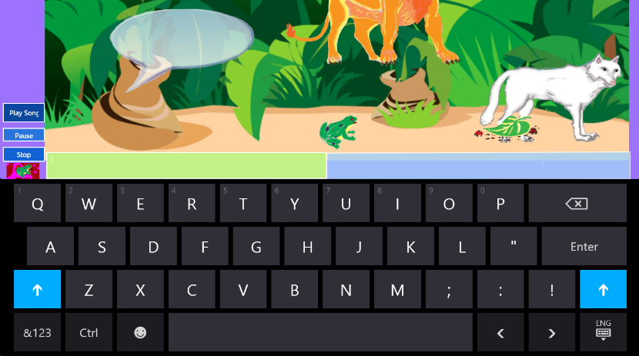 Screenshot with Keyboard

# Interfaces and HUD

## Main Menu Interface

The main menu will contain normal, key elements that your average Main Menu has. It will contain Start, Options, and Quit buttons. The main menu also contains the saved high score at the bottom of the screen in the centre. Below are examples of the Splash and Main Menu screens.

 Splash Screen

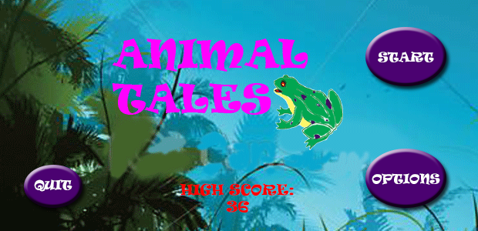 Main Menu Example

## HUD

The Head’s Up Display should contain the score clearly displayed in the top right-hand corner. The number of mistakes left you can make is displayed as lives remaining in the top left-hand corner of the screen. Music controls are displayed as buttons in the lower left corner of the screen as well.

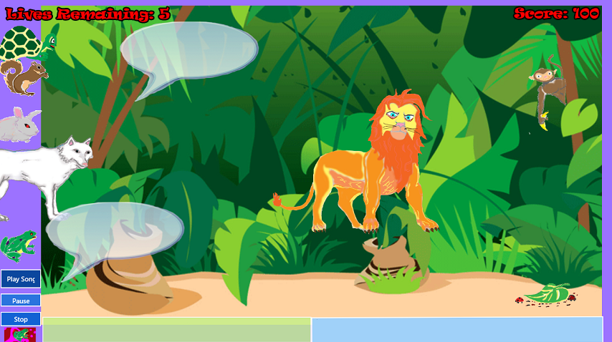

Screenshot with HUD Example

## Screenshots

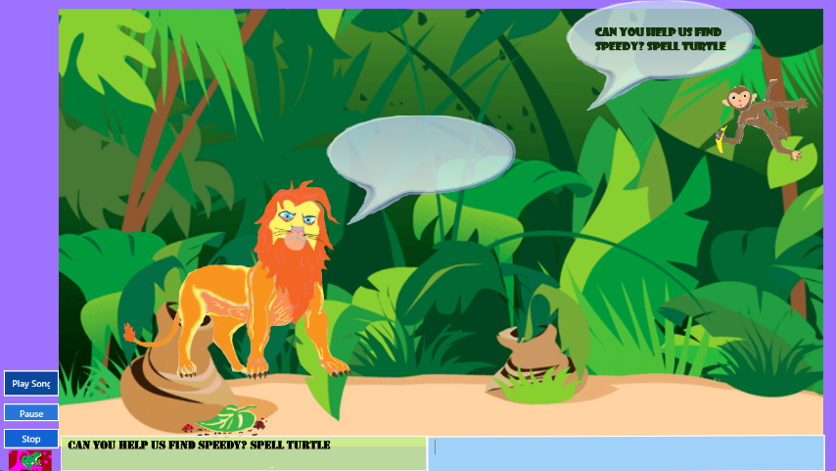 Gameplay Example Screenshot #1

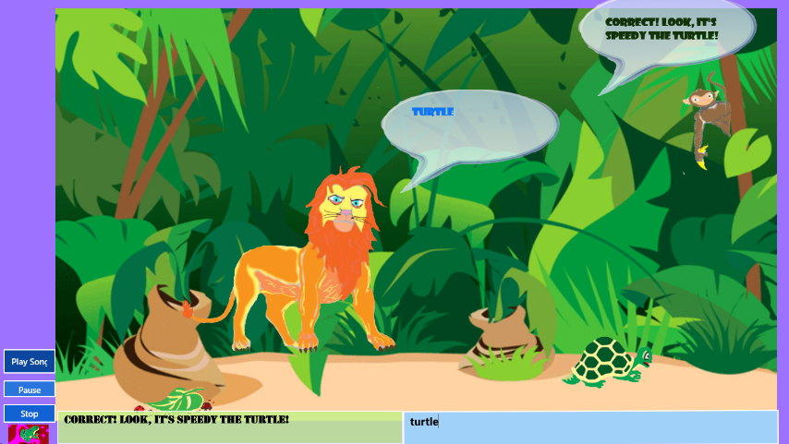 Gameplay Example Screenshot #2

# Menu and General Game Usage

## Game Flow Diagram

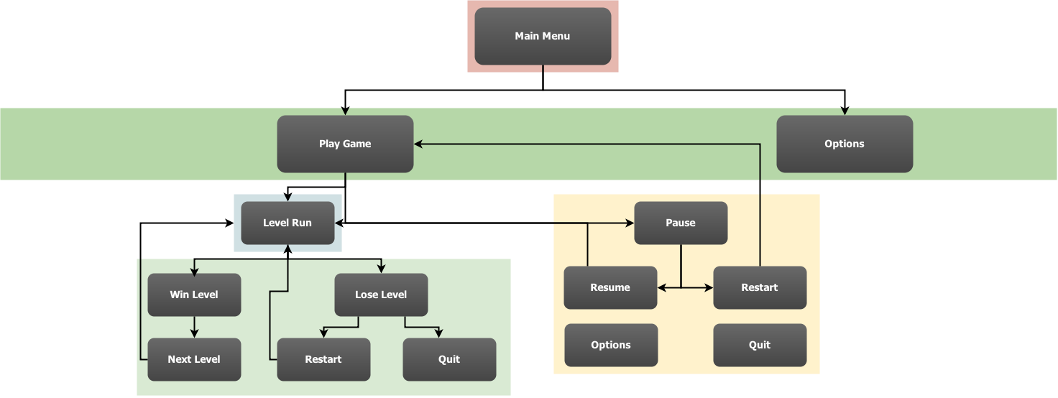

# Audio

There is an ambient track suited for this game that is on a loop playing in the background. Each animal will have its own sound effect that is triggered when the animal is clicked or tapped. There will also be a sound effect for when a word is misspelled.

# Notes

This section contains important notes that are not suited for other places in the document.

* Artwork will be all original, audio may not be (i.e. sound effects).
* Pause may not get implemented on HUD as pause can be achieved other ways on the users’ mobile device.

# Wish list

Here will be the list of features we would like to have in the game, but may not be able to fit into the timeline.

* Achievements
* Customization and/or Options Menu

# Development Technical Milestones

## Milestone 1 - Alpha Version

**Game Flow**

* Main Menu and Game State Machine, this includes the User Interface that runs the game from Main Menu to the start of the game and any other states that the game requires for user experience
* Basic drag-and-drop controls / tap & hold functionality implemented
* Game Aspect Ratio all screens need to be scalable to all device width and heights

## Milestone 2 - Beta Version

**Character Development**

* All described in the Alpha Phase needs to be properly implemented including tidying code structures, scripts, organization and fixing any issues or bugs that may be occurring in games current state
* HUD implemented – Score, Level, etc.
* Game Sounds: Arcade style audio tracks as ambient and in-game sound effects.

## Milestone 3 - Silver Version

**Tech-Demo**

* Performance enhancements
* Leveling-up implemented
* Story Mode: cut scenes/screens with congratulatory narration (possibly voice-overs which will need to be done) upon leveling-up. Artwork will also need to be done
* Load and Save Game Data implemented

## Milestone 4 - Gold Version

**Polish and Completion**

* Menus fully implemented
* Optimization
* Bugs fixed
* Polish lighting effects, particle effects
* Fancy fonts for Level Intros
* Transition effects between screens & menus

**Game Design Document**

For

**“Gem Run”**

A 2D Infinite Runner Game

Version 1.0

Alexander Sanchez

Oct. 22 / 2013

**Table of Contents**

Game Overview..………………………………………………………………………………………………………......3

Goal/Objective………………………………………………………………………………………………...…3

Target Platform………………………………………………………………………………………………….3

Target Audience…………………………………………………………………………………………………3

Visual Style………………………………………………………………………………………………………...3

Audio…………………………………………………………………………………………………………………3

Plot and Setting…….………………………………………………………………………………………………………4

Characters, NPCs, and Obstacles………………………………………………………………………….4

Basic Level Design Concepts…………………...………………………………………………………......5

Environment Elements……..………………………………………………………………………………………......6

Core Game Play…………………………………………………………………………………………………………….6

Interface Usage.…………………………………………………………………………………………………………….7

HUD and Controls……………………………………………………………………………………………….7

Menus and General Game Usage…...……………..…………………………………………………………………8

**Game Overview**

This is an infinite or endless runner game that falls under the platformer genre. It is a side-scroller and, being avatar-based, is intended for a single-player.

**Goal/Objective**

The goal of this game is to maneuver Laila through the levels without touching or falling into anything. The only thing you want Laila to touch are the coloured gems scattered throughout each level, required to get to the next level.

**Target Platform**

The target platform is for PC’s and mobile devices, including handheld and wireless devices. And with how small this game is, could be downloaded to any console as well.

**Target Audience**

The target audience is the adolescent and teenage age groups, mainly younger females, although anyone over the age of five can play and would enjoy this simple yet addicting game. The desired ESRB rating would be E for Everyone.



**Visual Style**

This infinite runner game will be viewed from a third person perspective since it is a side-scroller. There will be 2D graphics used throughout the game.

**Audio**

This would have a very basic soundtrack on a loop for background music. As well, small sound effects for when jump is pressed and when gems are collected. Both having the option to adjust the volume levels or turn off entirely.

**Plot and Setting**

Meet Laila. Help her maneuver her way through the levels, avoiding any obstacles, bottomless pits, or quicksand, by jumping over them. She must also collect all the coloured gems in each level to advance to the next one. There will be 3 levels to start with, more to come with updates.

**Characters, NPCs, and Obstacles**



Main Character: Gems to collect

Laila



NPC#1 - *reduces health 1* NPC#2 - *reduces health 1* NPC#3 - *reduces health 1*

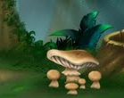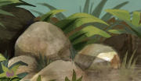

Rock Obstacle - *jump over* Mushroom Obstacle - *jump over* Deadly Nightshade - *death*



Quicksand - *death* Bottomless Pit - *death*

**Basic Level Design Concepts**

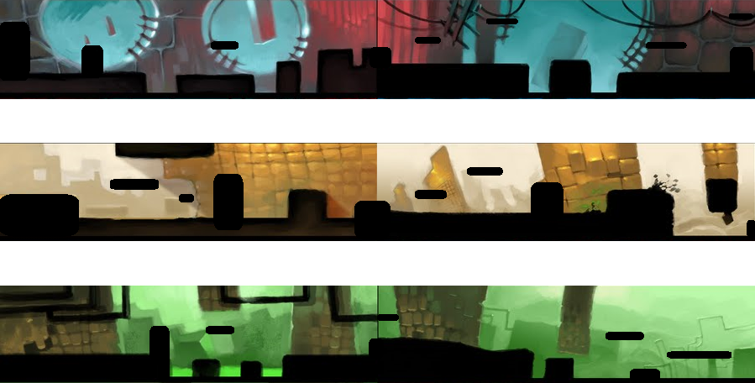

**Environment Elements**

The environments in the levels of this game include obstacles such as rocks, mushrooms, and other natural elements, like quicksand and bottomless pits. Also avoid touching the black Deadly Nightshade flower, resulting in instant death. There are also NPC’s consisting of different small creatures. There are also coloured gems scattered throughout each level randomly to be collected. The number of environment elements increases slightly throughout the levels, as well as upon choosing harder difficulties.

**Core Game Play**

After the game loads and seeing the splash screen, you continue to the main menu. If this is the first time play, choosing start/continue from here will bring you to the choose difficulty menu. If this is not first time play, upon choosing start/continue, you will be asked if you want to continue with previous game or start new game? Both choices bring you to the choose difficulty menu. After selecting the difficulty level, gameplay begins with Laila having 10 health. As she runs, jump over the obstacles, like rocks and mushrooms, and small NPC’s such as rodents and lizards. Each obstacle/NPC that Laila hits reduces her health by 1. If her health reaches 0, she dies and is returned to the main menu. Also, touching Deadly Nightshade, the black flower, results in instant death. Gems, however, Laila does want to touch and collect. There are 10 gems in the first level to collect, the number of gems increasing by 1 every other level. Every gem must be collected to advance to the next or Laila will be returned to the start of that level to try again. She must also be on the lookout for any bottomless pits or quicksand she must jump over or she dies and is returned to the start of that level to try again.

With each increasing difficulty level, Laila’s speed will slightly increase and there will be more obstacles and NPC’s to avoid on each level. The tempo of the music will increase as well.

Games are automatically saved upon exit, to be reloaded next play, if desired.

**Interface Usage**

**HUD and Controls**

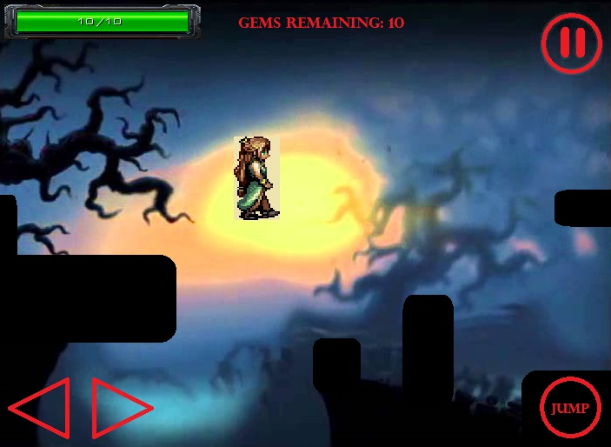

This is an example of how the HUD and controls would look on a mobile/ touchscreen device, since this would likely be the most popular platform for this game. The controls are very basic and easy to understand; left and right arrows to change direction, jump, and pause. There is also a health bar and gem count at the top right of the screen that stays the same for all platforms. For any console device, use left and right arrows/joystick to change direction, start to pause, and either X or A to jump.

There would also be basic, easy to read menus, as well as a splash screen upon loading the game, which would look something like this:

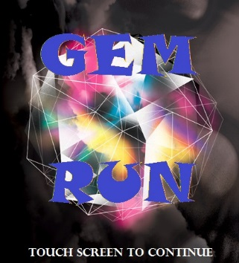

**Menus and General Game Usage**

Main Menu

- Start/Continue

- Options

- Quit

Chose Quit

Chose Start/Continue

Chose

Options

Choose Difficulty

- Easy

- Medium

- Hard

Options

Music Volume:

Off ⟵ ⟶

Sound FX Volume:

Off ⟵ ⟶

End Game

Chose Restart Level

Upon death, not collecting all gems, or completing all levels

Begin Level(s)

Pause Menu

- Resume

- Restart Level

- Quit

Game Paused

Difficulty

Chosen

Chose Quit

Menu Example:

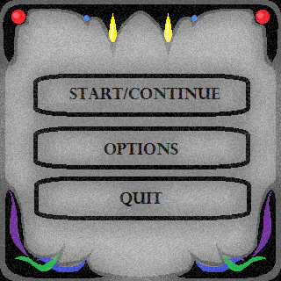

**Game Design Document**

For:

**Squirrel Crossing**

**Version 2.0**

Alexander Sanchez

**Table of Contents**

Game Overview - - - - - - - - - - - - - - - - - - - - - - - - - - - - - - - - - - - - - - - - - - - - - - - - - - - - - - - - - 3

Plot & Setting Information - - - - - - - - - - - - - - - - - - - - - - - - - - - - - - - - - - - - - - - - - - - - - - - - -3 Core Game Play - - - - - - - - - - - - - - - - - - - - - - - - - - - - - - - - - - - - - - - - - - - - - - - - - - - - - - - - - 3

Interface Usage (Controls, HUDs/Screenshots) - - - - - - - - - - - - - - - - - - - - - - - - - - - - - - - - - 4

Menus and General Game Usage (Flow Chart, Screenshots) - - - - - - - - - - - - - - - - - - - - - - - - 5

**Game Overview**

Squirrel Crossing is Frogger-like game, made with SDL. The objective is to collect as many acorns as possible by getting the squirrel across the street, avoiding all the vehicles. The visual style is 2D/arcade style, viewed from a top-down perspective. It is intended for smaller platforms such as mobile or PC, and the desired ESRB rating would be E for Everyone.



**Plot & Setting Information**

Meet Sammy Squirrel. He wants to collect as many acorns as possible. Help Sammy across the busy, 5-lane streets to collect his acorns. Collect an acorn for every street crossed without getting hit by any vehicles.

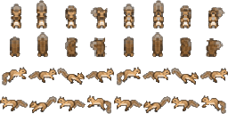

**Core Game Play**

 The game begins with a 4 second Squirrel Crossing splash screen, then play begins and you see Sammy Squirrel at the bottom of the screen in the centre. He can only move in 4 directions, and he jumps 64 pixels up or down and 32 pixels left or right. There are 5 lanes to cross, each lane with a different vehicle, each going a different direction, negatively or positively on the x-axis. Each vehicle has a random speed between 1 and 300 pixels per second and random spawn times between 1 and 1000 milliseconds. There is an acorn waiting for Sammy to collect at the top of the screen after getting across all 5 lanes. Sammy starts with 3 health but each car that touches him decreases his health by 1. Collect the acorn and move to the next street (start back at the starting position at the bottom of the screen) and collect the next acorn. If Sammy is hit by 3 cars, it is game over and the game over menu appears where you can chose to play again or quit.

**Interface Usage (Controls, HUDs/Screenshots)**

The only controls in this game are the movement controls. On the PC controls are up, left, down, and right, or w, a, s, d accordingly. For mobile/touch devices, tap the direction to jump on the directional pad in the bottom right corner of the screen. The health is displayed by the 3 hearts in the top left hand corner of the screen. Mobile screens will be locked in landscape orientation for this game.

PC HUD/Screenshot:

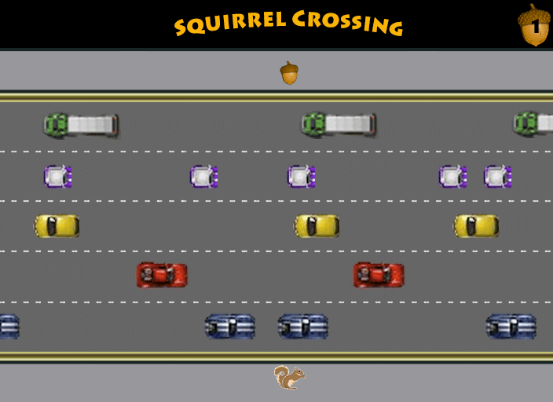

Mobile HUD/Screenshot:

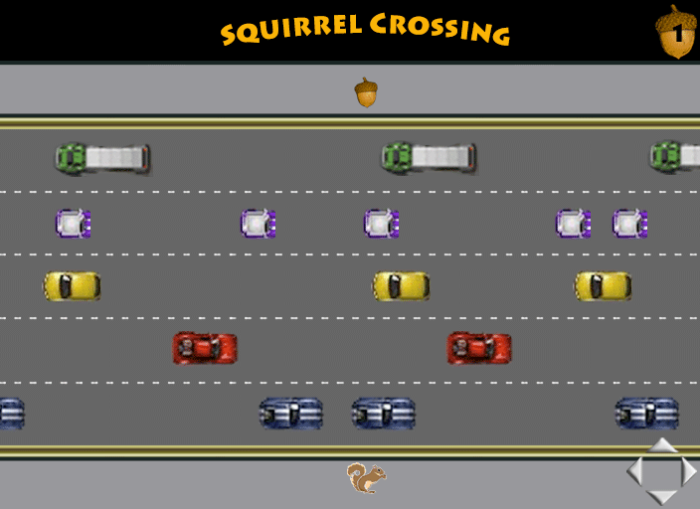



**Menus and General Game Usage (Flow Chart, Screenshots)**



Splash Screen:

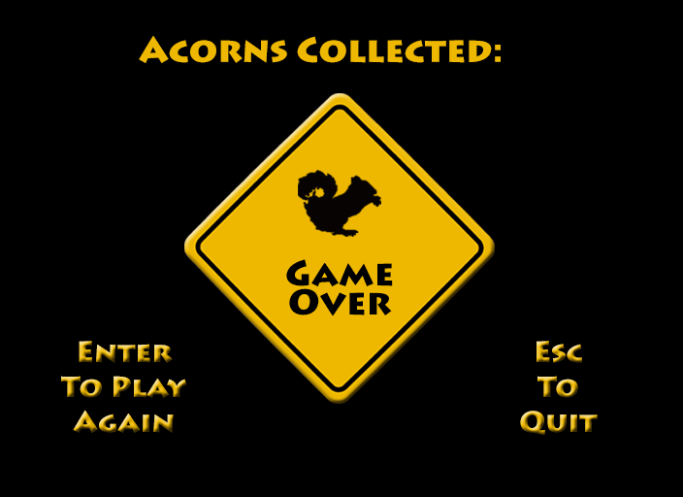Game Over Menu:

Dark Realm



Table of Contents

Game Overview

Plot

Environments

Chapter 1 – The Stranger’s Veil lifted

Episode 1: Midnight Wilderness

Episode 2: Into the Depths

Episode 3: Underworld Queen

Interface

Controls

PC:

XBOX/PS:

Menus

Splash Screen

*

Main Menu

Game States

In-game Menus

In-game HUD

Camera

Characters

Classes

Fighter

Mage

Cleric

Ranger

Bosses

Dantallion

Saudomage

Satyricon

The Witch

The Black Knight

Enemies

Basic Enemies

Skeleton Fighter

Skeleton Archer

Skeleton Mage

Goblin Fighter

Goblin Archer

Zombie

Blood Torso

Pirate

Bat

ITEMS

Weapons and Armor inventory and store icons.

Item Drop

Item Generator

ARMOUR

WEAPONS

Legendary Items

Game Titles:

# 

# Game Overview

This is a dungeon crawler type game, with 3D graphics using the latest version of the Unity game engine. This is a single player experience that with the visual style being seen from a top down type view. The target audience includes any Dungeons and Dragons or Legend of Zelda players; a younger audience. The target platform includes PC, including Stream and Greenlight. The setting of this game is to be a dungeon type environment where the player can upgrade skills and weapons while destroying AI enemies and advancing through the levels. For now, the levels consist of one chapter with three episodes, with a boss enemy at the end of each episode. Character abilities depend on the users’ initial character choice (4 to choose from – fighter, ranged, mage, or cleric) as well the users’ choice of which ability to upgrade. Each character has 6 abilities, 4 active and 2 passive. Weapon choice/pick up also depends on initial character choice, as well as the enemy defeated.

# Plot

A traveler wanders into a village. Several of the villagers were weeping and sobbing, others were locked in their houses staring out the windows at the traveler. The traveler walked up to the largest house and knocked. The head of the village answered and questioned why he was there. "I am just passing by but noticed people are terrified and thought I should figure out why." the mayor explained that several children were kidnapped and no one knows who did it. The stranger offered to help find the children. The mayor was skeptical but took him up on his offer to give the villagers hope and calm them. The traveler took his leave of the village in a perilous bid to find the missing children and return them to their homes.

# Environments

## Chapter 1 – The Stranger’s Veil lifted

### Episode 1: Midnight Wilderness

The moon is high above as the silent stranger leaves the village of Hebron to start his search for the missing children. There is a high breeze with the moisture of salty water from the nearby ocean. Our mysterious stranger pulls the cloak so tightly over his face that not even the moonlight is able to reveal any features. The guards at the gate watch as this stranger dissolves into the night without a sound. Reaching the top of the hill and overlooking the village down below, a faint hum of the bustling from the local inn, The Horseshoe and Bridle, could be heard.

Stretching out before the stranger, lay the hills, mountains, and valleys of distant lands but that is not what catches the attention of the warrior. A wolf pack is close by and they are on the hunt. He has to reach the place in the forest where the children were last seen. Can our mysterious stranger make it there safely?

### Episode 2: Into the Depths

After battling Shirvon, the Wicked Witch and her minions, the children were safe and sound. Lights started to shine through the mansion windows and the darkness started to melt away. Villagers have followed the path of destruction and mangled bodies to the mansion. Already parents and children have started to be reunited. But that is not the focus of our young hero who is intrigued by the stranger who was clearly an accomplice to the Witch and escaped through the portal. But what did she mean by, “Another Rosiden sticking their nose where it doesn’t belong.” Our young hero runs and jumps through the portal without further delay before it shimmers and disappears.

Out of the shimmering light of the portal, lands our young hero on the soft sandy floor. For the brief moment that the portal was in existence, our hero can see that he is in a vast cavern. It is full of tall and long stalagmites and stalactites reaching downward from the darkness above and forming from the ground upwards. The gurgling sound of water escaping into the far depth below echoes in the large cavern. Slowly walking forward, our hero draws his weapon in readiness. Red glowing eyes stare out of the darkness before scurrying into nearby hole.

### Episode 3: Underworld Queen

You turn the corner and step out into an illuminated cavern. Among the numerous luminous plants and moss on the walls and contours of the cavern, stands a naturally created castle. Expertly crafted from the stone found in the underground world, it looks magnificent and majestic. There is only one person who could live here, the Queen of the Underworld, Girlyn. You move forward, scurrying from rock to rock, stealthily avoiding guards and citizens of Underworld. Sneaking into a cart, you pass through the gate of the castle. Now you are in, soon you will have answers to your questions or die trying…

# 

# Interface

## Controls

### PC:

* Menu
  + Highlight/Action button
    - Highlight (WASD)
      * Up : W
      * Down : S
    - Selection (action button)
      * Enter
* Movement
  + WASD(directional arrows)/Joystick
    - W : Up
    - A : Left
    - S : Down
    - D : Right
* Attack
  + Abilities(1-4)
    - Ability 1 : 1
    - Ability 2 : 2
    - Ability 3 : 3
    - Ability 4 : 4
  + Base Attack (Space Bar) (right mouse button)

### XBOX/PS:

* Menu
  + Highlight/Action button
    - Highlight
      * Up : Joystick Up
      * Down : Joystick Down
    - Selection (action button)
      * Left Trigger
* Movement
  + WASD(directional arrows)/Joystick
    - Joystick Up : Up
    - Joystick Left : Left
    - Joystick Down : Down
    - Joystick Right : Right
* Attack
  + Abilities(1-4)
    - Ability 1 : Button 1
    - Ability 2 : Button 2
    - Ability 3 : Button 3
    - Ability 4 : Button 4
  + Base Attack (Right Trigger)

# Menus

A good and hefty use of a super game state machine to transition through the many different user interface driven scenarios of the game.

## 

## 

## Splash Screen



## 

## Main Menu



The main menu will consist of an elaborate art piece decided by the artist as a background and for the purposes of navigating there should be at least the following buttons to access the next screens in the game.

New Game: Starts a new game when the user clicks “New Game”.

Load Game: Loads previously saved game data which will itself store a limited number of saved game slots to choose from.

Options: Difficulty, sounds, extras and game features that can be adjusted to accommodate player preferences.

Credits: Optional, a page that outlines that cast and crew behind the production of the greatest game of this new age.

## Game States

Splash Screen, Menu, Story, Level1, Cut scenes, Credits, Lose, Win, Next Level, End,

Ending Credits.

## 

## In-game Menus



 

## In-game HUD

The look and feel of this game is also enriched with a dark and gloomy vision for the interface that looks both classic cutting- edge and at the same time harvests a very modern and stylish composure in many ways comparable to Diablo III’s style of Interface systems

.

The playing state in an inactive state HUD.



The active playing state HUD.



The Heads up Display is complete with all of its action buttons during the games playing state.

The illustration above represents what the players HUD panel would look like while playing the game.

Each button group serves a specific purpose.

Action buttons:

One of the groups is for general actions in the game such as basic attacks, use items, defend, parry, run away.



Status and Attribute Buttons:

Spells buttons:



The next group of buttons represents the mage class action buttons or spells to be cast during battle.

There is also a section for two short-cut preference slots which the player can edit at any time of the game he or she may choose to allow the readiness of those set items in battles. Ideally the player may select items that are more commonly than other items specific to battles.



Fire: Red, Water: Blue, Earth: Green, Air : Yellow.

Weapon selection:

There is always a selection of weapons the player may draw at any given instance of the battle and they may vary the effectiveness or effects caused during the attacks they inflict by the switching of weapons.

Multiplayer mode may allow for each player to have a different colored panel by the player or a unique panel based on character class.

Windows:

Main Player Window :

The largest window in the center acts as an interactive panel which is a container for important game data that is relevant to the events it pertains to given any instance. Information on items, missions, or attacks and spells is available in a dynamic structure and is powerful in visual representation.

Information Label Window:

An information text window also appears in the different button press scenarios to display the majority of descriptive information related to each button.



Character Buttons:

Anubis is the character displayed below along with his health and mana bar to reflect his current status.



Each active character whether in single mode or multiplayer will have its own tile or panel to reflect important attributes and stats.

Strength (Melee Weapons) +2 melee damage per point

Agility (attack speed / accuracy, range damage. + 0.1% attack speed per point, + 1 ranged damage per point

Intelligence (Spell Power) + 5 MP and 2 spell damage per point

Stamina (endurance) + 3 endurance per point

Vitality (health) + 5 HP per point

## Camera

For the style of retro graphics used, we maintain the camera style for this dungeon crawler to follow suit and be a top-down view. The camera remains fixed and as the player moves to the edge to exit a room, the camera snaps to the next room.

# Characters

## Classes

Note: Each class will start with a combination of 50 attributes divided amongst the available attributes. Also, on creation, each character may add another 10 attribute points to whichever attribute they choose. Each ability may be upgraded a total of 5 times. While in combat, each player will have a base health regen of 2 per second (+ 10% of Stamina) and a base MP regen of 3 per second(+15% int). While out of combat, the health regen will increase to 5 per second(+50 % stamina) and the base MP regen will increase to 6 per second (+ 50% int).

### Fighter

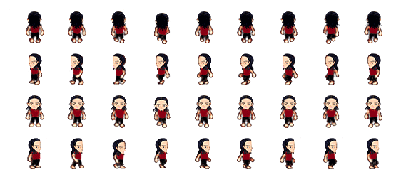

Initial Attributes:

15 - Strength

9 - Agility

2 - Intelligence

13 - Stamina

12 - Vitality

Abilities:

Active:

Bash - Deals 10 damage(+ strength), also stuns enemy for 1 second. Has a cooldown of 5 seconds. Each upgraded point into Bash increases the stun time by 0.2 seconds and the base damage by 2 points.

Rage - Boosts damage output by 15%, and also increases damage taken by 15% for 10 seconds. Has a cooldown of 30 seconds. Each point into Rage increases damage output by 1 % and lowers damage taken by 1 %.

Iron Skin- Reduces damage taken by 20 % for 5 seconds. Has a cooldown of 30 seconds. Each point into Iron Skin reduces damage taken by 0.5 % and increases the time it lasts by 1 seconds.

Flurry - Boosts attack speed by 20% for 5 seconds. Has a cooldown of 20 seconds. Each point into Flurry will increase the attack speed bonus by 2 %.

Ground Impact - Aoe slam onto ground that knocks back enemies by ?? units and deals 5 damage(+ 50% strength). Has a cooldown of 30 seconds. Each point into this ability will increase the knockback distance by ?? and the base damage by 1 point.

Passives:

Will of the warrior - increases base health by 5%. Each upgrade will increase the % by 1.

Guard - Blocks next physical attack on player. Has a cooldown of 25 seconds. Each point into this ability will decrease its cooldown by 1 second. When maxed level will block next attack regardless of being magical or physical.

### Mage

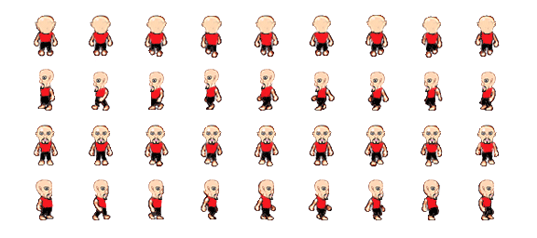

Initial Attributes:

Strength - 5

Agility - 7

Intelligence - 15

Stamina - 12

Vitality - 11

Abilities:

Active:

Fireball - deals 5 damage (+ intelligence) to enemy, applies a burn for 3 seconds. This burn deals ( 25% of int) damage each second. The fireball is a skillshot and will continue until it comes into contact enemy or a wall. It has a cooldown of 5 seconds ,will travel at a rate of ?? and will cost 5 MP. Each point into this ability will increase its movement speed by ?? and will increase the burn effect damage by 1 point.

Ice Burst - deals 5 damage (+ 50% int) to enemy, applies a slow for 3 seconds. The slow effect lowers the enemy move speed by 50%. The ice blast will instantly damage and slow the selected enemy. It has a cooldown of 10 seconds and will cost 10 MP. Each point into this ability will increase the move speed debuff by 5 %.

Thunderbolt - Deals 5 damage (+50% int) to multiple enemies (AOE effect). The thunder bolt will instantly damage enemies in the selected area. It will have a cooldown of 20 seconds and will cost 15 MP. Each point into this ability will increase the affected area by ??.

Nuclear Surge - Heavy damage fire attack that deals 20 damage (+ int) to enemy, but has a cooldown of 60 seconds and costs half of the player’s mana. Each point into this ability will decrease the cooldown by 2 seconds.

Passives:

Mana Ward - Decrease magic damage dealt to the player by 5%. Each point spent to upgrade this ability will increase the % by 1.

Arcane Intellect - Increases the player’s base int by 10 %. Each point spent to upgrade this ability will increase the % by 1.

### Cleric

Initial Attributes:

Strength - 12

Agility - 8

Intelligence - 13

Stamina - 5

Vitality - 12

Abilities:

Single Heal - Targets one player to heal them by 10 HP (+ 50 % int). This ability will cost 10 MP and will have a cooldown of 15 seconds. Each point spent into this ability will increase the base heal amount by 2 points.

AOE Heal - This ability targets all allied units to heal them by 5 HP (+ 25% int). This ability will cost 15 MP and will have a cooldown of 20 seconds. Each point spent into this ability will increase the base heal amount by 1 point.

Resurrection - This ability will bring a deceased player back from tom the dead. This ability will have a cast time of 5 seconds and will cost half of the cleric’s max mana. Also, when the player is raised from the dead, they will spawn with 35% of their max HP and MP. Also, this ability will have a cooldown of 120 seconds. Each point spent to upgrade this ability will increase the spawned health and MP by 5%, as well as decrease the ability cooldown by 5 seconds. Also When at max level it will provide a “re-raise” status that revives the player as soon as they die.

Mana Shield - This ability blocks the next spell dealt to the player. Has a cooldown of 25 seconds. Each point into this ability will decrease its cooldown by 1 second.

Blazing Aura - This ability is an aura that deals 2 damage (+ 5% int) to nearby enemies (?? on exact distance) each second while active. While active, this ability costs 2 MP per second. When deactivated, this ability has a cooldown of 10 seconds. Each point spent into this ability will increase the base damage by 1 point.

Protect - Reduces damage dealt to selected character by 5%. This ability costs 10 MP and lasts 10 seconds. It has a cooldown of 30 seconds. Each point spent into this ability will increase the damage mitigation by 1%.

Holy Bolt - This ability instantly deals damage to the selected enemy. It deals 10 damage( + 50% int) and lowers the selected enemy’s agility by 5 points. This ability has a cooldown of 10 seconds and costs 10 MP. Each point spent to upgrade this ability will increase the base damage by 2 points and the agility decrements by 1 point.

Passives:

Aura of the Divine - This ability is an aura that affects all nearby players. When active, this ability increases each affected player’s health regen by 20% when in combat. Each point spent into this ability will increase the health regen percentage by 1 %.

Aura of Retribution - This ability is an aura that affects all nearby allies. When active, this ability causes enemy attacks against affected players to return 2 damage per hit. Each point spent into this ability will increase the return damage by 1 point.

### Ranger

Strength - 7

Agility - 15

Intelligence - 8

Stamina - 10

Vitality - 10

Abilities:

Rapid Barrage - Fires three shots for every one attack for 5 seconds. Each upgrade will increase the duration by 0.5 seconds. At max level will fire 4 arrows per attack instead of 3. This ability has a cooldown of 15 seconds.

Heavy Shot - Deals 10 damage (+ Agility) and also knocks back the target enemy ?? distance. This ability has a cooldown of 10 seconds. Consumes 10 stamina. Each point spent into this ability will increase the knockback range by ??.

Trap Shot - Holds an enemy in place for 3 seconds. Each upgrade will increase the duration by 0.5 seconds. This ability has a cooldown of 20 seconds.

Swiftness - Increases Agility by 10% for 5 seconds. Each upgrade will increase the duration by 1 second. This ability will have a cooldown of 20 seconds.

Passives:

Deep Breath - increases stamina by 5%. Each upgrade will increase that by 1%.

Enhanced Range - increases attack range by 0.5. Each upgrade will increase that by a further 0.

## 

### Bosses

### Dantallion

  





A horrid demon from the deepest bowels of the underworld made famous by the modern world Goetia scriptures and the Lemegeton. He has the heads and thoughts of thousands combined and gives the summoner knowledge of the vast but when challenged or rejected this beast is like none other and strikes with an uncanny gargantuan force.

Dantallion Attributes:

1 - Strength 8/10

2 - Agility 2/10

3 - Intelligence 8/10

4 - Stamina 9/10

5 - Vitality 9/10

Attacks:

1(Lost my Head)

Animation of a flying head projected out of the original mass heads blob mesh that is Dantallion.

Projectile attack that inflicts 10 percent of the the players health in each instance upon collision.

2(Mind Annihilation)

Psychic attack represented by a bluish particle effect that causes partial to full paralysis to the player based on range and mana used by Dantallion for each instance it is used.

This also shaves more damage on the players health and mana bar,15 percent health damage and 10 percent of mana power is drained and absorbed by the creature.

### Saudomage





A first or second level mage boss. Has a few good elemental spells. He is the classic enemy boss sorcerer that uses 4 basic elemental attacks during battles (fire, water, earthquake, air-tornado).

Saudomage Attributes:

1 - Strength 4/10

2 - Agility 6/10

3 - Intelligence 7/10

4 - Stamina 7/10

5 - Vitality 9/10

### Satyricon



An evil and agoraphobic Satyr with a grudge. Satyricon has a vast array of physical attacks that are incredibly damaging and a quick recovery or cool down between attacks.

Attack Names:

Galloping Fury : basic Satyr attack sheds 7 percent off the players current health.

Cloven Hooves of Doom : To describe the animation or attack best it is a monster horse kick

that uses 3 to 5 animation frames and relieves the player of 15 percent of his current health.

Horsing around : Super satyr uppercut. 3rd row in the sprite sheet. Massive physical attack that inflicts 15 percent damage on the player health bar.

Pegasus Sweep or Slide

Trips the player and knocks him out, causes 7 percent damage.

Satyricon Attributes:

1 - Strength 10/10

2 - Agility 7/10

3 - Intelligence 3/10

4 - Stamina 6/10

5 - Vitality 9/10



### The Witch



Attributes:

2 - Strength

2 - Agility

10 - Intelligence

15 - Stamina

12 - Vitality

· This is the first boss of the game. It will appear at the end of the first episode of the first chapter.

· The Witch uses only ranged attacks so she will use multiple different spells.

· Throughout the fight, she will use her teleport ability.

Abilities

*Teleport*: Within the fighting area there will be a few different spots in which The Witch will teleport to at random. The only time she will teleport is after the 1 minute cool down of the ability.

*Fireball*: When she uses this and hit's the player, the player will take a low amount of damage along as having a 25% chance of causing burning

*Ice Ball*: When she uses this and hit's the player, the player will take a moderate amount of damage and will have a 50% chance of slowing the player's movement by 75%.

*Lightning Blast*: This ability is like the player's mage class Thunderbolt ability. If the player is caught in the AOE the will take a high amount of damage and stun them.

### The Black Knight Asmodeus

Attributes:

10 - Strength

6 - Agility

2 - Intelligence

12 - Stamina

20 - Vitality

· This will be a boss that the player will have to fight half way through the third episode of chapter 1.

· The Black Knight will be a slow enemy, but it will deal heavy damage.



· If the player gets The Black Knight to 25% 50% & 75%, it will use its Summoning Ritual ability.

· It will use the Fatal Blow ability at random time intervals throughout the fight.

Abilities

*Fatal Blow*: When this ability is triggered and it hits the player, they will be dealt 25% damage, knock back, and they will be stunned for 3 seconds.

*Summoning Ritual*: When The Black Knight has been damaged up to a certain point it will use this ability. When used, this causes a small group of zombies and skeletons to help fight alongside this boss

## Enemies

### Basic Enemies

As the player progresses through the game the difficulty of each enemy will be increased by a ratio.

**Skeletons:**

### Skeleton Fighter (Torsos)



Attributes:

3 - Strength

4 - Agility

2 - Intelligence

6 - Stamina

5 - Vitality

· These enemies will have your basic close range attacks.

· Some will appear with swords and shields to add difficulty to the game.

· Since these enemies are melee characters that need to be right up to the player to deal damage, they will deal more damage than the ranged class of skeleton.

· They will take less damage per hit than the ranged enemy since it will have a higher defensive value

Abilities

*Bash*: When used, this ability do additional damage as well as stun the player for a 3 seconds.

### 

### Skeleton Archer (Blood Torso)



Attributes:

2 - Strength

5 - Agility

2 - Intelligence

6 - Stamina

4 - Vitality

· This class of skeleton will use a bow to attack the player once they are within range of each other.

· Since the attack is from a larger distance than the fighter, they will deal half us much damage per attack.

· These enemies are significantly weaker than the fighter. Since they are based on being far away from the player they will have a much lower defensive value.

Abilities

*Heavy Shot*: When the enemy uses this ability, it fires an arrow that causes extra damage and causes knock back on the player

### Skeleton Mage

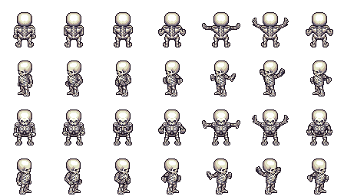

Attributes:

1 - Strength

3 - Agility

4 - Intelligence

8 - Stamina

3 - Vitality

· These enemies will use magic abilities that will include attack and defence spells

· Since this enemy get the extra attack bonus, their defence bonus will suffer by being the lowest of the 3 skeleton enemies.

· They will only use their fireball ability if the player is in range and in view.

Abilities

*Fireball*: When this enemy uses this and hit's the player, the player will take damage as well as having a 25% chance of causing burning

*Burning* will cause 3 damage/second for 5 seconds

**Goblin:**

### Goblin Fighter



Attributes:

4 - Strength

5 - Agility

2 - Intelligence

6 - Stamina

5 - Vitality

· Just like the Skeleton Fighter, uses melee attacks only

· They are equipped with short swords

· Since they are melee fighters, they will have an increased defensive stat that will allow them to take less damage than a ranged enemy.

Abilities

*Bash*: When used, this ability will do additional damage as well as stun the player for a 3 seconds.

### 

### Goblin Archer

Attributes:

2 - Strength

6 - Agility

2 - Intelligence

6 - Stamina

4 - Vitality

· This class of goblin will attack the player using a bow.

· Since the attack is from a larger distance than the fighter, they will deal half us much damage per attack.

· These enemies are significantly weaker than the fighter. Since they are based on being far away from the player they will have a much lower defensive value.

Abilities

*Heavy Shot*: When the enemy uses this ability, it fires an arrow that causes extra damage and causes knock back on the player

### Zombie

Attributes:

5 - Strength

2 - Agility

1 - Intelligence

6 - Stamina

6 - Vitality

· Zombies will be very slow moving enemies but they will compensate with a much stronger attack.

· They will not carry any weapons. They will only have their basic attack along with the bite ability.

Abilities

*Bite*: When this enemy uses this and hit's the player, the player will take damage along as having a 35% chance of causing poison.

*Poison* is almost like burning, but it will cause 5 damage/second for 5 seconds

### Fenrir wolves





Attributes:

0 - Strength

5 - Agility

1 - Intelligence

6 - Stamina

3 - Vitality

· The deer is one enemy that will deal no damage

· The only thing they will do is move back and forth but once the player is in view the player will be paralyzed

Abilities

*Deer in the Headlights*: When the deer uses this ability the player will be paralyzed for 5 seconds in which they will not be allowed to move or attack

### Pirate

### 

Attributes:

4 - Strength

3 - Agility

1 - Intelligence

6 - Stamina

4 - Vitality

· The pirate will be using ranged and melee attacks.

· In melee combat with the player they will use their sword, while at ranged they can use their pistol.

· They will be able to use their Flintlock Pistol ability while in either melee or ranged combat with the player

Abilities

*Flintlock Pistol*: This is an ability that can be used from a distance as well. When the player is hit with this, they will be stunned for 3 seconds.

### Bat



Attributes:

2 - Strength

4 - Agility

1 - Intelligence

6 - Stamina

2 - Vitality

· These enemies will fly in circles until the player is within a few units. This is when the bat will attack the player instead.

· After every few attacks the bat will use its screech ability to stun the player.

Abilities

*Screech*: This ability will cause a stun effect on the player when they are within range. This will not do any damage to the player.

# ITEMS

## Weapons and Armor inventory and store icons.

Buckler

Leather Armor

Dagger

Bow

Great Staff

Great Sword

Basic Armor

Long Sword

Mage Rod

Iron Shield

Steel Armor

Cleric Staff

Potions and additional items



Spells:

Earth

Air:

AIR 2:

## Item Drop

Potions(health, stamina, mana):

Drop Rates:

-Enemies lvl 1 - lvl 5 difficulty rating: Small potion 25 - 65% of the time

Medium potion 5 - 15% of the time

Large potion 0 - 4% of the time.

-Enemies lvl 6 - lvl 10: Small potion 25 - 50%

Medium potion 20 - 35%

Large potion 5 - 10%

-Enemies lvl 11 - lvl 15: Small potion 20 - 35%

Medium potion 30 - 50%

Large potion 5 - 15%

-Enemies lvl 16 - lvl 20: Small potion 10 - 15%

Medium potion 35 - 45%

Large potion 20 - 40%

-Enemies lvl 21 - lvl 25: Small potion 5 - 10%

Medium potion 30 - 40%

Large potion 40 - 50%

-Enemies lvl 26 - lvl 30: Small potion 0 - 5%

Medium potion 25 - 40%

Large potion 40 - 55%

-Enemies lvl 31 - lvl 35: Small potion 0 - 5%

Medium potion 15 - 35%

Large potion 40 - 60%

-Enemies lvl 36 - lvl 40: Small potion 0 - 5%

Medium potion 15 - 25%

Large potion 40 - 70%

Common enemies the player will encounter throughout the dungeon will drop 0 - 2 of each potion while bosses and mini bosses will drop 0 - 5 of each.

Armour:

Drop Rates:

-Enemies lvl 1 - lvl 5 difficulty rating: Common 95% of the time

Rare 3% of the time

Unique 2% of the time.

-Enemies lvl 6 - lvl 10: Common 25 - 55%

Rare 0 - 3%

Unique 0 - 1%

-Enemies lvl 11 - lvl 15: Common 25 - 75%

Rare 0 - 5%

Unique 0 - 3%

-Enemies lvl 16 - lvl 20: Common 25 - 85%

Rare 0 - 7%

Unique 0 - 3%

-Enemies lvl 21 - lvl 25: Common 25 - 90%

Rare 0 - 10%

Unique 0 - 5%

-Enemies lvl 26 - lvl 30: Common 25 - 90%

Rare 0 - 15%

Unique 0 - 8%

-Enemies lvl 31 - lvl 35: Common 25 - 90%

Rare 0 - 15%

Unique 0 - 12%

-Enemies lvl 36 - lvl 40: Common 25 - 90%

Rare 0 - 20%

Unique 0 - 12%

Weapons:

Drop Rates:

-Enemies lvl 1 - lvl 5 difficulty rating: Common 25 - 45% of the time

Rare 0 - 3% of the time

Unique 0 - 1% of the time.

-Enemies lvl 6 - lvl 10: Common 25 - 55%

Rare 0 - 3%

Unique 0 - 1%

-Enemies lvl 11 - lvl 15: Common 25 - 75%

Rare 0 - 5%

Unique 0 - 3%

-Enemies lvl 16 - lvl 20: Common 25 - 85%

Rare 0 - 7%

Unique 0 - 3%

-Enemies lvl 21 - lvl 25: Common 25 - 90%

Rare 0 - 10%

Unique 0 - 5%

-Enemies lvl 26 - lvl 30: Common 25 - 90%

Rare 0 - 15%

Unique 0 - 8%

-Enemies lvl 31 - lvl 35: Common 25 - 90%

Rare 0 - 15%

Unique 0 - 12%

-Enemies lvl 36 - lvl 40: Common 25 - 90%

Rare 0 - 20%

Unique 0 - 12%

Common enemies will only ever drop 0 - 1 piece of armour or a weapon, bosses and mini bosses will drop 0-3 pieces (eg. 2 weapons, 1 armour).

LEGENDARY WEAPONS and ARMOURS

## 

## 

## 

## Item Generator

Item level cap 40

Items

- Level (player must be a certain level to use item)

- Attribute requirements to use equipment

- Item class (common, rare, unique, item set items)

common items

- Armor Type (cloth, leather, scale, plate)

- Weapon Type (melee, ranged, magic)

- Item Bonuses

attribute bonus

ability bonus

- armour stats

defense

- weapon stats

attack damage

**Defense/Attack Rating Modifier**

Item defense/attack stats will be modified by item level.

Modifier: item level x 10

**Attribute Modifier**

Item attribute modifier for common items

Modifier: item level x 50

Item attribute modifier for rare items

Modifier: item level x 100

Item attribute modifier for unique items

Modifier: item level x 200

**Skill Modifier**

Item skill modifier for common items

Modifier: item level x 10

Item skill modifier for rare items

Modifier: item level x 20

Item skill modifier for unique items

Modifier: item level x 40

### ARMOUR

Armour Rating Chest and Legs the same,

Hands and feet the same.

Head hands plus 1ish

Item class: Common

Cloth Armour

Head

- Defense Rating: 2 - 3

- 1 attribute bonus x Modifier

- 1 skill bonus x Modifier

Chest

- Defense Rating: 3 - 5

- 1 attribute bonus x Modifier

- 1 skill bonus x Modifier

Hands

- Defense Rating: 1 - 3

- 1 attribute bonus x Modifier

Legs

- Defense Rating: 3 - 5

- 1 attribute bonus x Modifier

Feet

- Defense Rating: 1 - 3

- 1 attribute bonus x Modifier

Leather armour will be cloth amour x 2.0

Leather Armour

Head

- Defense Rating: 4 - 6

- 1 attribute bonus x Modifier

- 1 skill bonus x Modifier

Chest

- Defense Rating: 6 - 10

- 1 attribute bonus x Modifier

- 1 skill bonus x Modifier

Hands

- Defense Rating: 2 - 6

- 1 attribute bonus x Modifier

Legs

- Defense Rating: 6 - 10

- 1 attribute bonus x Modifier

Feet

- Defense Rating: 2 - 6

- 1 attribute bonus x Modifier

Scale armour will be cloth armour x 4.0

Scale Armour

Head

- Defense Rating: 8 - 12

- 1 attribute bonus x Modifier

- 1 skill bonus x Modifier

Chest

- Defense Rating: 12 - 20

- 1 attribute bonus x Modifier

- 1 skill bonus x Modifier

Hands

- Defense Rating: 4 - 12

- 1 attribute bonus x Modifier

Legs

- Defense Rating: 12 - 20

- 1 attribute bonus x Modifier

Feet

- Defense Rating: 4 - 12

- 1 attribute bonus x Modifier

Plate armour will be cloth armour x 6.0

Plate Armour

Head

- Defense Rating: 12 - 18

- 1 attribute bonus x Modifier

- 1 skill bonus x Modifier

Chest

- Defense Rating: 18 - 30

- 1 attribute bonus x Modifier

- 1 skill bonus x Modifier

Hands

- Defense Rating: 6 - 18

- 1 attribute bonus x Modifier

Legs

- Defense Rating: 18 - 30

- 1 attribute bonus x Modifier

Feet

- Defense Rating: 6 - 18

- 1 attribute bonus x Modifier

Item class: Rare

Rare item defense ratings 1.5 x common

Cloth Armour

Head

- Defense Rating: 3 - 4.5

- 1 attribute bonus x Modifier

- 1 skill bonus x Modifier

Chest

- Defense Rating: 4.5 - 7.5

- 1 attribute bonus x Modifier

- 1 skill bonus x Modifier

Hands

- Defense Rating: 1.5 - 4.5

- 1 attribute bonus x Modifier

Legs

- Defense Rating: 4.5 - 7.5

- 1 attribute bonus x Modifier

Feet

- Defense Rating: 1.5 - 4.5

- 1 attribute bonus x Modifier

Leather armour will be cloth amour x 2.0

Leather Armour

Head

- Defense Rating: 6 - 9

- 1 attribute bonus x Modifier

- 1 skill bonus x Modifier

Chest

- Defense Rating: 9 - 15

- 1 attribute bonus x Modifier

- 1 skill bonus x Modifier

Hands

- Defense Rating: 3.5 - 9

- 1 attribute bonus x Modifier

Legs

- Defense Rating: 9 - 15

- 1 attribute bonus x Modifier

Feet

- Defense Rating: 3 - 9

- 1 attribute bonus x Modifier

Scale armour will be cloth armour x 4.0

Scale Armour

Head

- Defense Rating: 12 - 18

- 1 attribute bonus x Modifier

- 1 skill bonus x Modifier

Chest

- Defense Rating: 18 - 30

- 1 attribute bonus x Modifier

- 1 skill bonus x Modifier

Hands

- Defense Rating: 6 - 18

- 1 attribute bonus x Modifier

Legs

- Defense Rating: 18 - 30

- 1 attribute bonus x Modifier

Feet

- Defense Rating: 6 - 18

- 1 attribute bonus x Modifier

Plate armour will be cloth armour x 6.0

Plate Armour

Head

- Defense Rating: 18 - 27

- 1 attribute bonus x Modifier

- 1 skill bonus x Modifier

Chest

- Defense Rating: 27 - 45

- 1 attribute bonus x Modifier

- 1 skill bonus x Modifier

Hands

- Defense Rating: 9 - 27

- 1 attribute bonus x Modifier

Legs

- Defense Rating: 27 - 45

- 1 attribute bonus x Modifier

Feet

- Defense Rating: 9 - 27

- 1 attribute bonus x Modifier

Item class: Rare

Rare item defense ratings 2.0 x common

Cloth Armour

Head

- Defense Rating: 4 - 6

- 1 attribute bonus x Modifier

- 1 skill bonus x Modifier

Chest

- Defense Rating: 6 - 10

- 1 attribute bonus x Modifier

- 1 skill bonus x Modifier

Hands

- Defense Rating: 2 - 6

- 1 attribute bonus x Modifier

Legs

- Defense Rating: 6 - 10

- 1 attribute bonus x Modifier

Feet

- Defense Rating: 2 - 6

- 1 attribute bonus x Modifier

Leather armour will be cloth amour x 2.0

Leather Armour

Head

- Defense Rating: 8 - 12

- 1 attribute bonus x Modifier

- 1 skill bonus x Modifier

Chest

- Defense Rating: 12 - 20

- 1 attribute bonus x Modifier

- 1 skill bonus x Modifier

Hands

- Defense Rating: 4 - 12

- 1 attribute bonus x Modifier

Legs

- Defense Rating: 12 - 20

- 1 attribute bonus x Modifier

Feet

- Defense Rating: 4 - 12

- 1 attribute bonus x Modifier

Scale armour will be cloth armour x 4.0

Scale Armour

Head

- Defense Rating: 16 - 24

- 1 attribute bonus x Modifier

- 1 skill bonus x Modifier

Chest

- Defense Rating: 24 - 40

- 1 attribute bonus x Modifier

- 1 skill bonus x Modifier

Hands

- Defense Rating: 8 - 24

- 1 attribute bonus x Modifier

Legs

- Defense Rating: 42 - 40

- 1 attribute bonus x Modifier

Feet

- Defense Rating: 2 - 24

- 1 attribute bonus x Modifier

Plate armour will be cloth armour x 6.0

Plate Armour

Head

- Defense Rating: 24 - 36

- 1 attribute bonus x Modifier

- 1 skill bonus x Modifier

Chest

- Defense Rating: 36 - 60

- 1 attribute bonus x Modifier

- 1 skill bonus x Modifier

Hands

- Defense Rating: 12 - 36

- 1 attribute bonus x Modifier

Legs

- Defense Rating: 36 - 60

- 1 attribute bonus x Modifier

Feet

- Defense Rating: 12 - 36

- 1 attribute bonus x Modifier

### WEAPONS

Common

Melee weapons

- 3 - 8 Attack Rating

- 1 attribute bonus x Modifier

- 1 skill bonus x Modifier

Ranged weapons

- 2 - 6 Attack Rating

- 1 attribute bonus x Modifier

- 1 skill bonus x Modifier

Magic weapons

- 2 - 4 Attack Rating

- 1 attribute bonus x Modifier

- 1 skill bonus x Modifier

Rare

item attack rating 1.5 x common

Melee weapons

- 4.5 - 12 Attack Rating

- 1 attribute bonus x Modifier

- 1 skill bonus x Modifier

Ranged weapons

- 3 - 9 Attack Rating

- 1 attribute bonus x Modifier

- 1 skill bonus x Modifier

Magic weapons

- 3 - 6 Attack Rating

- 1 attribute bonus x Modifier

- 1 skill bonus x Modifier

Unique

item attack rating 2.0 x common

Melee weapons

- 6 - 16 Attack Rating

- 1 attribute bonus x Modifier

- 1 skill bonus x Modifier

Ranged weapons

- 4 - 12 Attack Rating

- 1 attribute bonus x Modifier

- 1 skill bonus x Modifier

Magic weapons

- 4 - 8 Attack Rating

- 1 attribute bonus x Modifier

- 1 skill bonus x Modifier

### Legendary Items

|  |  |  |  |  |  |  |  |  |
| --- | --- | --- | --- | --- | --- | --- | --- | --- |
| Classes | HEAD | BODY | TORSO | HANDS | BELT | LEGS | FEET | WEAPON |
| Fighter | Helm of Light | - | Golden Bear Breastplate | Gauntlets of Strength | Golden Snakebelt | Golden Bear Cuisass | Argent Boots | Angelic Spear (Spear) |
|  |  |  |  |  |  |  |  | Illumina Shield (Shield) |
|  |  |  |  |  |  |  |  |  |
| Ranger | Elven Skymask | Nightshade - Cloak of Darkness | Nightingale Armour | Valeria Bracers | Dragonhide Baldrics | Asselin Jerkins | SwiftRift | SpearGlaive (Bow) |
|  |  |  |  |  |  |  |  | Lugar - Tooth of Fenris (Rapier) |
|  |  |  |  |  |  |  |  |  |
| Mage | - | Mystic Robe of Hedaryn | - | Avalio's Grasp | Sacred Gilded Rope | - | Hidden Boots | Galadion(Staff) |
|  |  |  |  |  |  |  |  | Wand of the Immortal (Wand) |
|  |  |  |  |  |  |  |  |  |
| Cleric | StormCrown | Cloak of Radiance | DragonScale Armour | Ornate Gauntlets | Sash of Raintribe | Sash of Raintribe | Dwarven Boot | Spellcaster Tome |
|  |  |  |  |  |  |  |  | Radiant Orb |
|  |  |  |  |  |  |  |  | Holy Mace |

# Raven Games: Dark Realm

Purple Pendulum

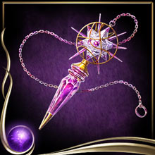

**Team Personnel:**

Alex Sanchez…………………………………Artist/Programmer

Tyler Drury…….………………………………….Programmer

**Table of Contents**

Team Personnel………………………………………….…………………………………………….…1

1. Game Overview…………...………………………………………………………………………....3

2.0 Plot and Setting…………………………………...………………………………………………….3

2.1 Plot………………………...…………………………………………………………………3

2.2 Characters…………………....……………………………………………………………….3

2.3 Environment……………....………………………………………………………………….4

2.4 Artistic Style………………………………………………………………………………….4

3.0 Core Gameplay……………………...……………………………………………………………….4

3.1 Attributes……………………………………………………………………………………..4

3.2 Units………………………………………………………………………………………….6

3.3 Character Base Stats………………………………………………………………………….7

3.4 Level Changes……………………………...……………………………………………….11

3.5 Unit Commands……………………………………………………………………………..11

3.6 Items…………………………………...……………………………………………………13

3.7 Level Up System…………………………………...……………………………………….14

Equipment………………….……………………………………………………………16

Equipment Effects………………………………………………………………………17

4.0 Controls…………………………………………………………………………………………......23

5.0 Game Interface………………………………...……………………………………………………23

5.1 Splash Screen………………………………………………..……………………………...23

5.2 Start Menu…………………..………………………………………………………………24

5.3 HUD……………......……………………………………………………………………….24

5.4 Shop Menu…………………………………………………......…………………………...25

**1.0 Game Overview:**

Commander Defence is a 2D Tactical RPG that requires the player to command their units in battle to defeat various enemies. The game will include various melee, ranged, and magical enemies that the player will encounter. The player and enemy will take turns moving their units, and attacking the opposing forces. The victor will be declared by which player has completely destroyed their enemy's units.

**2.0 Plot and Setting Information:**

2.1 Plot:

The forces of evil are plotting to rule all the land. These forces consist of the Southern Orc Tribe and their leader Grawl Doomhammer, the forces of Undead under the spell of Fal'Thazar the Necromancer, and lastly, the Dark Elves under the rule of Kael'Thassad. The Orc soldiers, although less intelligent than the average human, are significantly larger. The Orc forces also consist of their powerful shamans that bend nature to their wills in order to support other Orc soldiers, or to hinder their enemies. The Orc forces ferocity and strength will prove to be difficult to surpass. The forces of the Undead consist of the recently deceased raised from the grave such as soldiers and archers. The forces also consist of lesser Necromancers under the rule of Fal'Thazar , but these enemies are not to be taken lightly. The Dark Elves consist of highly trained soldiers in the arts of magic and hand to hand combat and will make a worthy foe. The brave commander must lead his army to victory against these forces of evil in order to save the land.

2.2 Characters:

2.2.1 The Commander:



The Commander will be controlled by the player. The Commander is a seasoned strategist and leader and has seen many battles in his time. He has been chosen to lead the land's army against the newly emerged evil. The mechanics of the Commander will be described in a later section.

2.2.2 Grawl Doomhammer:



Grawl Doomhammer is the current war-chief of the Southern Orc Tribe. He is stronger and smarter than the average Orc and has seen many battles in his time. The Orcs’ will follow him into battle no matter what the circumstances. Grawl's mechanics will be described in a later section.

2.2.3 Fal'Thazar:

Fal'Thazar has summoned an entire undead army on his own, which continues to get stronger each and every day. No one truly knows his age or where he came from, only that he is extremely powerful. Fal'Thazar's mechanics will be described in a later section.

2.2.4 Kael'Thassad:

Kael'Thassad is the current leader of Dark Elves. He is an extremely powerful magic user and is not to be taken lightly. He has attained his leadership by usurping the throne from his predecessor who had ruled for a 1000 years previously. Kael'Thassad's mechanics will be described in a later section.

2.3 Environment:

The game will consist of one level, but will alternate from day to night between battles. This level will be 32 by 32 tiles. Each tile will be 32 pixels by 32 pixels. Also, the player's forces will start on the left side of the area, and the player's enemies will start on the right side of the area. There will be ten waves of each race. At the tenth wave of each race, their leader will enter battle. After each wave, the level attribute increases by one point.

2.4 Artistic Style:

The artistic style will be using 8-Bit style graphics and animations, similar to that of Super Mario games on the SNES.

**3.0 Core Gameplay:**

3.1 Attributes:

3.1.1 Health Points (Hp):

Health Points (Hp) determine whether a unit is alive or dead. If a unit's health points reach 0, that unit is dead and is no longer playable within the current battle. When a unit attacks another unit, the defending unit will lose health.

3.1.2 Mana Points (Mp):

Mana Points (Mp) determine whether a player can use a magical attack or not. Spells will cost a base amount of mana points, and if that unit does not have enough Mana Points, they may not cast that spell.

3.1.3 Attack (Atk):

Attack (Atk) determine the physical damage that a unit inflicts upon another unit when attacked. The higher the attack attribute, the more physical damage the unit will inflict.

3.1.4 Accuracy (Acc):

Accuracy (Acc) will determine the chance that a unit has to inflict physical damage to another unit. The higher the accuracy, the greater the chance that the unit will hit another unit.

3.1.5 Magic (mag):

Magic (mag) determines the magical damage that a unit inflicts upon another unit when a spell is cast. Also, the higher the Magic, the more a unit's heal will restore another unit's health.

3.1.6 Defense (Def):

Defense (Def) determines how much physical damage a target will mitigate when physical damage is inflicted.

3.1.7 Movement (Mov):

Movement (Mov) determines how far a unit may move per turn. The higher the movement attribute, the further the unit may move per turn. For example, if a unit has a movement of 5, that unit may move 5 squares each turn.

3.1.8 Speed (Spd):

Speed (Spd) determines how often a unit may move. The higher the speed attribute, the more often a unit may move. The unit's speed is added from 0. The unit with the highest speed will go first. After this unit moves, their speed is set to 0. Other units that have not moved yet will add their speed to their total again. This process repeats for each unit will they move. Also, instead of adding the speed directly, the unit's speed will be multiplied by a random number between 0.5 and 1 before being added which will produce some variation in the order of unit movement. The way speed determines movement order is shown below in an example. Each column represents a turn taken.

For example with three units. Character A has 7 Spd, Character B has 5 Spd, and Character C has 4 Spd.

CharA 7 0 7 14

CharB 5 10 0 5

CharC 4 8 12 0

3.1.9 Evasion (Eva):

Evasion (Eva) determines the chance that a unit has to dodge a physical attack. The higher the evasion attribute, the higher the chance that unit will dodge the incoming physical attack. The way evasion determines whether the hit is landed is determined by the following equation. If (Acc / Eva) is greater than or equal to (1 + (random number between 1 and 0)) then the hit will land. This allows for a physical attack to always hit if the unit has twice as much accuracy than the enemy's evasion. Also, using the random number will allow for some variation.

3.1.10 Resistance (res):

Resistance (res) determines the amount of magic damage dealt to a unit will be mitigated. There are three types of resistances: fire, ice, and lighting. The higher the resistance value, the less damage that will be dealt by that type of spell.

3.1.11 Level (lvl):

The level attribute starts at one and is increased by one after each wave. The level attribute determines how the player's enemy stats are increased.

3.2 Units:

Note: Each race has their own version of the following units.

3.2.1 Knights:

Knights are heavily armoured units that move slightly slower than other units. Knights also have the strongest melee attack, as well as the highest defence and Hp values. Knights may attack any adjacent square with their melee attack.

3.2.2 Archers:

Archers shoot enemies from a distance and have a far range at which they can attack. Archers start with a range of two squares that they may attack, but this range may be upgraded in the shop.

3.2.3 Wizards:

Wizards deal damage via ranged attack spells. They may also attack enemies with a melee attack if they are close enough. The Wizard's spells cost Mp. Wizard's melee attacks may be used on any adjacent square. Wizard's spells however have a range of two squares.

3.2.4 Priests:

Priests are the only healer classes in the game. The priests’ only offensive move is a melee attack. Also, Priest's spells cost Mp. Priest's melee attacks may be used on any adjacent square. The priest's heals however have a range of three squares.

3.3 Character Base Stats:

3.3.1 Human Units:

|  |  |  |  |  |  |
| --- | --- | --- | --- | --- | --- |
| Attribute | Knight | Archer | Wizard | Priest | Commander |
| Hp | 20 | 12 | 10 | 9 | 18 |
| Mp | 3 | 5 | 10 | 14 | 8 |
| Atk | 7 | 5 | 1 | 1 | 6 |
| Acc | 8 | 11 | 6 | 9 | 8 |
| Mag | 1 | 2 | 6 | 5 | 4 |
| Def | 6 | 2 | 2 | 3 | 5 |
| Mov | 3 | 5 | 4 | 4 | 5 |
| Spd | 5 | 7 | 6 | 6 | 6 |
| Eva | 2 | 6 | 4 | 3 | 5 |
| Fire res | 0.00% | 5.00% | 30.00% | 15.00% | 10.00% |
| Ice res | 0.00% | 5.00% | 30.00% | 15.00% | 10.00% |
| Light res | 0.00% | 5.00% | 30.00% | 15.00% | 10.00% |

3.3.1.1 Human Knight:

The knight simply has a melee attack.

3.3.1.2 Human Archer:

The archer simply has a ranged attack.

3.3.1.3 Human Wizard:

The wizard has three spells that they may use. Each spell costs 2 Mp to use. The first spell is a fireball that does 10 points of damage to a single unit. The next spell is a lighting attack that deals 5 damage to the selected target, as well as 2 damage to any target that is adjacent to the selected target. Lastly, the next spell is an ice attack that deals 8 damage to the selected unit, but also reduces the targets movement speed by 2 for that unit's next turn. Each spell may be upgraded via the shop.

3.3.1.4 Human Priest:

The priest has two healing spells that they may use. The first costs 3 Mp and is a direct heal that restores 15 hp. The second heal costs 4 Mp and restores 5 Hp to every friendly unit. The priest also has a support ability that increases a selected unit's movement for one turn by 2 and costs 2 Mp. The priest also has another support ability that increases a selected unit's defence for one turn by 4 and costs 3 Mp. Each spell may be upgraded via the shop.

3.3.1.5 Commander:

The Commander has a melee attack meaning that he may attack a unit that is adjacent to him. The Commander has a few abilities as well. The first ability is the Commander's horn blow which increases all allied unit's attributes by 1 point for each of their next turns. The horn blow costs 2 Mp. The Commander's second ability summons vines that snare enemy units until the Commander's next turn. This ability also deals 5 damage (+ Commander's mag) to each unit. This ability costs 5 Mp. The Commander also has a charge ability. This ability deals 10 (+ Commander's Atk) damage to all enemy units up to 4 tiles in front of the Commander. Once the Commander's charge is used, the Commander returns to his original position. This ability also costs 5 Mp. The Commander's last ability is earthquake. This ability costs 8 Mp and deals 10 damage (+ Commander's mag) damage to each enemy unit. The Commander's abilities may be upgraded via the shop.

3.3.2 Orc Units:

|  |  |  |  |  |
| --- | --- | --- | --- | --- |
| Attribute | Ogre (Knight) | Archer | Warlock (Wizard) | Shaman (Priest) |
| Hp | 25 | 12 | 10 | 9 |
| Mp | 3 | 5 | 10 | 14 |
| Atk | 8 | 5 | 1 | 1 |
| Acc | 5 | 11 | 6 | 9 |
| Mag | 1 | 2 | 6 | 5 |
| Def | 5 | 2 | 2 | 3 |
| Mov | 3 | 5 | 4 | 4 |
| Spd | 4 | 7 | 6 | 6 |
| Eva | 2 | 6 | 4 | 3 |
| Level | 1 | 1 | 1 | 1 |
| Fire res | 0.00% | 5.00% | 40.00% | 15.00% |
| Ice res | -20.00% | -15.00% | 0.00% | -15.00% |
| Light res | 0.00% | 5.00% | 30.00% | 15.00% |

3.3.2.1 Orc Ogre:

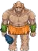The ogre simply has a basic attack.

3.3.2.2 Orc Archer:



The archer simply has a ranged attack.

3.3.2.3 Orc Warlock:

The warlock has two abilities. The first is a fire attack that deals damage to the selected unit as well as each enemy adjacent to that unit. This spell deals 5 damage to each unit and costs 3 Mp. The next ability is also fire based and deals 8 points of damage to a selected unit. This spell also leaves a debuff on the target that deals 2 damage each turn for the next two turns. The warlock also has a melee attack.

3.3.2.4 Orc Shaman:



The shaman has two abilities. The first ability costs 5 Mp and is a direct heal that heals an ally for 15 points of health. The second ability costs 5 Mp, targets an enemy, and slows their movement by 2 points for that unit's next turn.

3.3.3 Undead Units:

|  |  |  |  |  |
| --- | --- | --- | --- | --- |
| Attribute | Knight | Archer | Wizard | Necromancer (Priest) |
| Hp | 15 | 10 | 10 | 9 |
| Mp | 3 | 5 | 10 | 14 |
| Atk | 8 | 5 | 1 | 1 |
| Acc | 5 | 11 | 6 | 9 |
| Mag | 1 | 2 | 6 | 5 |
| Def | 6 | 2 | 2 | 3 |
| Mov | 3 | 5 | 4 | 4 |
| Spd | 4 | 7 | 6 | 6 |
| Eva | 2 | 6 | 4 | 3 |
| Level | 1 | 1 | 1 | 1 |
| Fire res | -40.00% | -50.00% | -50.00% | -50.00% |
| Ice res | 5.00% | 10.00% | 40.00% | 25.00% |
| Light res | 0.00% | 5.00% | 30.00% | 15.00% |

3.3.3.1 Undead Knight:



The knight simply has a basic attack.

3.3.3.2 Undead Archer:



The archer simply has a ranged attack.

3.3.3.3 Undead Wizard:

The wizard has two abilities. The first ability is an ice based spell that deals 8 points of damage to the selected target as well as slowing that target's movement speed by a factor of 2 for its next turn. The other ability applies a de-buff to all opposing enemies that slows their movement speed by 2 for one units turn.

3.3.3.4 Necromancer Priest:



The necromancer has two healing abilities. The first spell heals a selected unit for 5 points of health and costs 4 Mp to use. The second ability heals all allied units for 2 points of health and costs 4 Mp to use. Also, the necromancer may not heal himself, only his allied units.

3.3.4 Dark Elvish Units:

|  |  |  |  |  |
| --- | --- | --- | --- | --- |
| Attribute | Knight | Archer | Wizard | Priest |
| Hp | 15 | 10 | 10 | 9 |
| Mp | 3 | 5 | 10 | 14 |
| Atk | 8 | 5 | 1 | 1 |
| Acc | 5 | 11 | 6 | 9 |
| Mag | 1 | 2 | 6 | 5 |
| Def | 6 | 2 | 2 | 3 |
| Mov | 3 | 5 | 4 | 4 |
| Spd | 6 | 7 | 6 | 6 |
| Eva | 2 | 6 | 4 | 3 |
| Level | 1 | 1 | 1 | 1 |
| Fire res | 0.00% | 5.00% | 30.00% | 15.00% |
| Ice res | 0.00% | 5.00% | 30.00% | 15.00% |
| Light res | -15.00% | -20.00% | -20.00% | -20.00% |

3.3.4.1 Dark Elvish Knight:

The knight simply has a basic attack.

3.3.4.2 Dark Elvish Archer:

The archer simply has a ranged attack.

3.3.4.3 Dark Elvish Wizard:

The wizard has three spells that they may use. Each spell costs 3 Mp to use. The first spell is a fireball that does 8 points of damage to a single unit. The next spell is a lighting attack that deals 3 damage to the selected target, as well as 3 damage to any target that is adjacent to the selected target. Lastly, the next spell is an ice attack that deals 3 damage to the selected unit, but also reduces that targets movement by 2 for their next turn.

3.3.4.4 Dark Elvish Priest:

The priest has two healing spells that they may use. The first costs 5 Mp and is a direct heal that restores 10 hp. The second heal costs 5 Mp and restores 5 Hp to every friendly unit.

3.3.5 Bosses:

|  |  |  |  |
| --- | --- | --- | --- |
| Attribute | Grawl | Fal'Thazar | Kael'Thassad |
| Hp | 55 | 60 | 75 |
| Mp | 10 | 65 | 80 |
| Atk | 35 | 20 | 30 |
| Acc | 20 | 25 | 25 |
| Mag | 5 | 35 | 45 |
| Def | 20 | 25 | 30 |
| Mov | 10 | 10 | 10 |
| Spd | 15 | 15 | 20 |
| Eva | 12 | 15 | 18 |
| Fire res | 15.00% | 45.00% | 65.00% |
| Ice res | 15.00% | 45.00% | 65.00% |
| Light res | 15.00% | 45.00% | 65.00% |

3.3.5.1 Grawl DoomHammer:

Grawl has a simple melee attack, but he ignores 50% of the defence of the unit he is attacking. Grawl also has a second ability that is ranged. During this ability, Grawl throws one of his axes which does half of his base attack and also ignores 50% defence of the unit he is attacking.

3.3.5.2 Fal'Thazar:

Fal'Thazar has a basic melee attack. He also has two spells that he may cast. The first spell costs 5 Mp and deals 3 damage to every enemy unit and is ice based. His last ability costs 5 Mp as well and heals each allied unit for 3 points of hp.

3.5.3 Kael'Thassad:

Kael'Thassad has a basic melee attack. He also has three spells that he may cast. Each spell that Kael'Thassad has costs 5 Mp. The first ability is fire based and deals 5 damage to each enemy unit. The next ability is a debuff that slows all target movement speed by 2 points for 1 turn. The last ability applies a de-buff that lowers all enemies accuracy by 1 point for 1 turn and deals 2 damage to each enemy unit.

3.4 Level-up Changes:

Note: Each stat is increased by the listed amount each time the level attribute is increased.

3.4.1 Orc Units:

|  |  |  |  |  |
| --- | --- | --- | --- | --- |
| Attribute | Ogre (Knight) | Archer | Warlock (Wizard) | Shaman (Priest) |
| Hp | 2 | 1 | 1 | 1 |
| Mp | 1 | 1 | 2 | 2 |
| Atk | 1 | 1 | 1 | 1 |
| Acc | 1 | 2 | 1 | 1 |
| Mag | 0 | 1 | 2 | 1 |
| Def | 1 | 1 | 0 | 1 |
| Mov | 0.2 | 0.2 | 0.2 | 0.2 |
| Spd | 1 | 1 | 1 | 1 |
| Eva | 1 | 1 | 1 | 1 |
| Level | 1 | 1 | 1 | 1 |
| Fire res | 1.00% | 1.00% | 2.00% | 2.00% |
| Ice res | 1.00% | 1.00% | 2.00% | 2.00% |
| Light res | 1.00% | 1.00% | 2.00% | 2.00% |

3.4.2 Undead Units:

|  |  |  |  |  |
| --- | --- | --- | --- | --- |
| Attribute | Knight | Archer | Wizard | Necromancer (Priest) |
| Hp | 1 | 1 | 1 | 1 |
| Mp | 0 | 1 | 2 | 2 |
| Atk | 2 | 1 | 1 | 1 |
| Acc | 1 | 1 | 1 | 1 |
| Mag | 1 | 1 | 1 | 1 |
| Def | 2 | 1 | 1 | 1 |
| Mov | 0.2 | 0.2 | 0.2 | 0.2 |
| Spd | 1 | 1 | 1 | 1 |
| Eva | 1 | 1 | 1 | 1 |
| Level | 1 | 1 | 1 | 1 |
| Fire res | 1.00% | 1.00% | 2.00% | 2.00% |
| Ice res | 1.00% | 1.00% | 2.00% | 2.00% |
| Light res | 1.00% | 1.00% | 2.00% | 2.00% |

3.4.3 Dark Elvish Units:

|  |  |  |  |  |
| --- | --- | --- | --- | --- |
| Attribute | Knight | Archer | Wizard | Priest |
| Hp | 1 | 1 | 1 | 1 |
| Mp | 0 | 1 | 2 | 2 |
| Atk | 1 | 1 | 1 | 1 |
| Acc | 1 | 2 | 1 | 1 |
| Mag | 0 | 1 | 1 | 1 |
| Def | 2 | 1 | 1 | 1 |
| Mov | 0.2 | 0.2 | 0.2 | 0.2 |
| Spd | 1 | 1 | 1 | 1 |
| Eva | 1 | 1 | 1 | 1 |
| Level | 1 | 1 | 1 | 1 |
| Fire res | 1.00% | 1.00% | 2.00% | 2.00% |
| Ice res | 1.00% | 1.00% | 2.00% | 2.00% |
| Light res | 1.00% | 1.00% | 2.00% | 2.00% |

3.5 Unit Commands:

Note: The battles will be turn based. The order in which each character moves is determined by their speed as previously stated in the attributes section. Each character will be highlighted during their respective turn. The camera will be centred about the current highlighted character. During combat, each unit will have the option to Attack, use Magic, Defend, or to use Items. During the enemy turn the player controls will be disabled until the enemy turn is over. Each unit has a chance to move throughout the map, and then may use one of the four commands.

3.5.1 Attack:

When attack is selected, the attack-able squares will become highlighted. An attack animation will play depending on which character is being used. As previously stated in the attribute section, whether or not a player hits a unit will depend on accuracy and evasion. The unit that is damaged will have their health bar reflect the damage dealt. If a unit is killed in the process, a death animation will play. The amount of damage dealt to the attacked unit is determined by the following equation:

max (Attacking unit's Atk – (defending unit's Def) * (random number between 0.5 and 1.0), 1)

3.5.2 Magic:

When magic is selected, the attack-able squares will become highlighted. Magic attacks never miss and therefore do not have to check whether they hit. When casting a spell, a spell animation will play depending on which character is currently active. Similar to the Attack command, death animations will play if the unit is killed, and the unit's health bar will reflect the damage dealt. The amount of damage dealt to the attacked unit is determined by the following equation:

(Spell damage + attacking unit's mag) * (1 – defending unit's res)

Healing is also affected by magic. The following equation determines how much is actually healed.

Direct Heal = (Healing amount + unit's mag) * 0.8

Group Heal = (Healing amount + unit's mag) * 0.2

3.5.3 Defend:

Defend will result in the unit taking half damage from all attacks. Defend will last until the unit's next turn.

3.5.4 Item:

When item is selected, the squares in which the item may be used are highlighted. This allows for units to use items on nearby allies. When an item is used, it will be discarded. The highlighted squares will only be on the adjacent squares of the current unit.

3.6 Items:

3.6.1 Healing Potion:

Healing potions may be bought for 10 gold in the shop menu between battles. The healing potions will restore 10 points of health when used on a unit.

3.6.2 Mana Potion:

Mana potions may be bought for 10 gold in the shop menu between battles. The mana potions will restore 10 points of mana when used on a unit.

3.7 Levelling Up System:

Note: Each unit that the player kills will reward 10 experience per current level. Also, each enemy killed will reward the player with 20 gold per current level. Bosses however will reward the player with double the amount of gold and experience. Also, the player will be given a chance to level-up and use the shop between each battle. Gold will be used to upgrade the Commander's units. Experience will be used to upgrade the Commander.

3.7.1 Experience:

As stated, experience will be used to upgrade the Commander. The Commander may upgrade his horn blow five times. Each upgrade will increase the attribute bonus by one point. The first upgrade costs 30 experience, with each preceding upgrade costing an additional 30 experience. The Commander may also upgrade each of his attributes. For every ten points of the Commander's attributes, the cost to upgrade an attribute will increase by 10 experience points. For example, if the Commander's Attack is 8, it will cost 10 experience points. If the Commander's attack is 11, the upgrade will cost 20 experience points. Movement however, costs triple than what any other attribute costs. Accuracy and evasion cost double than any other attribute. The Commander may spend 100 experience to increase the range of his charge by one tile. After purchasing this upgrade, the Commander may spend 200 experience to upgrade the charge range another tile. The Commander may also upgrade the damage of his vines by 1 point for 30 experience. Each additional upgrade costs an additional 30 experience with a maximum of 5 upgrades. The Commander may also upgrade his earthquake ability's damage by 2 points per upgrade. The upgrade initially costs 40 experience, with each additional upgrade costing an additional 40 experience with a maximum of 5 upgrades.

3.7.2 Gold:

Gold will be used to upgrade the Commander's army units between battles. Upon selecting the “Purchase Equipment” option, the player will be able to see a menu showing the available items and upgrades. Potions can be selected for purchase by clicking the corresponding menu icon. Each class also has an equipment set consisting of five equipment slots which may be upgraded individually. After selecting something to purchase, the player must click the buy button to confirm their choice. When items are purchased, they may be accessed by any allied unit during battle via the “Item” command. When equipment is purchased, its effect is automatically applied to all allied units of the appropriate class. See equipment section (3.7.3) for more details.

**3.7.3 Equipment:**

3.7.3.1 Knight Equipment:

|  |  |  |  |  |  |  |  |  |  |
| --- | --- | --- | --- | --- | --- | --- | --- | --- | --- |
| Equipment Slot | Tier1 (60g) | Tier2 (120g) | Tier3 (250g) | Tier4 (400g) | Tier5 (650g) | Tier6 (1000g) | Tier7  (1500g) | Tier8 (2100g) | Tier9 (3000g) |
| Weapon | Bamboo Sword | Bronze Sword | Iron Sword | Longsword | Steel Sword | Katana | Magic Sword | Blood Sword | Excalibur |
| Head | Wooden Helm | Bronze Helm | Iron Helm | Shell Helm | Steel Helm | Winged Helm | Magic Helm | Ancient Helm | Titan's Helm |
| Chest | Wooden Armour | Bronze Armour | Iron Armour | Chain  Armour | Steel Armour | Mythril Armour | Magic Armour | Diamond Armour | Adamantium Armour |
| Feet | Dull Greaves | Bronze Greaves | Iron Greaves | Resilient Greaves | Steel Greaves | Obsidian Greaves | Magic Greaves | Haste Greaves | Justice Greaves |
| Relic | String Bracers | Bronze Bracers | Iron Bracers | Elemental Bracers | Steel Bracers | Ice Bracers | Magic Bracers | Jade Bracers | Sun Bracers |

3.7.3.2 Archer Equipment:

|  |  |  |  |  |  |  |  |  |  |
| --- | --- | --- | --- | --- | --- | --- | --- | --- | --- |
| Equipment Slot | Tier1 (60g) | Tier2 (120g) | Tier3 (250g) | Tier4 (400g) | Tier5 (650g) | Tier6 (1000g) | Tier7  (1500g) | Tier8 (2100g) | Tier9 (3000g) |
| Weapon | Practice Bow | Short Bow | Longbow | Hunter's Bow | Great Bow | Recurve Bow | Magic Bow | Elven Bow | Artemis Bow |
| Head | Cloth Cap | Leather Cap | Studded-Leather Cap | Hunter's Cap | Hide Cap | Survival Cap | Magic Cap | Elven Cap | Dragonhide Cap |
| Chest | Cloth Vest | Leather Vest | Studded-Leather Vest | Hunter's Vest | Hide Vest | Survival Vest | Magic Vest | Elven Vest | Immortal Vest |
| Feet | Worn Boots | Leather Boots | Studded-Leather Boots | Hunter's Boots | Hide Boots | Survival Boots | Magic Boots | Elven Boots | Hermes Boots |
| Relic | Yellow Bracelet | Leather Bracelet | Studded-Leather Bracelet | Hunter's Bracelet | Hide Bracelet | Survival Bracelet | Magic Bracelet | Elven Bracelet | Moon Bracelet |

3.7.3.3 Wizard Equipment:

|  |  |  |  |  |  |  |  |  |  |
| --- | --- | --- | --- | --- | --- | --- | --- | --- | --- |
| Equipment Slot | Tier1 (60g) | Tier2 (120g) | Tier3 (250g) | Tier4 (400g) | Tier5 (650g) | Tier6 (1000g) | Tier7  (1500g) | Tier8 (2100g) | Tier9 (3000g) |
| Weapon | Apprentice Wand | Acolyte Wand | Fire Wand | Ice Wand | Lightning Wand | Protect Wand | Mystic Wand | Gaia Wand | Sky Wand |
| Head | Cloth Cowl | Pointy Cowl | Feathered Cowl | Wizard's Cowl | Red Cowl | Protect Cowl | Mystic Cowl | Archmage Cowl | Wisdom Cowl |
| Chest | Cloth Robe | Expensive Robe | Blue Robe | Yellow Robe | Red Robe | Protect Robe | Mystic Robe | Archmage Robe | Demigod Robe |
| Feet | Cloth Shoes | Expensive Shoes | Noble Shoes | Shell Shoes | Shiny Shoes | Protect Shoes | Mystic Shoes | Archmage Shoes | Wind Shoes |
| Relic | Old Ring | Iron Ring | Silver Ring | Gold Ring | Power Ring | Protect Ring | Mystic Ring | Archmage Ring | Energy Ring |

3.7.3.4 Priest Equipment:

|  |  |  |  |  |  |  |  |  |  |
| --- | --- | --- | --- | --- | --- | --- | --- | --- | --- |
| Equipment Slot | Tier1 (60g) | Tier2 (120g) | Tier3 (250g) | Tier4 (400g) | Tier5 (650g) | Tier6 (1000g) | Tier7  (1500g) | Tier8 (2100g) | Tier9 (3000g) |
| Weapon | Practice Staff | Wooden Staff | Strong Staff | Shield Staff | Healing Staff | Peacemaker Staff | Mystic Staff | Light Staff | Divinity Staff |
| Head | Cloth Hat | Fine Hat | Thick Hat | Sage's Hat | Healing Hat | Peacemaker Hat | Mystic Hat | Light Hat | Mercy Hat |
| Chest | Cloth Garb | Fine Garb | Thick Garb | Sage's Garb | Healing Garb | Peacemaker Garb | Mystic Garb | Light Garb | Justice Garb |
| Feet | Worn Sandals | Fine Sandals | Tough Sandals | Sage's Sandals | Healing Sandals | Peacemaker Sandals | Mystic Sandals | Light Sandals | Benevolence Sandals |
| Relic | Rusted Amulet | Copper Amulet | Sapphire Amulet | Opal Amulet | Healing Amulet | Peacemaker Amulet | Mystic Amulet | Light Amulet | Truth Amulet |

3.7.3.5 Equipment Effects:

The following tables contain information about each piece of equipment's effect on equipped units.

|  |  |
| --- | --- |
| Item | Effect |
| Bamboo Sword | +1 ATK + 1 DEF + 1 ACC + 1 EVA |
| Bronze Sword | +2 ATK + 2 ACC |
| Iron Sword | +3 ATK + 1 DEF + 1 ACC |
| Longsword | +3 ATK + 1 EVA + 1 SPD |
| Steel Sword | +3 ATK + 1 DEF + 3 ACC |
| Katana | +4 ATK +1 EVA + 2 SPD |
| Magic Sword | + 4 ATK + 3 ACC + 15 AR(all resists) |
| Blood Sword | +3 ATK + Gain 50% of damage as HP |
| Excalibur | + 10 ATK + 12 ACC + 5 DEF + 5 AR |
| Practice Bow | + 1 ATK + 3 ACC |
| Short Bow | + 2 ATK + 2 ACC |
| Longbow | + 2 ATK + 3 ACC |
| Hunter's Bow | + 2 ATK + 1 ACC + 2 EVA + 1 SPD |
| Great Bow | + 4 ATK |
| Recurve Bow | + 5 ATK + 1 ACC |
| Magic Bow | + 5 ATK + 3 ACC + 10AR |
| Elven Bow | + 4 ATK + 5 ACC + 3 EVA + 1 SPD + 1 MOV |
| Artemis Bow | + 7 ATK + 10 ACC + 4 EVA + 4 SPD + 1 MOV |
| Apprentice Wand | + 2 MAG + 4 MP + 1 ACC + 1 ATK |
| Acolyte Wand | + 3 MAG + 6 MP + 1 ACC + 1 ATK |
| Fire Wand | + 4 MAG + 3 MP + 1 ATK Fire mag. + 20% |
| Ice Wand | + 4 MAG + 4 MP + 1 ATK Ice mag. + 20% |
| Lightning Wand | + 4 MAG + 5 MP + 1 ATK Lightning mag.+ 20% |
| Protect Wand | + 2 MAG + 4 MP + 4 DEF + 1 ACC |
| Mystic Wand | + 6 MAG + 8 MP + 20 AR + 1 ACC |
| Gaia Wand | + 6 MAG + 10 MP + 5 DEF + 1 ACC |
| Sky Wand | + 10 MAG + 15 MP + 5 EVA + 2 SPD + 1 MOV |
| Practice Staff | + 1 MAG + 6 MP + 2 ACC + 1 ATK |
| Wooden Staff | + 1 MAG + 6 MP + 1 ACC + 2 ATK |
| Strong Staff | + 1 MAG + 5 MP + 2 ACC + 3 ATK |
| Shield Staff | + 2 MAG + 4 MP + 2 DEF + 1 ATK |
| Healing Staff | + 4 MAG + 1 MP + 2 ACC + 2 SPD |
| Peacemaker Staff | + 4 MAG + 6 MP + 3 DEF + 4 ATK |
| Mystic Staff | + 3 MAG + 11 MP + 20 AR + 2 DEF + 1 ATK |
| Light Staff | + 6 MAG + 12 MP + 10 AR + 1 DEF + 2 SPD |
| Divinity Staff | + 8 MAG + 22 MP + 15AR + 3 DEF + 3 ATK |

Headgear:

|  |  |
| --- | --- |
| Item | Effect |
| Wooden Helm | + 2 DEF + 4 HP |
| Bronze Helm | + 1 DEF + 8 HP |
| Iron Helm | + 1 DEF + 10 HP |
| Shell Helm | + 1 DEF + 9 HP + 5 AR |
| Steel Helm | + 2 DEF + 12 HP |
| Winged Helm | + 3 DEF + 12 HP |
| Magic Helm | + 2 DEF + 10 HP + 10 AR |
| Ancient Helm | + 2 DEF + 16 HP + 10 LR |
| Titan's Helm | + 7 ATK + 4 DEF + 20 HP |
| Cloth Cap | + 1 DEF + 6 HP |
| Leather Cap | + 1 DEF + 6 HP + 1 EVA |
| Studded-Leather Cap | + 2 DEF + 6 HP + 1 EVA |
| Hunter's Cap | + 1 DEF + 4 HP + 2 EVA + 2 SPD |
| Hide Cap | + 1 DEF + 12 HP + 1 SPD |
| Survival Cap | + 3 DEF + 8 HP + 2 EVA |
| Magic Cap | + 1 DEF + 8 HP + 1 EVA + 1 SPD + 10 AR |
| Elven Cap | + 1 DEF + 12 HP + 2 EVA + 2 SPD |
| Dragonhide Cap | + 4 DEF + 17 HP + 4 EVA + 2 SPD + 25FR |
| Cloth Cowl | + 1 DEF + 4 HP + 2 MP |
| Pointy Cowl | + 1 DEF + 6 HP + 2 MP |
| Feathered Cowl | + 1 DEF + 8 HP + 2 MP |
| Wizard's Cowl | + 6 HP + 6 MP + 1 MAG |
| Red Cowl | + 1 DEF + 8HP + 4 MP + 10 FR |
| Protect Cowl | + 4 DEF + 8 HP + 2 MP |
| Mystic Cowl | + 1 DEF + 4 HP + 8 MP + 15 AR |
| Archmage Cowl | + 1 DEF + 7 HP + 7 MP + 3 MAG |
| Wisdom Cowl | + 1 DEF + 10 HP + 16 MP + 4 MAG + 10 AR |
| Cloth Hat | + 1 DEF + 3 HP + 1 MP |
| Fine Hat | + 1 DEF + 7 HP + 1 MP |
| Thick Hat | + 2 DEF + 8 HP |
| Sage's Hat | + 7 HP + 5 MP + 5 AR |
| Healing Hat | + 1 DEF + 10HP + 2 MP + 1 MAG |
| Peacemaker Hat | + 2 DEF + 9 HP + 5 MP |
| Mystic Hat | + 1 DEF + 8 HP + 4 MP + 15 AR |
| Light Hat | + 1 DEF + 7 HP + 5 MP + 2 MAG + 1 SPD |
| Mercy Hat | + 3 DEF + 14 HP + 10 MP + 6 MAG |

Chestpieces:

|  |  |
| --- | --- |
| Item | Effect |
| Wooden Armour | + 3 DEF |
| Bronze Armour | + 4 DEF |
| Iron Armour | + 5 DEF |
| Chain Armour | + 4 DEF + 4 HP |
| Steel Armour | + 7 DEF |
| Mythril Armour | + 4 DEF + 2 SPD + 2 EVA |
| Magic Armour | + 6 DEF + 1 SPD + 10 AR |
| Diamond Armour | + 9 DEF + 4 HP |
| Adamantium Armour | + 13 DEF + 10 HP + 10 AR |
| Cloth Vest | + 2 DEF + 1 EVA + 2 HP |
| Leather Vest | + 3 DEF + 1 EVA + 2 HP |
| Studded-Leather Vest | + 3 DEF + 1 HP + 2 EVA |
| Hunter's Vest | + 3 DEF + 2 HP + 2 EVA + 1 SPD |
| Hide Vest | + 4 DEF + 6 HP + 1 SPD |
| Survival Vest | + 4 DEF + 4 HP + 3 EVA |
| Magic Vest | + 4 DEF + 1 EVA + 2 SPD + 10 AR |
| Elven Vest | + 3 DEF + 5 EVA + 3 SPD |
| Immortal Vest | + 7 DEF + 10 HP + 4 EVA + 4 SPD |
| Cloth Robe | + 2 DEF + 2 HP + 2 MP |
| Expensive Robe | + 2 DEF + 2 HP + 4 MP |
| Blue Robe | + 3 DEF + 2 HP + 4 MP + 10 IR |
| Yellow Robe | + 3 DEF + 2 HP + 2 MP + 10 LR |
| Red Robe | + 3 DEF + 2 HP + 6 MP + 10 FR |
| Protect Robe | + 6 DEF + 4 HP + 3 MP |
| Mystic Robe | + 3 DEF + 4 HP + 6 MP + 15 AR |
| Archmage Robe | + 4 DEF + 7 MP + 4 MAG |
| Demigod Robe | + 5 DEF + 8 HP + 14 MP + 5 MAG |
| Cloth Garb | + 2 DEF + 2 HP + 2 MP |
| Fine Garb | + 3 DEF + 3 HP + 1 MP |
| Thick Garb | + 6 DEF |
| Sage's Garb | + 4 DEF + 4 HP + 5 MP + 5 AR |
| Healing Garb | + 3 DEF + 4HP + 6 MP + 2 MAG |
| Peacemaker Garb | + 7 DEF + 5 HP + 5 MP |
| Mystic Garb | + 4 DEF + 6 HP + 6 MP + 15 AR |
| Light Garb | + 3 DEF + 7 HP + 7 MP + 1 MAG + 2 SPD |
| Justice Garb | + 4 DEF + 10 HP + 10 MP + 4 MAG + 1 SPD |

Footgear:

|  |  |
| --- | --- |
| Item | Effect |
| Dull Greaves | + 2 SPD + 1 DEF + 1 EVA |
| Bronze Greaves | + 3 SPD + 1 DEF |
| Iron Greaves | + 3 SPD + 1 DEF |
| Resilient Greaves | + 3 SPD + 1 DEF + 1 EVA |
| Steel Greaves | + 3 SPD + 2 DEF + 2 EVA |
| Obsidian Greaves | + 4 SPD + 2 DEF + 10 AR |
| Magic Greaves | + 4 SPD + 1 DEF + 2 EVA + 10 AR |
| Haste Greaves | + 6 SPD + 2 DEF + 1 MOV |
| Justice Greaves | + 5 SPD + 11 DEF + 3 EVA + 2 ACC |
| Worn Boots | + 2 SPD + 1 DEF + 1 EVA |
| Leather Boots | + 3 SPD + 1 DEF |
| Studded-Leather Boots | + 3 SPD + 1 DEF |
| Hunter's Boots | + 3 SPD + 1 DEF + 1 EVA |
| Hide Boots | + 3 SPD + 1 DEF + 3 EVA |
| Survival Boots | + 4 SPD + 1 DEF + 6 HP |
| Magic Boots | + 4 SPD + 1 DEF + 2 EVA + 10 AR |
| Elven Boots | + 5 SPD + 1 DEF + 5 EVA |
| Hermes Boots | + 11 SPD + 2 DEF + 6 EVA + 1 MOV |
| Cloth shoes | + 1 MAG + 2 SPD + 2 MP |
| Expensive shoes | + 1 MAG + 2 SPD + 1 EVA + 2 MP |
| Noble Shoes | + 2 MAG + 2 SPD + 1 EVA + 2 MP |
| Shell Shoes | + 1 MAG + 2 SPD + 1 EVA + 10 AR |
| Shiny Shoes | + 2 MAG + 2 SPD + 2 EVA + 2 MP |
| Protect Shoes | + 2 MAG + 2 SPD + 1 EVA + 3 DEF + 4 MP |
| Mystic Shoes | + 3 MAG + 5 MP + 10 AR + 1 SPD + 4 EVA |
| Archmage Shoes | + 3 MAG + 6 MP + 1 DEF + 4 SPD + 1 EVA |
| Wind Shoes | + 6 MAG + 8 MP + 5 EVA + 7 SPD + 1 MOV |
| Worn Sandals | + 1 MAG + 2 SPD + 1 DEF |
| Fine Sandals | + 1 MAG + 2 SPD + 1 EVA + 2 HP |
| Tough Sandals | + 1 MAG + 3 SPD + 1 DEF + 1 EVA + 2 HP |
| Sage's Sandals | + 1 MAG + 3 SPD + 1 EVA + 10 AR |
| Healing Sandals | + 2 MAG + 4 SPD + 2 EVA + 4 MP |
| Peacemaker Sandals | + 2 MAG + 4 SPD + 2 EVA + 2 DEF + 2 MP |
| Mystic Sandals | + 4 MAG + 4 SPD + 1 EVA + 7 MP + 10 AR |
| Light Sandals | + 4 MAG + 6 SPD + 3 EVA + 1 DEF + 20 LR |
| Benevolence Sandals | + 6 MAG + 5 SPD + 4 EVA + 3 SPD + 1 MOV |

Relics:

|  |  |
| --- | --- |
| Item | Effect |
| String Bracers | + 2 ACC + 1 EVA + 2 HP |
| Bronze Bracers | + 2 ACC + 1 EVA + 4 HP |
| Iron Bracers | + 3 ACC + 1 EVA + 4 HP |
| Elemental Bracers | + 3 ACC + 1 EVA + 10 AR |
| Steel Bracers | + 3 ACC + 2 EVA + 6 HP |
| Ice Bracers | + 4 ACC + 1 EVA + 4 HP + 20 IR |
| Magic Bracers | + 5 ACC + 3 EVA + 4 HP |
| Jade Bracers | + 6 ACC + 2 EVA + 5 HP + 15 LR |
| Sun Bracers | + 9 ACC + 5 EVA + 4 HP + 2 SPD + 20 FR |
| Yellow Bracelet | + 2 ACC + 2 HP + 10 LR |
| Leather Bracelet | + 2 ACC + 1 DEF + 4 HP |
| Studded-Leather Bracelet | + 2 ACC + 1 DEF + 6 HP |
| Hunter's Bracelet | + 4 ACC + 2 DEF + 2 HP |
| Hide Bracelet | + 3 ACC + 2 DEF + 6 HP |
| Survival Bracelet | + 2 ACC + 3 DEF + 8 HP |
| Magic Bracelet | + 3 ACC + 2 DEF + 6 HP + 2 SPD |
| Elven Bracelet | + 6 ACC + 1 DEF + 8 HP + 1 SPD |
| Moon Bracelet | + 9 ACC + 6 DEF + 6 HP + 2 SPD |
| Old Ring | + 4 MP + 1 EVA + 1 SPD |
| Iron Ring | + 6 MP + 1 DEF + 1 SPD |
| Silver Ring | + 6 MP + 1 DEF + 2 MAG |
| Gold Ring | + 8 MP + 1 DEF + 1 EVA + 1 SPD |
| Power Ring | + 8 MP + 1 DEF + 1 EVA + 1 SPD + 1 MAG |
| Protect Ring | + 4 MP + 3 DEF + 2 EVA + 4 HP |
| Mystic Ring | + 12 MP + 1 EVA + 1 SPD + 2 MAG |
| Archmage Ring | + 16 MP + 4 MAG |
| Energy Ring | + 18 MP + 6 DEF + 6 HP + 2 SPD |
| Rusted Amulet | + 4 MP + 1 EVA + 1 SPD |
| Copper Amulet | + 6 MP + 1 DEF + 1 SPD |
| Sapphire Amulet | + 5 MP + 1 DEF + 1 MAG + 15 IR |
| Opal Amulet | + 10 MP + 2 DEF |
| Healing Amulet | + 8 MP + 1 SPD + 3 MAG |
| Peacemaker Amulet | + 8 MP + 3 DEF + 2 SPD |
| Mystic Amulet | + 12 MP + 1 EVA + 1 SPD + 2 MAG |
| Light Amulet | + 14 MP + 1 EVA + 1 SPD + 1 MAG + 20 LR |
| Truth Amulet | + 18 MP + 2 DEF + 4 EVA + 6 HP + 2 SPD |

**4.0 Controls:**

Using the “W”, “A”, “S” and “D” keys, the player can move the active character around the battlefield. This movement is limited to one square in either the up (“W”), down (“S”), left (“A”) and right (“D”) direction, with each key press. The character will only have a certain number of move points. The number of move points will be set by the value of the characters move attribute. Each move will decrement the unit's move points by 1. The movement phase will end when the player presses the “J” key. Pressing this key will begin the battle phase. Pressing the “H” key will take the player back to the movement phase. When in the battle phase, actions will be chosen using the arrow keys to highlight the corresponding buttons on screen. This action will then be confirmed by pressing the enter key.

Once an action is chosen, a sub menu will drop down and the arrow keys along with the enter key will be used to select the final action. While in a menu, be it the Main menu or the Shop menu, the mouse will be used to select and activate choices.

**5.0 Game Interface**

5.1 Splash Screen:

The program is initiated with an epic esoteric splash screen inspired by the game genre and magic.

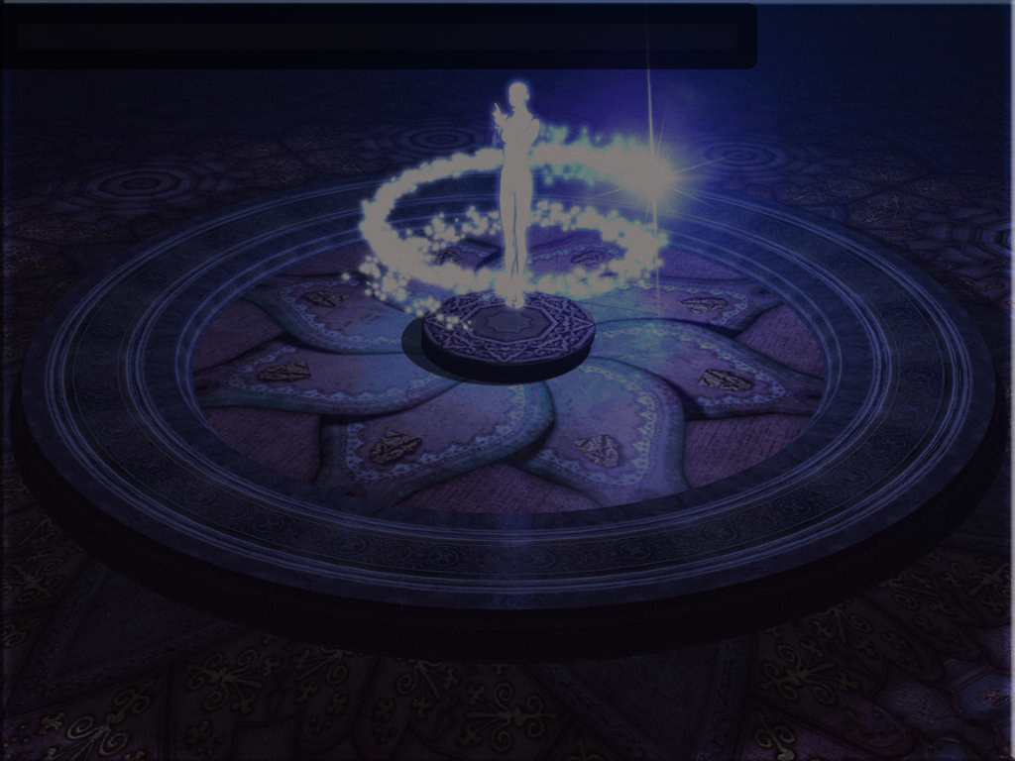

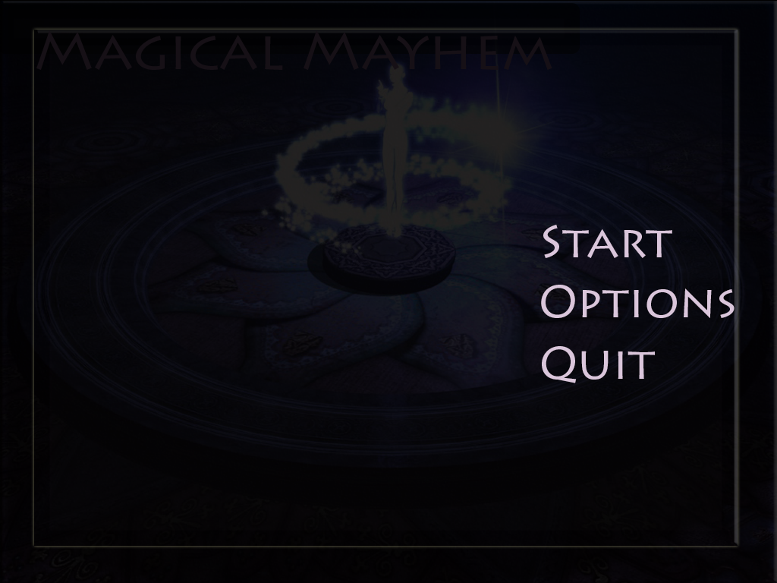

5.2 Start Menu:

A Game Menu is how the fun begins. This menu contains 3 portals to different areas of the program and they are Start, Options and Quit.

Start: Fires up the game from the first level.

Options: The player is transported to the options menu where they can change settings before gameplay such as sound on or off, difficulty and game modes.

5.3 HUD:

The player while in battle mode uses the display interface to interact with the game using the 4 action buttons in the shape of a cross as seen in many traditional RPG style games. The top button is used to attack, the left button is for using items in a fight and lastly for the remaining two, on the right is defend and the lower button is for magic attacks.

Action Buttons:

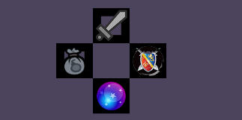

Attack: The attack button is represented above with the sword icon and when selected during battle the character uses his primary range attack.

Magic: Located at the very bottom of this cross of buttons is the icon for magic, when the player selects this button a drop-down menu for his magic attacks becomes available.

Inventory: To the left is the items button and when selected it displays a drop down menu with the items the character can use during battle.

Defend: The shield icon is used to represent that a character will take a defensive stance during battle.

5.4 Shop Menu:



At the end of each battle a menu button will appear on the top left corner of the game screen offering the player a momentary escape from the battle mode sequence to use their coins accumulated to shop for items, weapons and upgrades for the other team players.

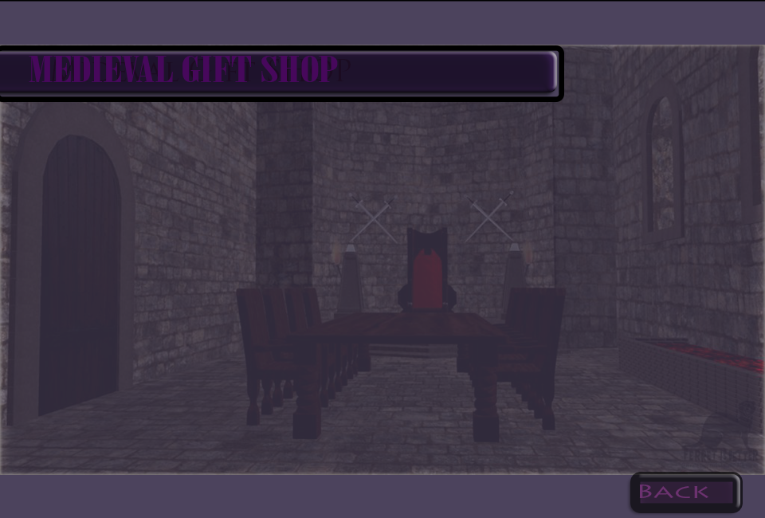

Once the player has entered the room with the shop, he or she is then welcomed and after a swift 2 second wait he is presented with a new menu that contains the options to shop for items and upgrades by character type.

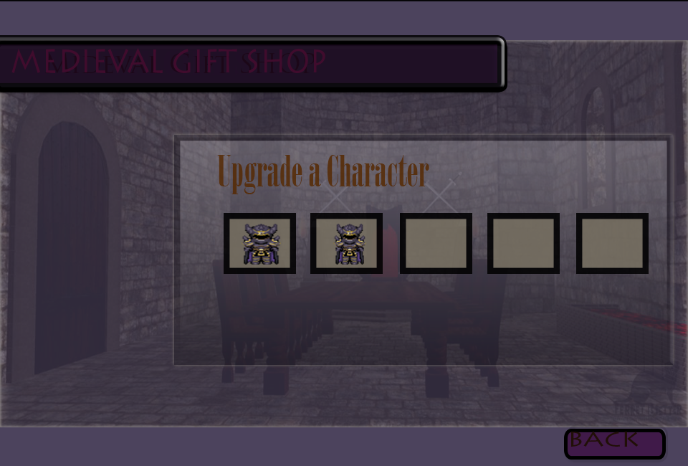

From here on the player can choose the type of character he wants to shop for or upgrade and by clicking on the character icon he crosses over to the next menu portal where the shopping for the character begins.

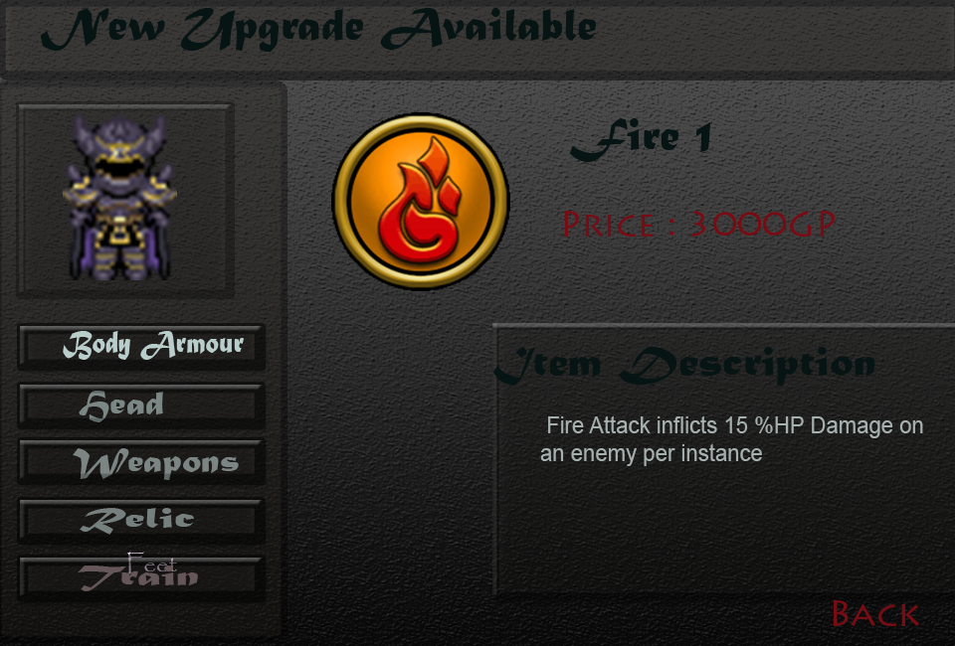

In the window above we can observe that the player has selected train to view the next available magic technique the character of the type selected can learn if purchased.

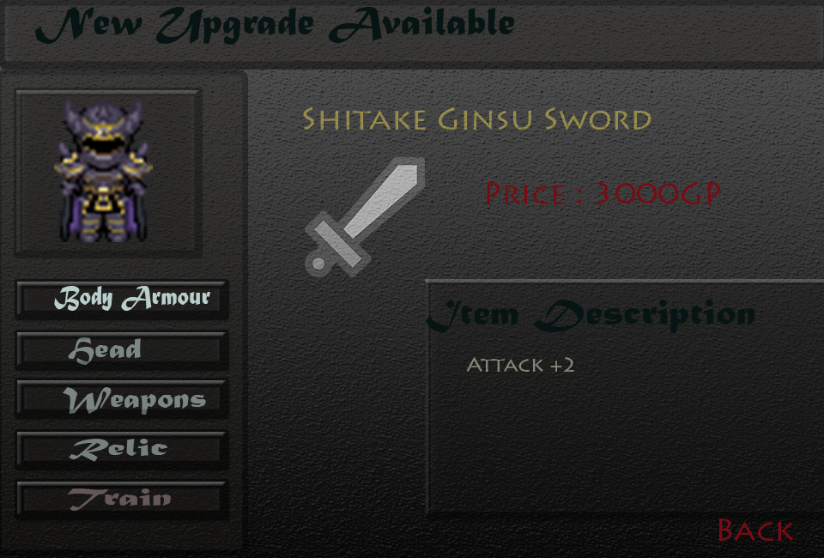

The menu objects are stored in array that includes the prices, item description and image that are generated in the screen when the respective button for the item is clicked.

Once an item is purchased by the player it is added to his inventory or equipment list and in the current screen a window will appear when an item is purchased with the details.